Name: _______________________________________________
Higher Unit 10 topic test
Date:
Time: 65 minutes
Total marks available: 59
Total marks achieved: ______

Questions
Q1.
There are 20 sweets in a box.
x of the sweets are red.
The rest of the sweets are yellow.
Tom takes at random a sweet from the box.
Write down an expression, in terms of x, for the probability that Tom takes a yellow sweet.
...........................................................
(Total for Question is 2 marks)

Q2.
Josh plays a game with two sets of cards.
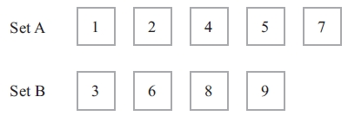
Josh takes at random one card from each set.
He adds the numbers on the two cards to get the total score.
(a) Complete the table to show all the possible total scores.
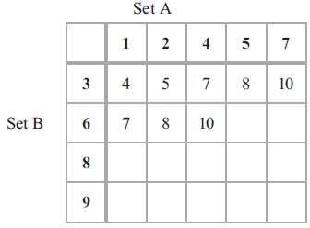
(1)
(b) What is the probability that Josh's total score will be greater than 12?
...........................................................
(2)

Josh's year group are raising money for a sponsored skydive.
60 students are each going to play Josh's card game once.
Each student pays 50p to play the game.
Josh pays £1.50 to any player getting a total of 8
(c) Show that Josh can expect to make a profit of £21 from his game.
(4)
(Total for Question is 7 marks)

Q3.
Ali throws a biased dice 200 times.
The table shows information about his results.
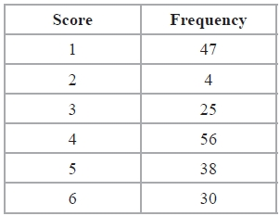
Charlie throws the dice 550 times.
Work out an estimate for the total number of times that Charlie will get a score of 4
..........................
(Total for Question is 3 marks)

Q4.
There are only red counters, blue counters, white counters and black counters in a bag.
The table shows the probability that a counter taken at random from the bag will be red or blue.
Colour | red | blue | white | black
Probability | 0.2 | 0.5
The number of white counters in the bag is the same as the number of black counters in the bag.
Tania takes at random a counter from the bag.
(a) Work out the probability that Tania takes a white counter.
..............................................................................................................................................
(2)
There are 240 counters in the bag.
(b) Work out the number of red counters in the bag.
..............................................................................................................................................
(2)
(Total for Question is 4 marks)

Q5.
Jane has a packet of seeds.
The probability that a seed will grow is 0.75
(a) What is the probability that a seed will not grow?
...........................................................
(1)
Jane plants 200 of these seeds.
(b) Estimate the number of the seeds that will grow.
...........................................................
(2)
(Total for Question is 3 marks)
Q6.
Four friends each throw a biased coin a number of times.
The table shows the number of heads and the number of tails each friend got.
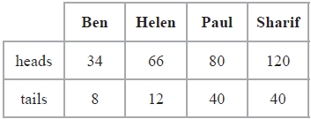
The coin is to be thrown one more time.
(a) Which of the four friends' results will give the best estimate for the probability that the coin will land heads?
Justify your answer.
.............................................................................................................................................
.............................................................................................................................................
.............................................................................................................................................
(1)
Paul says,
"With this coin you are twice as likely to get heads as to get tails."
(b) Is Paul correct?
Justify your answer.
.............................................................................................................................................
.............................................................................................................................................
.............................................................................................................................................
(2)
The coin is to be thrown twice.
(c) Use all the results in the table to work out an estimate for the probability that the coin will land heads both times.
...........................................................
(2)
(Total for question is 5 marks)
Q7.
The probability that Rebecca will win any game of snooker is p.
She plays two games of snooker.
(a) Complete, in terms of p, the probability tree diagram.
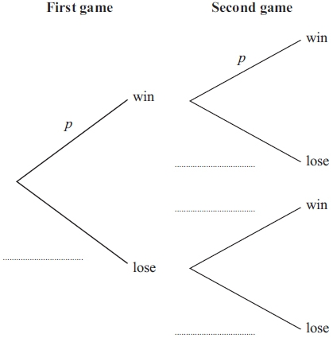

(2)
(b) Write down an expression, in terms of p, for the probability that Rebecca will win both games.
..............................................................................................................................................
(1)
(c) Write down an expression, in terms of p, for the probability that Rebecca will win exactly one of the games.

..............................................................................................................................................
(2)
(Total for Question is 5 marks)

Q8.
Isobel plays a game against Eric.
Isobel is twice as likely as Eric to win the game.
The probability that the game is drawn is 0.1
(a) Work out the probability that Eric wins the game.

. . . . . . . . . . . . . . . . . . . . . .
(2)
Isobel and Eric play the game three times.
(b) Work out the probability that all three games are drawn.

. . . . . . . . . . . . . . . . . . . . . .
(2)

(c) Work out the probability that Eric wins at least one of the three games.

. . . . . . . . . . . . . . . . . . . . . .
(3)
(Total for Question is 7 marks)
Q9.
The probability that Sanay is late for school tomorrow is 0.05
The probability that Jaden is late for school tomorrow is 0.15
Alfie says that the probability that Sanay and Jaden will both be late for school tomorrow
is 0.0075 because 0.05 × 0.15 = 0.0075
What assumption has Alfie made?
.............................................................................................................................................
.............................................................................................................................................
(Total for question = 1 mark)

Q10.
Lily and Anna take a test.
The probability that Lily will pass the test is 0.6
The probability that Anna will pass the test is 0.8
(a) Work out the probability that both of these girls fail the test.

..............................................................................................................................................
(3)
(b) Work out the probability that both of these girls pass the test or that both of these girls fail the test.

..............................................................................................................................................
(3)
(Total for Question is 6 marks)

Q11.
Thelma spins a biased coin twice.
The probability that it will come down heads both times is 0.09
Calculate the probability that it will come down tails both times.
...........................................................
(Total for question is 3 marks)

Q12.
Fiza has 10 coins in a bag.
There are three £1 coins and seven 50 pence coins.
Fiza takes at random, 3 coins from the bag.
Work out the probability that she takes exactly £2.50

..............................................................................................................................................
(Total for Question is 4 marks)

Q13.
Sami asked 50 people which drinks they liked from tea, coffee and milk.
All 50 people like at least one of the drinks
19 people like all three drinks.
16 people like tea and coffee but do not like milk.
21 people like coffee and milk.
24 people like tea and milk.
40 people like coffee.
1 person likes only milk.
Sami selects at random one of the 50 people.
(a) Work out the probability that this person likes tea.
...........................................................
(4)
(b) Given that the person selected at random from the 50 people likes tea, find the probability that this person also likes exactly one other drink.
...........................................................
(2)
(Total for question = 6 marks)

Q14.
David has designed a game.
He uses a fair 6–sided dice and a fair 5–sided spinner.
The dice is numbered 1 to 6
The spinner is numbered 1 to 5
Each player rolls the dice once and spins the spinner once.
A player can win £5 or win £2
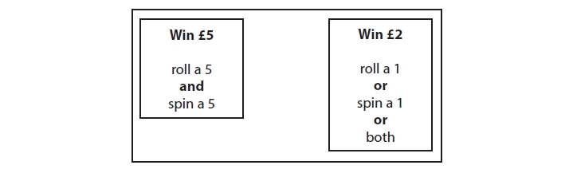
David expects 30 people will play his game.
Each person will pay David £1 to play the game.
(a) Work out how much profit David can expect to make.
£ ...........................................................
(4)
(b) Give a reason why David's actual profit may be different to the profit he expects to
make.
.............................................................................................................................................
.............................................................................................................................................
(1)
(Total for question = 5 marks)

Examiner's Report
Q1.
A disappointingly small proportion of higher tier students could give a correct expression in response to this question. When correct answers were seen ^{20−x}⁄₂₀ was seen much more often than 1 − ^{x}⁄₂₀, many students were awarded 1 mark for "20 − x" but they often failed to realise that this expression could not represent a probability.

Q2.
There were too many that lost the mark for the basic addition required in part (a). Even with the error in the table most then went on to score either part or full marks in part (b). The most common mistake in part (b) was not realising that 'greater than 12' does not include 12, but ⁷⁄₂₀ still gained one mark. The vast majority of responses were presented using correct probability notation, with very few 'out of' or ratios seen.
In part (c), the layout of many of the candidates working for this question was haphazard, with a minimal use of words to explain steps. In spite of this many scored full marks. The weaker candidates could not link the ²⁄₂₀ to a situation of 60 people, but most were able to get 1 mark for working out the income of £30. Although there were a number that worked backwards, making the mathematics fit, these rarely justified why 6 had won and so lost part of the marks for the question. There were a number that showed the profit from the non-winners only and loss of £1 to each of the winners, this was an alternative valid method and could if done correctly gain full marks.

Q3.
This question was generally well answered though a significant number of students worked out either 550 ÷ 4 or 56 ÷ 4. Some students multiplied 56 by 550. Obviously neither of these approaches yielded any marks. Some students were awarded one mark for a partially correct or a partially completed method. A common approach was for students to work out how many would be expected in 100 trials, using this to then find the expectation for 500 trials and then 50 trials, eventually leading to an expectation for 550 trials. Some students were successful in this approach, but others made errors on the way.

Q4.
In part (a), a significant number of candidates demonstrated problems with decimals, confusing 0.015, 0.1.1 and 0.1 ½ . Some added 0.5 and 0.2 and then divided by 2, but generally halving a decimal was a major weakness. Quite a few showed 0.3 in their working but then failed to give 0.15 as their answer.
In part (b), the most common error was dividing 240 by 0.2 rather than multiplying. 12 was a common incorrect answer which was arrived at from 240 ÷ 2, then a division of 10. Some divided 240 by 4 because there were 4 colours.

Q5.
Part (a) was answered correctly by most candidates.
In part (b) many gained one mark for 200 × 0.75 but a surprising number failed to evaluate this correctly. Some candidates over-complicated the calculation and attempted to use a long multiplication method. Other common errors were working out an estimate for the number of seeds that would not grow, giving 200 × 0.25 = 50 as the answer, and misunderstanding the meaning of the word 'estimate' and working out 200 × 0.8.

Q6.
No Examiner's Report available for this question

Q7.
Many candidates failed to accurately complete the probability tree diagram in part (a). Sight of 1 – p anywhere was not the norm; -p, not p, q were the most common labels on the 'lose' branches. Some candidates tried to replace the letters with fractions or decimals, 0.5 being the most common.
However, p was usually the answer shown on the 'win' branch and this usually led to the correct answer in part (b), although 2p was often seen. A significant number of candidates actually wrote p × p = 2p.
It was rare to see a fully correct expression in terms of p for answers to part (c). Many, who did have algebraic expressions in terms of p for their probabilities in part (a), gained one mark for correct application of probability theory. Many candidates recorded p x p – 1, instead of p x (p – 1) omitting the brackets and therefore failed to simplify correctly.

Q8.
Part (a) was done well. Many candidates were able to divide 0.9 in the ratio 1:2 (usually by inspection), but some incorrectly gave 0.6 on the answer line. A very common error here was 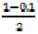 (=0.45).
Part (b) was not done well. Few candidates could work out the required probability by calculating (0.1)³. A very common incorrect answer here was 3 × 0.1. Some candidates, having reached the correct calculation (0.1×0.1×0.1) were unable to evaluate this correctly. A common incorrect answer here was 0.01.
Part (c) was not done well. Only the best candidates opted for the direct approach and were able to deal with the probabilities 0.3 and 0.7 correctly to arrive at the correct calculation (usually by drawing a tree diagram). Many candidates attempted this question by dealing with all three probabilities 0.1, 0.3 and 0.6 and drawing a tree diagram with 27 outcomes. Few of those candidates attempting this approach were able to select all the correct outcomes for the required probability.

Q9.
No Examiner's Report available for this question

Q10.
There were many correct answers – with or without a full or partial probability tree – although some candidates were not able to complete their attempt at such a diagram. A very common answer to part (a) was 0.6 obtained from 0.2 + 0.4.
Generally candidates who got part (a) correct also got part (b) correct. Oddly enough, this did not seem to happen the other way around. In part (b), in many cases candidates displayed the correct calculation of 0.4 × 0.2 + 0.6 × 0.8 = 0.56, but got a completely wrong answer to part (a). For part (b), a few candidates worked out the 0.4 × 0.2 and the 0.6 × 0.8 but then multiplied the answers to the two calculations.

Q11.
No Examiner's Report available for this question

Q12.
This question discriminated well between the more able candidates taking this paper. There were many good concise and accurate solutions to this question usually including the use of a tree diagram. Most of the candidates who recognised that a tree diagram was appropriate also realised that the problem involved non-replacement of the coins and so used fractions with denominators 10, 9 and 8. The focus of the question was not on simplification of fractions so answers where fractions which were not given in fully simplified form, for example ¹²⁶⁄₇₂₀ , were awarded full marks. Weaker candidates usually lacked a strategy to follow and often gave answers from little or no working.

Q13.
No Examiner's Report available for this question

Q14.
No Examiner's Report available for this question

Mark Scheme
Q1.
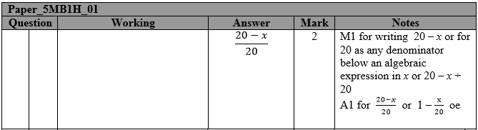

Q2.
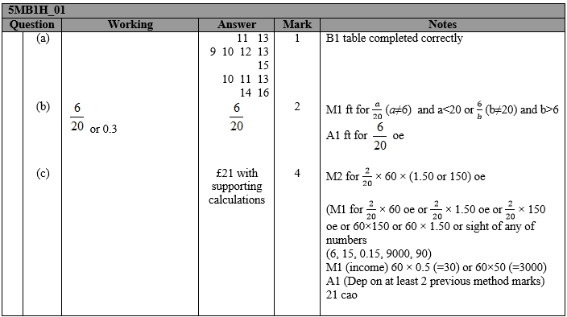

Q3.
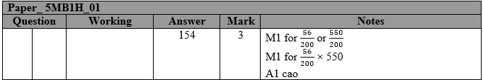

Q4.
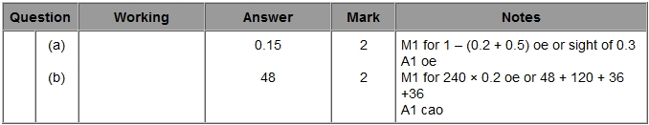

Q5.
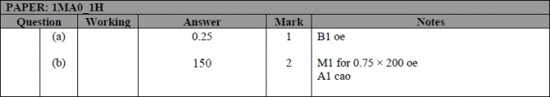

Q6.
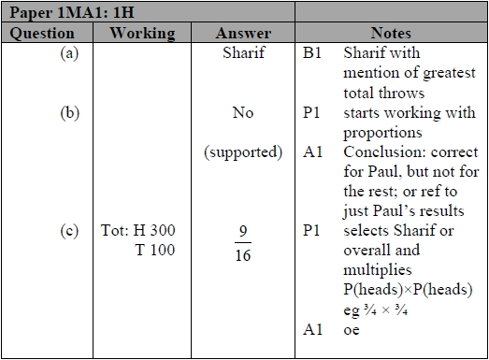

Q7.
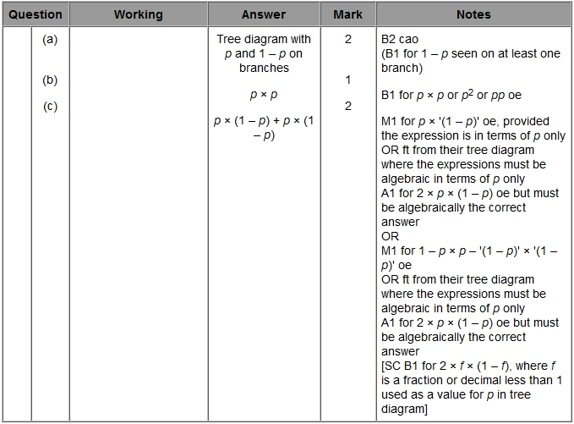

Q8.
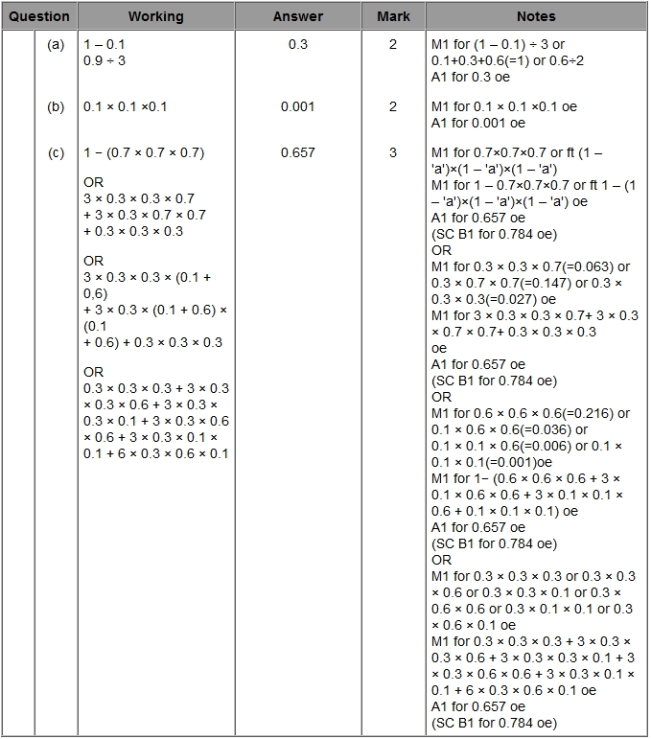

Q9.
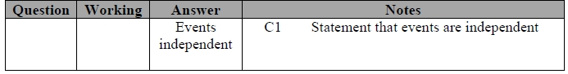

Q10.
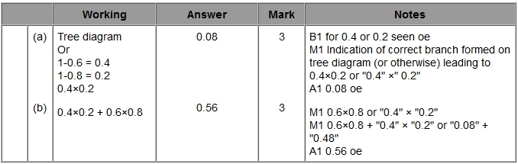

Q11.
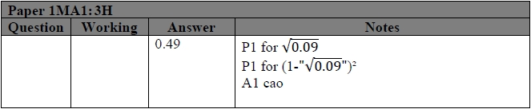

Q12.
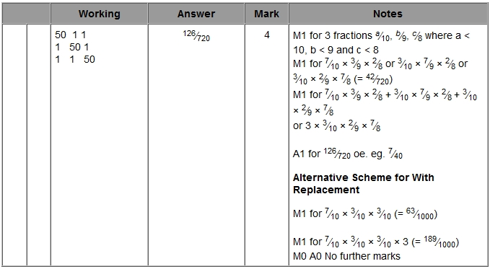

Q13.
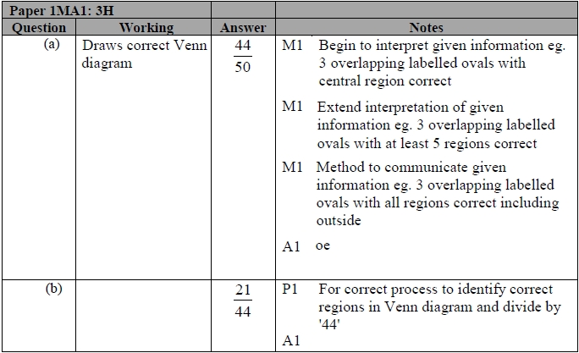

Q14.
