Name: _______________________________________________
Higher Unit 11 topic test
Date:
Time: 55 minutes
Total marks available: 48
Total marks achieved: ______

Questions
Q1.
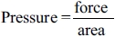
Find the pressure exerted by a force of 900 newtons on an area of 60cm².
Give your answer in newtons/m².
........................................................... newtons/m²

(Total for question = 2 marks)

Q2.
Mrs Jennings shares £770 between her two sons, Pete and Tim.
She shares the money in the ratio of her sons' ages.
The combined age of her two sons is 66 years.
Pete is 6 years younger than Tim.
Work out how much money each son gets.
You must show all your working.

Pete £ . . . . . . . . . . . . . . . . .
Tim £ . . . . . . . . . . . . . . . . .
(Total for Question is 5 marks)

Q3.
160 cm of gold wire has a weight of 17.8 grams.
Work out the weight of 210 cm of the gold wire.

..............................................................................................................................................
(Total for Question is 3 marks)

Q4.
y is directly proportional to x.
When x = 600, y = 10
(a) Find a formula for y in terms of x.

y = . . . . . . . . . . . . . . . . . . . . . .
(3)
(b) Calculate the value of y when x = 540

y = . . . . . . . . . . . . . . . . . . . . . .
(1)
(Total for Question is 4 marks)

Q5.
Bella invests £5000 in an account for two years.
The account pays 3% compound interest per annum.
Bella has to pay 20% tax on the interest earned each year.
This tax is taken from the account at the end of each year.
How much money will Bella have in her account at the end of the two years?

(Total for question = 4 marks)

Q6.
Peter has £20 000 to invest in a savings account for 2 years.
He finds information about two savings accounts.
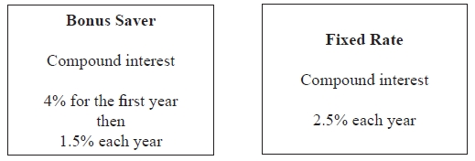
Peter wants to have as much money as possible in his savings account at the end of 2 years.
Which of these savings accounts should he choose?

(Total for question = 4 marks)

Q7.
Asif is going on holiday to Turkey.
The exchange rate is £1 = 3.5601 lira.
Asif changes £550 to lira.
(a) Work out how many lira he should get.
Give your answer to the nearest lira.
........................................................... lira
(2)
Asif sees a pair of shoes in Turkey.
The shoes cost 210 lira.
Asif does not have a calculator.
He uses £2 = 7 lira to work out the approximate cost of the shoes in pounds.
(b) Use £2 = 7 lira to show that the approximate cost of the shoes is £60
(2)
(c) Is using £2 = 7 lira instead of using £1 = 3.5601 lira a sensible start to Asif's method to work out the cost of the shoes in pounds?
You must give a reason for your answer.
.............................................................................................................................................
.............................................................................................................................................
(1)

(Total for question = 5 marks)

Q8.
Katy invests £2000 in a savings account for 3 years.
The account pays compound interest at an annual rate of
2.5% for the first year
x% for the second year
x% for the third year
There is a total amount of £2124.46 in the savings account at the end of 3 years.
(a) Work out the rate of interest in the second year.
...........................................................
(4)
Katy goes to work by train.
The cost of her weekly train ticket increases by 12.5% to £225
(b) Work out the cost of her weekly train ticket before this increase.
£...........................................................
(2)

(Total for question = 6 marks)

Q9.
T is inversely proportional to d²
T = 160 when d = 8
Find the value of T when d = 0.5

..............................................................................................................................................
(Total for Question is 3 marks)

Q10.
The diagram shows a solid triangular prism.
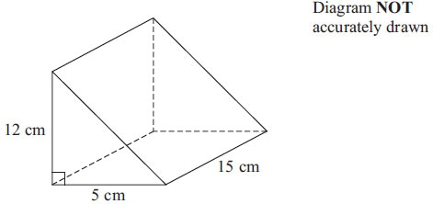
The prism is made from metal.
The density of the metal is 6.6 grams per cm³.
Calculate the mass of the prism.

..............................................................................................................................................
(Total for Question is 3 marks)

Q11.
A frustum is made by removing a small cone from a large cone as shown in the diagram.
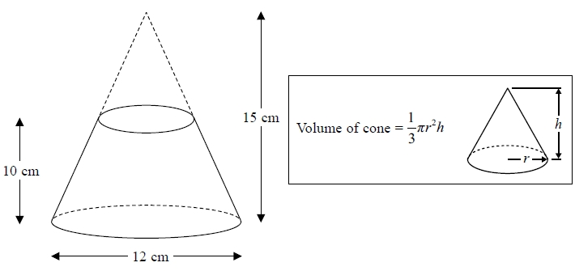
The frustum is made from glass.
The glass has a density of 2.5 g / cm³
Work out the mass of the frustum.
Give your answer to an appropriate degree of accuracy.
........................................................... g

(Total for question = 5 marks)

Q12.
The diagram shows a solid wooden sphere.
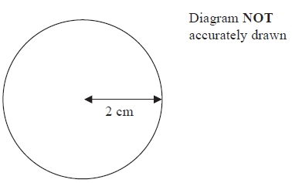
The radius of the sphere is 2 cm.
The mass of the sphere is 45 grams.
Wood will float on the Dead Sea only when the density of the wood is less than 1.24 g/cm³.
Will this wooden sphere float on the Dead Sea?
(Total for Question is 4 marks)

Examiner's Report

Q1.
No Examiner's Report available for this question

Q2.
Most candidates were able to gain 2 marks here for finding the ages as 30 and 36. The better candidates went on to simplify 30:36 to give 5:6 thus giving easier calculations and most of these went on to score full marks. Those who attempted to divide 770 by 66 often gave their answer to this as 11 remainder 44 or 11.6 or sometimes just 11. Whilst many were then able to score the next method mark for multiplying their answer to the division by 30 or 36 they lost the accuracy mark for the final answers due to premature rounding.

Q3.
Many candidates clearly did not understand the concept of density. A common error was to start with 160 ÷ 17.8; the vast majority of candidates who did this failed to gain any marks as they went onto multiply their result by 210. Candidates who carried out the correct method in two steps frequently lost marks due to premature rounding.
The majority of candidates found the weight of 1 cm then scaled this up to find the weight of 210 cm. However, some candidates successfully found the weight of either 50 cm (the difference in the two lengths) or 10 cm and used these weights to give the right answer.
A common error was to state that the weight of 10cm was 1.78g. A relatively high proportion of candidates lost the accuracy mark when using the latter method, however. Candidates who used repeated division to get 80,40 20 and 10 often lost marks due to premature rounding.

Q4.
In part (a) a significant number were able to understand that y was proportional to x and continued to write y=kx, usually writing 10=k×600. Completion of this was frequently flawed, leading to 60x rather than x/60. The mark in part (b) was usually gained, in many cases using their flawed equation (used correctly).

Q5.
No Examiner's Report available for this question

Q6.
Those who chose to work with multipliers regularly failed to score in this question, mainly due to a poor choice of multiplier, for example 0.4 rather than 0.04, or combining the 4% and 1.5%. 2.5² was also seen regularly. Many chose to use simple interest methods and therefore gained few marks, if any. Those who recognised this as compound interest were usually able to work out a correct figure for one of the banks, but both calculated correctly was rare.

Q7.
No Examiner's Report available for this question

Q8.
No Examiner's Report available for this question

Q9.
This inverse proportion question differentiated between candidates. Some candidates followed the complete method expected for full marks but it was not done well by the majority of candidates, with some not even attempting it. Of those who established the usual routine with a proportion sign and then the use of the constant k, many used direct proportion or inverse (rather than inverse square) proportion and gained no marks. When candidates did write down a correct algebraic statement, the rearrangement of the equation to make k the subject sometimes went wrong. Many of the candidates who correctly found the value of k then went on to achieve full marks. Some, though, got an incorrect final answer through careless substitution. A common incorrect answer was 10, obtained from ¹⁶⁰⁄₈ = 20 followed by 0.5 × 20 = 10.

Q10.
The volume calculation was frequently incorrect with the formula for the volume of a cuboid being calculated rather than the volume of the given triangular prism. The other common error was to divide, rather than multiply, the volume by the density to obtain the mass of the prism. Some candidates attempted to work out the surface area or find the sum of all the edges; such incorrect methods gained no marks.

Q11.
No Examiner's Report available for this question

Q12.

Even though the formula to find the volume of a sphere is given on the formula sheet, many used alternative formulae, often formulae for finding area. All methods using area gained no marks at all. Many students working with the correct volume and subsequent density failed to score the final mark with an incomplete conclusion. Students here were required to compare their calculated density to that given.

Mark Scheme
Q1.
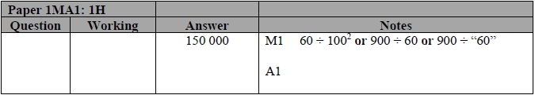

Q2.
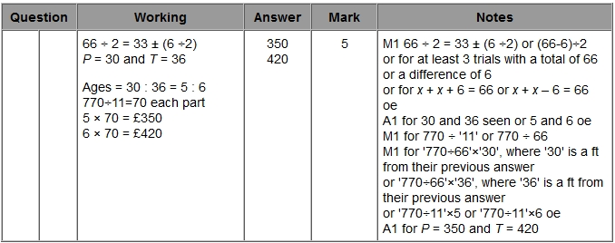

Q3.
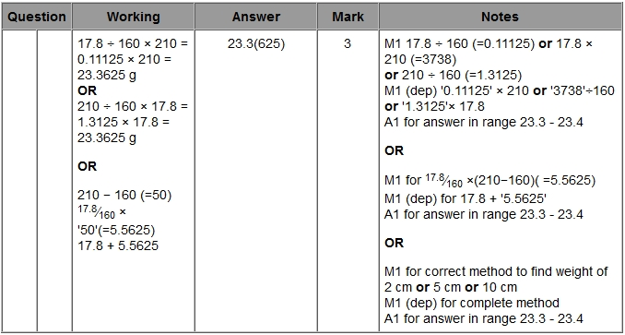

Q4.
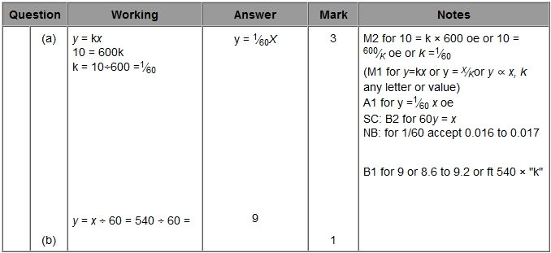

Q5.
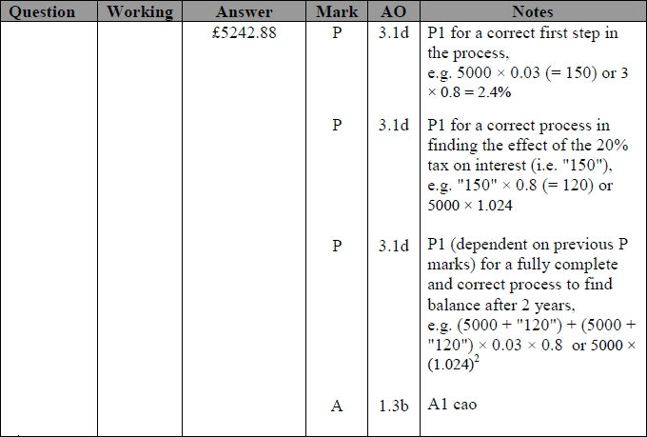

Q6.
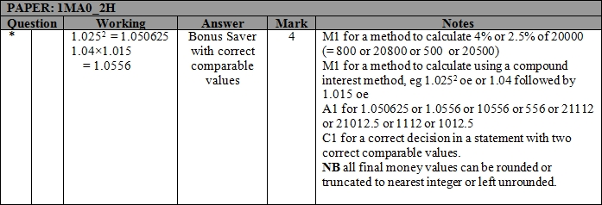

Q7.
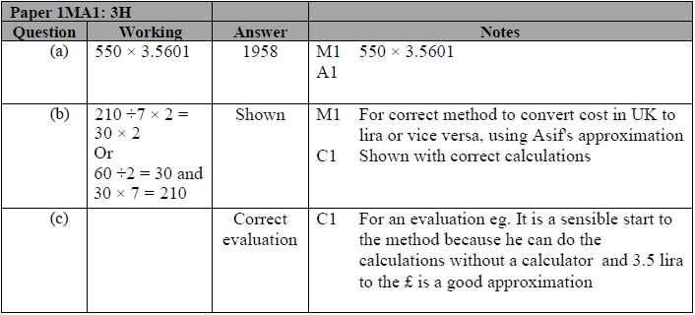

Q8.
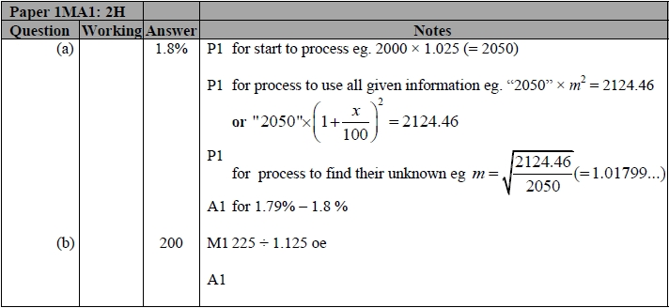

Q9.
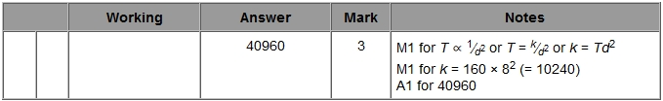

Q10.
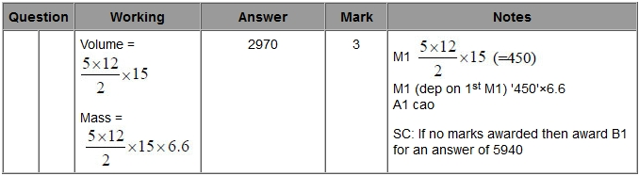

Q11.
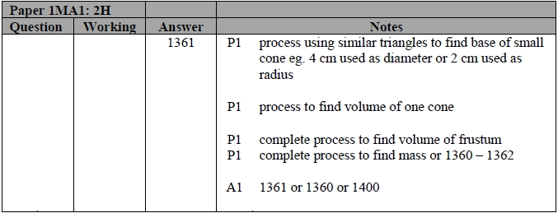

Q12.
