Name: _______________________________________________
Higher Unit 13 topic test
Date:
Time: 55 minutes
Total marks available: 46
Total marks achieved: ______

Questions
Q1.
ABC is an isosceles triangle.
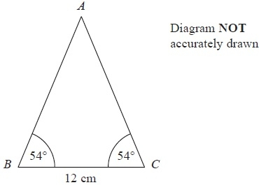
Work out the area of the triangle.
Give your answer correct to 3 significant figures.
........................................................... cm²
(Total for Question is 4 marks)

Q2.
The diagram shows a sketch of the graph of y = cos x°
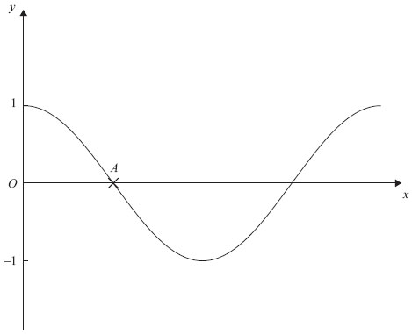
Write down the coordinates of the point A.

..............................................................................................................................................
(Total for Question is 1 mark)

Q3.
The diagram shows part of a sketch of the curve y = sin x°.
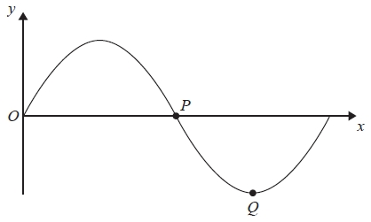
(a) Write down the coordinates of the point P.
(.............................. , ..............................)
(1)
(b) Write down the coordinates of the point Q.
(.............................. , ..............................)
(1)
(Total for Question is 2 marks)

Q4.
Here is the graph of y = sin x° for –180 ≤ x ≤ 180
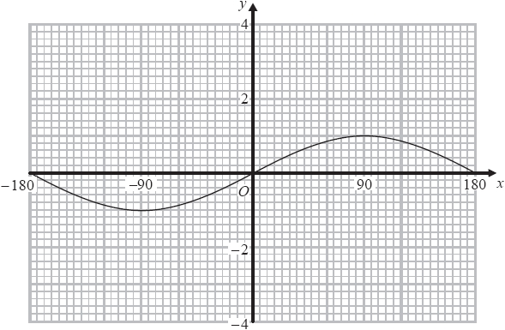
On the grid above, sketch the graph of y = sin x° + 2 for –180 ≤ x ≤ 180
(Total for question is 2 marks)

Q5.
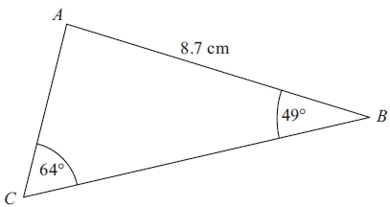 Diagram NOT accurately drawn
ABC is a triangle.
AB = 8.7 cm.
Angle ABC = 49°.
Angle ACB = 64°.
Calculate the area of triangle ABC.
Give your answer correct to 3 significant figures.

. . . . . . . . . . . . . . . . . . . . . cm²
(Total for Question is 5 marks)

Q6.
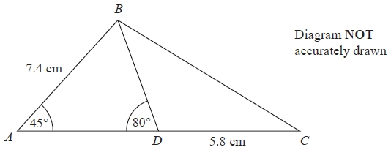
ABC is a triangle.
D is a point on AC.
Angle BAD = 45°
Angle ADB = 80°
AB = 7.4 cm
DC = 5.8 cm
Work out the length of BC.
Give your answer correct to 3 significant figures.
........................................................... cm
(Total for question = 5 marks)

Q7.
The diagram shows triangle LMN.
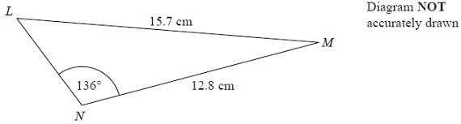
Calculate the length of LN.
Give your answer correct to 3 significant figures.
........................................................... cm
(Total for Question is 5 marks)

Q8.
ABCD is a quadrilateral.
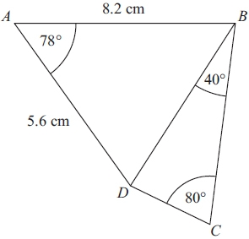 Diagram NOT accurately drawn
Work out the length of DC.
Give your answer correct to 3 significant figures.

. . . . . . . . . . . . . . . . . . . . . . cm
(Total for Question is 6 marks)

Q9.
In triangle RPQ,
RP = 8.7 cm
PQ = 5.2 cm
Angle PRQ = 32°
(a) Assuming that angle PQR is an acute angle,
calculate the area of triangle RPQ.
Give your answer correct to 3 significant figures.
...........................................................cm²
(4)
(b) If you did not know that angle PQR is an acute angle, what effect would this have on your calculation of the area of triangle RPQ?
.............................................................................................................................................
.............................................................................................................................................
.............................................................................................................................................
(1)
(Total for question = 5 marks)

Q10.
Jerry wants to cover a triangular field, ABC, with fertiliser.
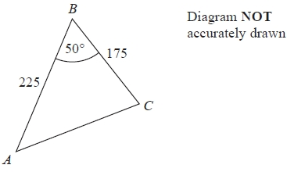
Here are the measurements Jerry makes
angle ABC = 50° correct to the nearest degree,
BA = 225 m correct to the nearest 5 m,
BC = 175 m correct to the nearest 5 m.
Work out the upper bound for the area of the field.
You must show your working.
...........................................................m²
(Total for Question is 3 marks)

Q11.
* The diagram shows the triangle PQR.
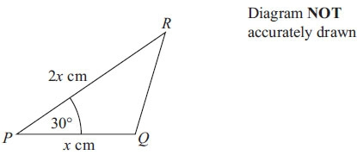
PQ = x cm
PR = 2x cm
Angle QPR = 30°
The area of triangle PQR = A cm²
Show that x = 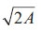

(Total for Question is 3 marks)

Q12.
VABCD is a solid pyramid.
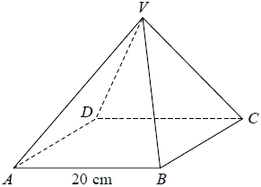
ABCD is a square of side 20 cm.
The angle between any sloping edge and the plane ABCD is 55°
Calculate the surface area of the pyramid.
Give your answer correct to 2 significant figures.
...........................................................cm²
(Total for question = 5 marks)

Examiner's Report
Q1.
This was the first question on the paper that was poorly attempted. The preferred route taken by candidates was to find either AB or AC, which was nearly always correctly done. Most of these candidates then went on to substitute their values into ½abSinC with just a few using the wrong value for the included angle. A few candidates, having found the slant height, used it as the perpendicular height of the triangle when calculating the area using ½ b×h, resulting in the loss of marks. It was rare to see the triangle split into two right angled triangles and tan54 used to find the height, though those who chose this route usually did it well.

Q2.
This question proved to be a good discriminator between the most able candidates. In part (a) the most commonly seen incorrect answers seen included (1, 0) and (0, 90).

Q3.
The first two parts of the question were basically about how well candidates knew their trigonometric curves. The response was very poor with very few being able to give the correct coordinates. Surprisingly for this target level, there were candidates who gave the correct values, but reversed − for example (0, 180) instead of the correct (180, 0)

Q4.
There were a few good answers to part (a) and some further students managed to score 1 mark for a reasonably convincing translation parallel to the y-axis.

Q5.
This question was often omitted and it was generally not well done by those who did attempt it. A number of candidates treated the triangle as right angled and used cos/sin/tan to find one of the sides. Those who used the sine rule were mostly able to find at least one side successfully. Many candidates found both missing sides which was unnecessary. Most knew that they had to use 1/2absinC for the area but sometimes did not use the angle included by their two sides.

Q6.
From this point on, a significant number of students failed to attempt these later questions in the paper. In this question many incorrectly assumed ABC was 90° and tried to use Pythagoras. Some tried to use Sine Rule but frequently substituted incorrect values; few considered the need to use Cosine Rule.

Q7.
Many candidates started off by using the Cosine Rule with the angle 136 or basic trigonometry, but alone this would not have led to a complete solution. It was rare to find Cosine Rule being used correctly as a first stage. In some cases a start using the Sine Rule was not developed, as a significant number of candidates did not know what to do with it once they had substituted the numbers. Those who did so successfully usually went on to use Cosine Rule or Sine Rule again to complete the solution. Premature rounding spoilt many solutions.

Q8.
There were some who did not understand the topic and associated this question with Pythagoras and right-angled trigonometry. The majority deduced Cosine rule was needed and correctly substituted in their values. In many cases the order of operations in Cosine Rule was flawed, resulting in an incorrect length for DB. Many then went on to use Sine Rule, with greater success and sound method shown resulted in additional marks.

Q9.
No Examiner's Report available for this question

Q10.
Seeing the correct bounds was rare and 225.5 and 175.5 or 230 and 180 were often seen as the upper bounds of BA and BC respectively. Many students however earned the first mark for a correct upper bound for the angle.
Use of ¹⁄₂absinC was good, however it was not uncommon to see the students' upper bounds for BA and BC and then sin 50° used.

Q11.
The majority of candidates who realised that they had to use ½ ab sin C for the area of the triangle often substituted the given lengths and angle correctly but then could not progress any further. Some good fully correct proofs were seen but a very few candidates were unable to gain full marks because their calculators were clearly set in radian or gradian rather than degree mode.

Q12.
No Examiner's Report available for this question

Mark Scheme
Q1.
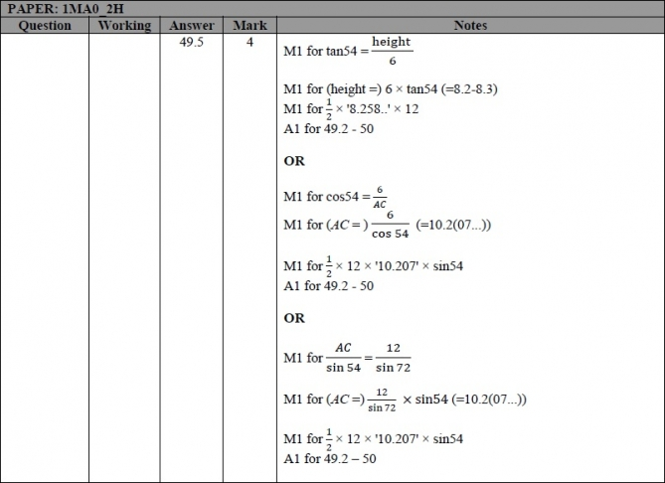

Q2. (part (a) only)
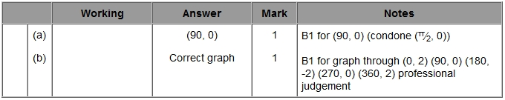

Q3. (parts (a) and (b) only)
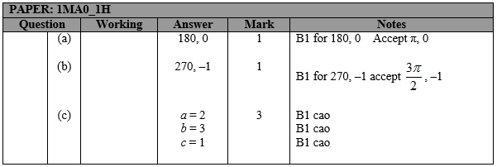

Q4. (part (a) only)
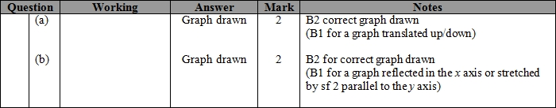

Q5.
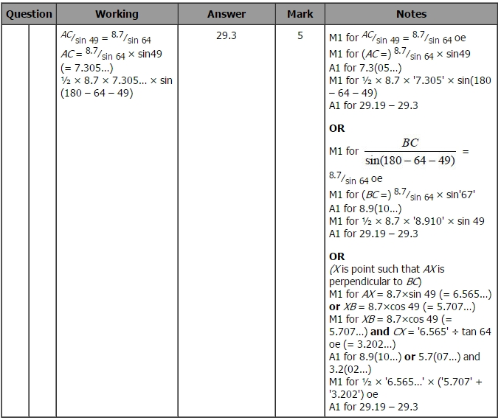

Q6.
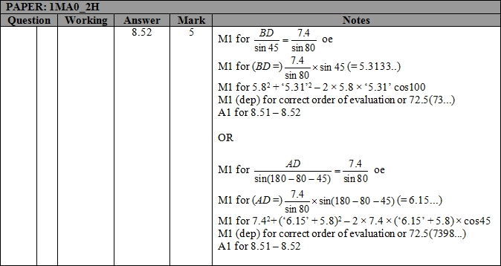

Q7.
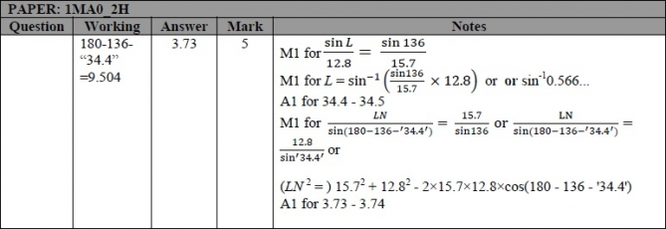

Q8.
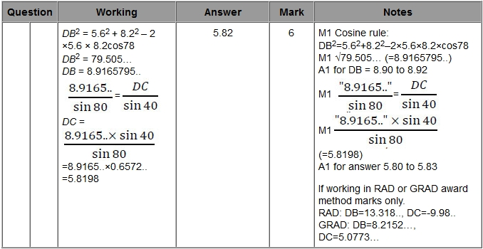

Q9.
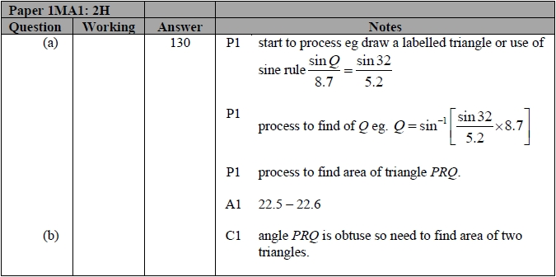

Q10.
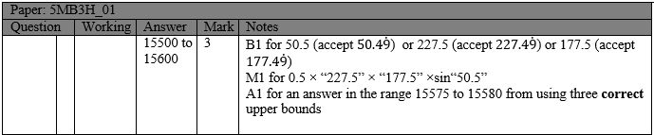

Q11.
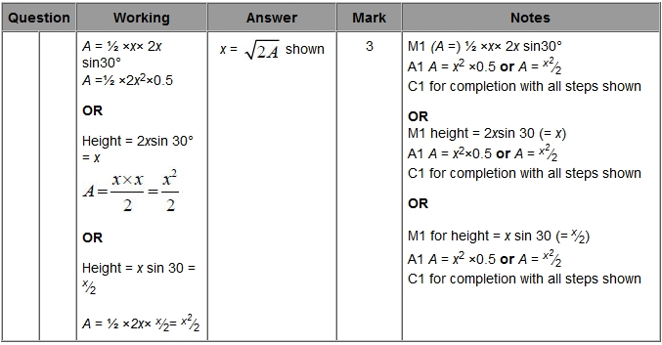

Q12.
