Name: _______________________________________________
Higher Unit 14 topic test
Date:
Time: 55 minutes
Total marks available: 51
Total marks achieved: ______

Questions
Q1.
* Mr and Mrs Jennings are planning a holiday to Italy.
They will go on holiday with their 11 year old daughter.
The table below shows some information about the prices of flights.
Flight to Italy | %%% |  | Flight to Italy
Date | Price per adult (£) | Date | Price per adult (£)
28th October | 282 | 4th November | 305
29th October | 283 | 5th November | 303
30th October | 282 | 6th November | 285
31st October | 272 | 7th November | 283
Child fares 0 to 2 years old No charge Over 2 to 12 years old 75% of the adult fare
Mr and Mrs Jennings and their daughter want to fly to Italy on 29th October.
They want to fly back from Italy on 6th November.
They have £1600 to spend on flights.
Do they have enough money for the flights?
You must show all your working.

(Total for Question is 6 marks)

Q2.
The table below shows information about the times, in minutes, a group of students took to answer 10 maths questions.
 | Least | Lower quartile | Median | Upper quartile | Greatest
Time in minutes | 14 | 18 | 20 | 25 | 30
On the grid below, draw a box plot to show the information in the table.
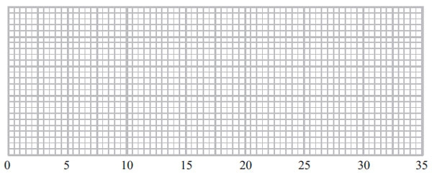
(Total for Question is 3 marks)

Q3.
Colin took a sample of 80 football players.
He recorded the total distance, in kilometres, each player ran in the first half of their matches on Saturday.
Colin drew this box plot for his results.
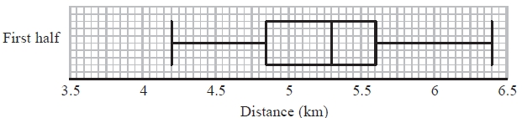
(a) Work out the interquartile range.
...........................................................km
(2)
There were 80 players in Colin's sample.
(b) Work out the number of players who ran a distance of more than 5.6 km.
...........................................................
(2)
Colin also recorded the total distance each player ran in the second half of their matches.
He drew the box plot below for this information.
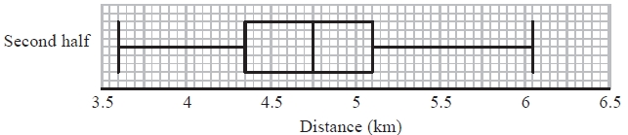
(c) Compare the distribution of the distances run in the first half with the distribution of the distances run in the second half.
.............................................................................................................................................
.............................................................................................................................................
.............................................................................................................................................
.............................................................................................................................................
(2)
(Total for Question is 6 marks)
Q4.
* Toga wants to estimate the number of termites in a nest.
On Monday Toga catches 80 termites.
He puts a mark on each termite.
He then puts all 80 termites back in the nest.
On Tuesday Toga catches 60 termites.
12 of these termites have a mark on them.
Work out an estimate for the total number of termites in the nest.
You must write down any assumptions you have made.
...........................................................

(Total for question = 4 marks)

Q5.
* A farmer wants to estimate the number of rabbits on his farm.
On Monday he catches 120 rabbits.
He puts a tag on each rabbit.
He then lets the rabbits run away.
On Tuesday the farmer catches 70 rabbits.
15 of these rabbits have a tag on them.
Work out an estimate for the total number of rabbits on the farm.
You must write down any assumptions you have made.
(Total for Question is 4 marks)

Q6.
Harry grows tomatoes.
This year he put his tomato plants into two groups, group A and group B.
Harry gave fertiliser to the tomato plants in group A.
He did not give fertiliser to the tomato plants in group B.
Harry weighed 60 tomatoes from group A.
The cumulative frequency graph shows some information about these weights.
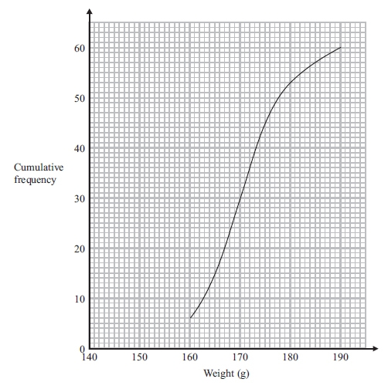
(a) Use the graph to find an estimate for the median weight.
. . . . . . . . . . . . . . . . . . . . . . g
(1)
The 60 tomatoes from group A
had a minimum weight of 153 grams
and a maximum weight of 186 grams.
(b) Use this information and the cumulative frequency graph to draw a box plot for the 60 tomatoes from group A.
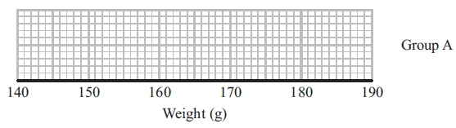
(3)
Harry did not give fertiliser to the tomato plants in group B.
Harry weighed 60 tomatoes from group B.
He drew this box plot for his results.
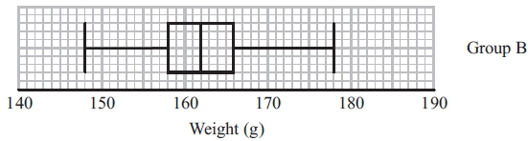
(c) Compare the distribution of the weights of the tomatoes from group A with the distribution of the weights of the tomatoes from group B.

..............................................................................................................................................
..............................................................................................................................................
..............................................................................................................................................
..............................................................................................................................................
(2)
(Total for Question is 6 marks)

Q7.
The table shows some information about the times, in minutes, 60 people took to get to work.
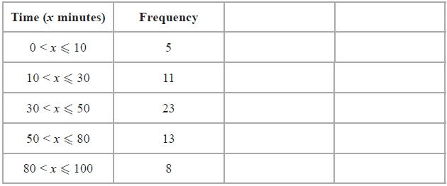
(a) Calculate an estimate for the mean.
..........................minutes
(4)
(b) Complete the cumulative frequency table.
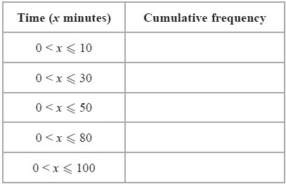
(1)
(c) On the grid draw a cumulative frequency graph for your table.
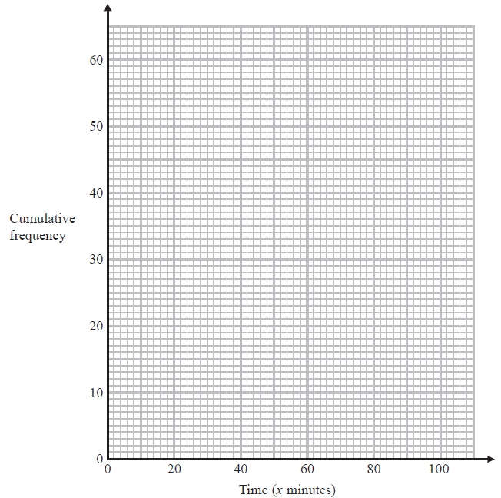
(2)
(d) Find an estimate for the number of people who took more than 1 hour to travel to work.
..........................
(2)
(Total for Question is 9 marks)

Q8.
The cumulative frequency graph shows information about the speeds of 60 cars on a motorway one Sunday morning.
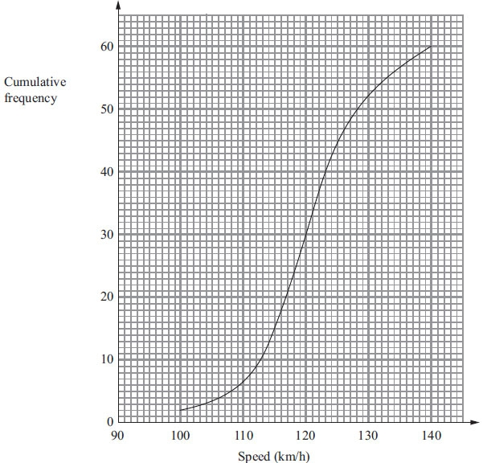
(a) Use the graph to find an estimate for the median speed.

. . . . . . . . . . . . . . . . . . . . . . km/h
(1)

The speed limit on this motorway is 130 km/h.
The traffic police say that more than 20% of cars travelling on the motorway break the speed limit.
(b) Comment on what the traffic police say.
(3)

For these 60 cars
the minimum speed was 97 km/h
and the maximum speed was 138 km/h.
(c) Use the cumulative frequency graph and the information above to draw a box plot showing information about the speeds of the cars.
(3)
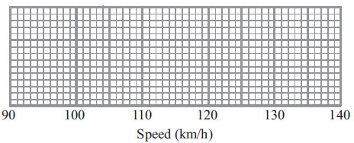
(Total for Question is 7 marks)

Q9.
The table gives some information about the speeds, in km/h, of 100 cars.
Speed (s km/h) | Frequency
60 < s ≤ 65 | 15
65 < s ≤ 70 | 25
70 < s ≤ 80 | 36
80 < s ≤ 100 | 24
(a) On the grid, draw a histogram for the information in the table.
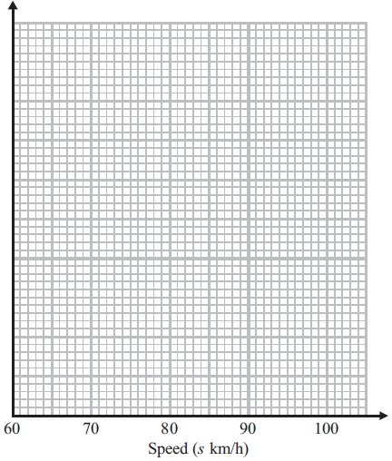
(3)
(b) Work out an estimate for the number of cars with a speed of more than 85 km/h.

..............................................................................................................................................
(2)
(Total for Question is 5 marks)

Q10.
The table shows some information about the total rainfall, in millimetres, recorded at 85 weather stations one month.
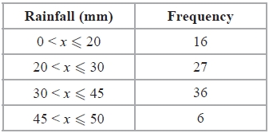
(a) Draw a histogram for this information.
(3)
(b) One of the weather stations is selected at random.
Work out the probability that the rainfall recorded was over 40 mm.
...........................................................
(3)
(Total for Question is 6 marks)

Examiner's Report
Q1.
This proved to be a mark earner for many candidates. The main loss of marks came about because of the confusion between 'of' and 'off', resulting in many cases of reductions of 75% rather than 25%. Another area of confusion came from dealing with the total adult fare, for example, £566 for the two adults on the outward journey, and finding 75% of that. Also common was 75% of the total adult return cost (£1136). A few candidates struggled with the mechanics of working out 25% (or 75%) of the ticket cost.
This was a quality of written communication question (QWC), so candidates were expected to state a conclusion and support it with a clearly indicated total cost, including the £ sign, or the difference between the total cost and the £1600 that was available. Some did not and so lost a mark.

Q2.
Many candidates knew what a box plot (box and whisker diagram) should look like and indeed knew how the plot related to the five given values. However, very many candidates lost marks through inaccurate drawing. The three upper values caused few problems as they were multiples of 5 and so were plotted above the corresponding values on the time axes. But very many candidates plotted the 18 at 19, not taking note of the scale. Similar poor plotting happened with the lowest value of 14, which was often plotted at 12.

Q3.
In part (a) candidates were expected to read off the values of the upper and lower quartiles from the box plot and then to subtract. The standard of subtraction was very poor with 5.6 − 4.85 often been worked out as 0.85. Even worse, it was sometimes worked out as 1.25. Of course, many candidates did not get that far and commonly worked out the range. Reading off the scale was also a challenge for many students.
Part (b) was a problem for those candidates who did not have a grasp of the meaning of the quartiles and that the upper quartile essentially divides off the upper 25% of the population. Some candidates had some idea but worked it out as the upper 75%.
In part (c), candidates only scored a mark if they referred to a meaningful statistic from both the distributions and made a comparison. For many candidates this comparison naturally involved the median. A second comparison had to come from a measure of dispersion in keeping with practice from previous examinations. Candidates could compare the range or the interquartile range. For full marks one of the comparisons had to be in context (rather than as an interpretation) so a reference to distance ran, for example, was expected. Many candidates were unable to abstract meaningful statistics from the box plots and resorted to vague answers such as ' they ran further in the first half than in the second half' which, of course, scored 0 marks. Answers which just referred to maximum and/or minimum values were not awarded any marks.

Q4.
A small proportion of students answered this question apparently without hesitation and a few of these students gave a concise clear assumption. However, for most students the working space contained many calculations few of which were relevant to a correct solution.

Q5.
This question proved difficult for many candidates. It was clear that many candidates had never met this 'capture/recapture' concept and many used a method of addition/subtraction assuming that all the rabbits had been collected over the two days so there were 175 in total (ie 120 − 15 + 70) − scoring no marks. The explanation part was also often misunderstood with many candidates thinking that they had to explain in detail what their calculation was for, rather than assumptions about rabbit population or still attached tags. However a few did score a mark for a correct assumption with no correct working.

Q6.
Those candidates who understood the concept of finding the median from a cumulative frequency graph were generally successful in part (a) although some did use 64 rather than 60 as the total frequency and so used the wrong value on the cumulative frequency axis in their attempt to find the median. Others gave a value of 30 from 'half-way' up the cumulative frequency axis, failing to read across and down to the weight axis. With a boxplot already drawn in part (c), most candidates realised in (b) what sort of diagram they were aiming for but were unsure where to get the appropriate figures from. Indeed some candidates ignored the given max and min values and took 160 and 190 from the graph instead of using the given minimum and maximum values for the 'whiskers' which was enough to gain one mark. The most common loss of a mark in this question was an inability to read the upper and lower quartiles from the graph.
The demand in part (c) was to compare the distributions of the two groups. Some candidates misinterpreted and gave statements regarding the effect of the fertilizer on group A. There were two marks available - one to compare the range or inter-quartile range and the other to compare a specific value (eg. the median). Many candidates did do this and gave two correct comparisons but some failed to answer the question and just quoted, for example, the two medians without making an attempt to compare them in any way. Candidates should ensure that they use correct mathematical language when answering questions that require distributions to be compared. Responses such as 'distribution is spread out, 'heavier because of average', 'group A bigger as they had fertilizer' all hat scored no marks.

Q7.
It was encouraging to see that a good proportion of all students were able to work out an estimate for the mean in part (a) of this question. Errors arose because the class intervals did not all have the same width and 60 was often used as the midpoint of the interval 50 < x ≤ 80. Some students rounded their answer to 46. Examiners accepted this provided 45.5 had been seen in the working space. A small minority of students worked out class width multiplied by frequency rather than midpoint by frequency and there were some students who divided by 5 rather than 60.
Nearly all students completed the table in part (b) correctly.
In part (c) students usually plotted their points using the upper boundary of the class intervals though some used the midpoints instead.
Cumulative frequency curves were generally well drawn and used correctly to find the estimate required in part (d), though some students failed to subtract the value obtained from their graph from 60.

Q8.
It is encouraging to report that well over 80% of candidates were able to find an estimate for the median speed. Part (b) was more challenging and a substantial proportion of candidates did not appreciate the need to use the graph to estimate how many cars broke the speed limit. These candidates often restricted themselves to working out 20% of 60 or even 20% of 130 km/h. Other candidates provided a correct, concise and clear argument to support their conclusion that the police were wrong. Good attempts were made to draw an accurate box and whisker diagram, with few candidates not knowing what was expected. Many weaker candidates were able to gain some marks here. The drawing of the whiskers and the median was generally well done. However candidates' attempts at finding and drawing the lower and upper quartiles were less successful.

Q9.
When candidates are drawing histograms they should be encouraged to show their frequency densities or key. A number of candidates went straight into drawing a histogram but, when their chosen scale was very small or some bars of the wrong height it was difficult to award marks without sight of their overall method. Candidates who realised that area had to be taken into consideration rather than just the heights of the bars generally did go on to gain full marks in part (a). In part (b) some candidates who had not drawn a histogram in (a) still gave the correct method and answer from using the given frequency table. Those who mistakenly drew a cumulative frequency diagram in (a) were able to use this successfully in order to answer part (b). A small minority of students found answers to this question which were above 24 which was the total for the interval.

Q10.
This question on histograms attracted a good proportion of correct answers. Many students understood the need to calculate/use frequency densities rather than just draw a diagram where the heights of the bars were proportional to the frequencies. Their calculations were usually accurate as was the translation of frequency densities found onto a diagram. A small but significant minority of students represented the interval 0 ≤ x ≤ 20 with a bar the same width as the bar representing the interval 20 ≤ x ≤ 30. The scaling and labelling of axes was generally well executed but some students did lose a mark for failing to provide labels.
For part (b) of the question there were also a good number of fully correct responses. Indeed, some students who were unsuccessful in part (a) went on to answer part (b) successfully by using an approach based on linear interpolation. A surprisingly large proportion of students worked out a correct estimate for the number of weather stations where the rainfall was recorded as over 40 mm (18) but failed to convert this to a probability (¹⁸⁄₈₅). A check of their work might have alerted some students to their error.

Mark Scheme
Q1.
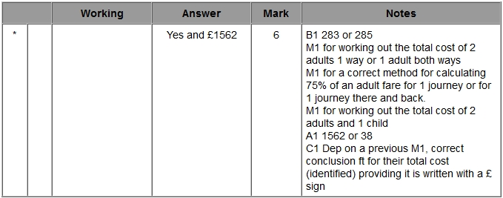

Q2.
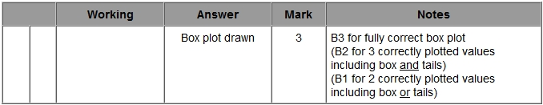

Q3.
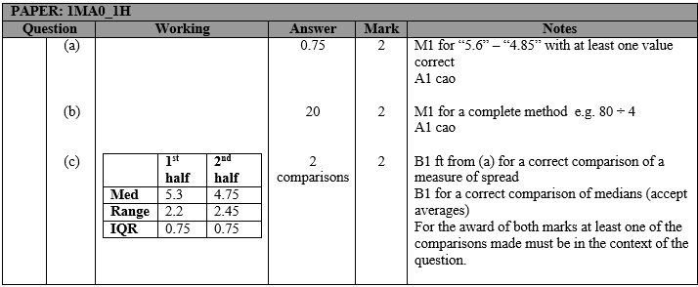

Q4.
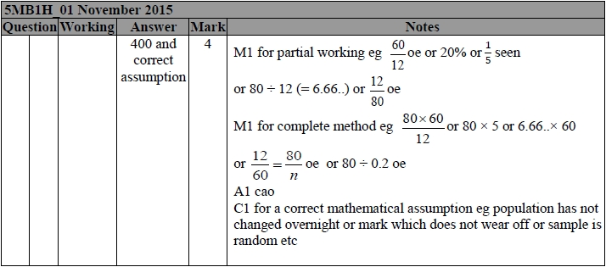

Q5.
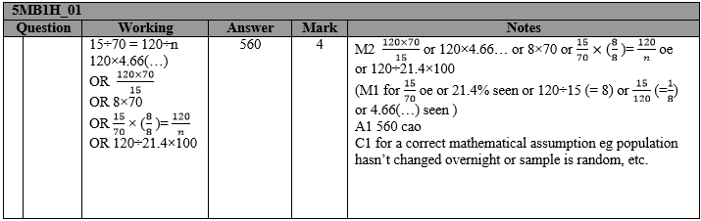

Q6.
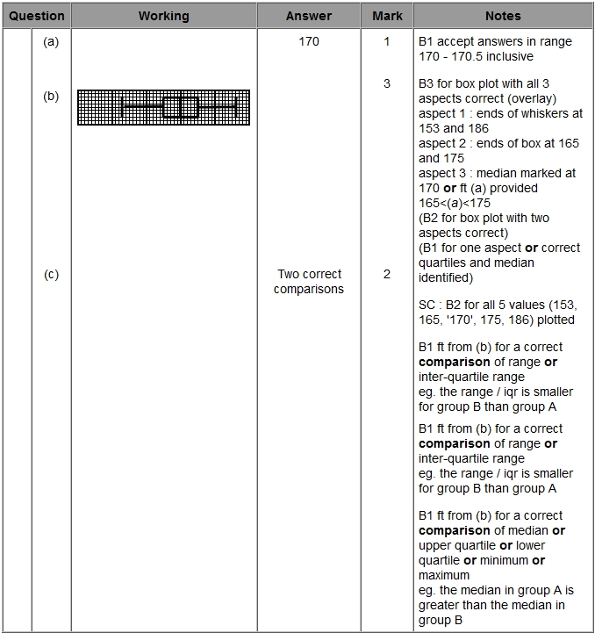

Q7.
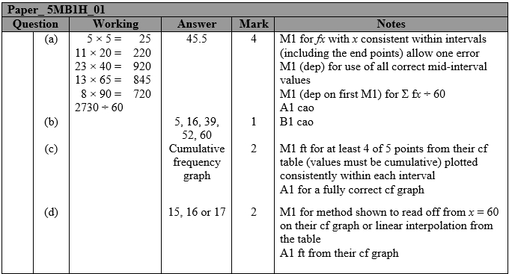

Q8.
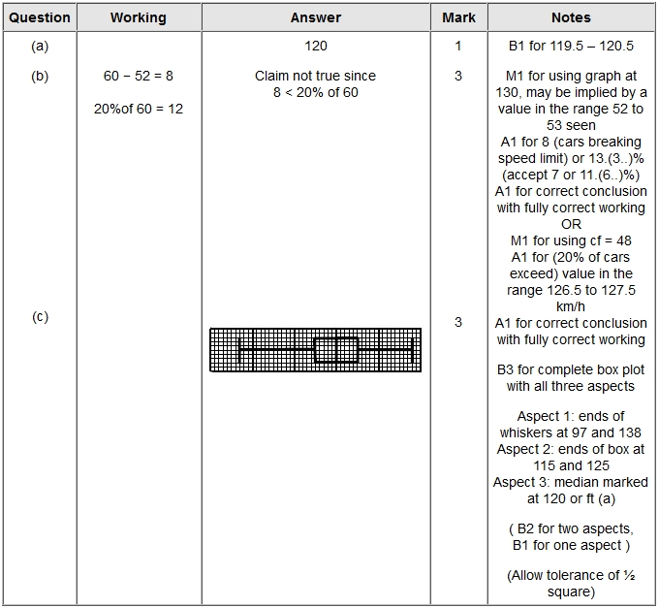

Q9.
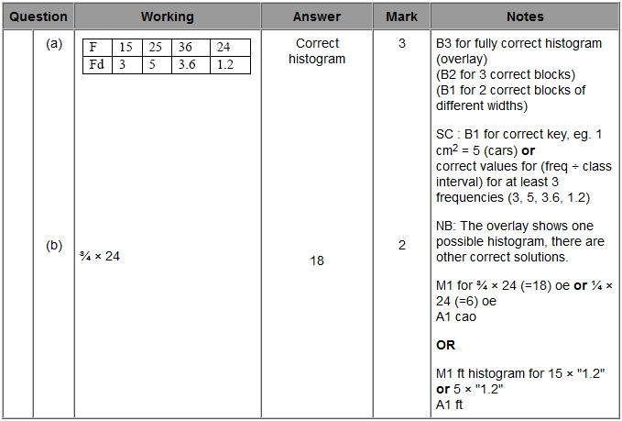

Q10.
