Name: _______________________________________________
Higher Unit 15 topic test
Date:
Time: 65 minutes
Total marks available: 59
Total marks achieved: ______

Questions
Q1.
The lines y = x – 2 and x + y = 10 are drawn on the grid.
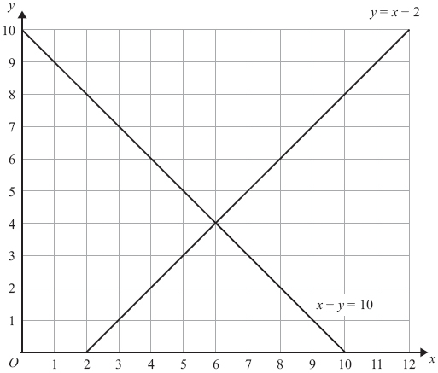
On the grid, mark with a cross (×) each of the points with integer coordinates that are in the region defined by
y > x – 2
x + y < 10
x > 3

(Total for Question is 3 marks)

Q2.
On the grid, shade the region that satisfies all these inequalities.

x + y < 4 y > x − 1 y < 3x

Label the region R.
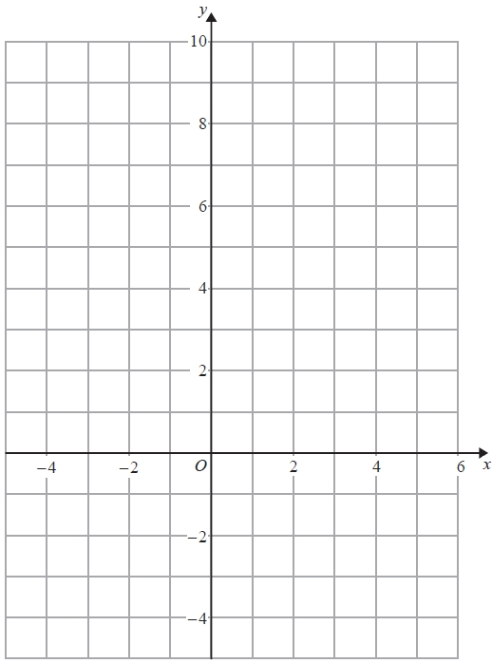

(Total for question is 4 marks)
Q3.
(a) Complete the table of values for y = x² − 2x − 1
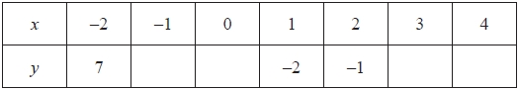
(2)
(b) On the grid, draw the graph of y = x² − 2x − 1 for values of x from −2 to 4
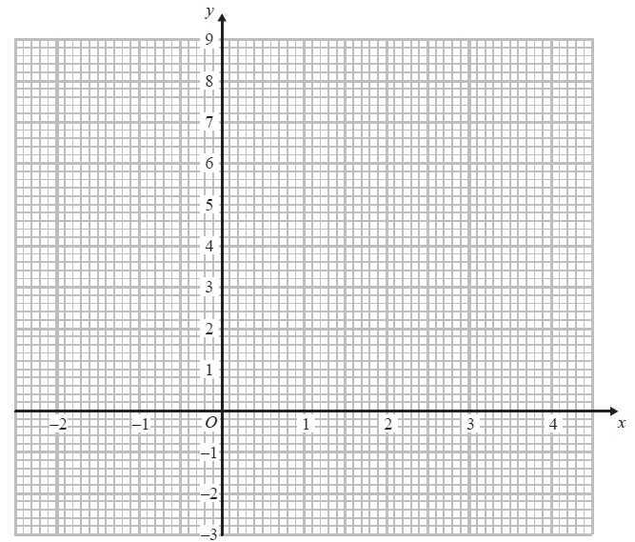
(2)
(c) Solve x² − 2x − 1 = x + 3
...........................................................
(2)
(Total for Question is 6 marks)

Q4.
(a) Complete this table of values for y = x³ + 2x – 1
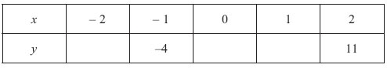

(2)
(b) On the grid, draw the graph of y = x³ + 2x – 1
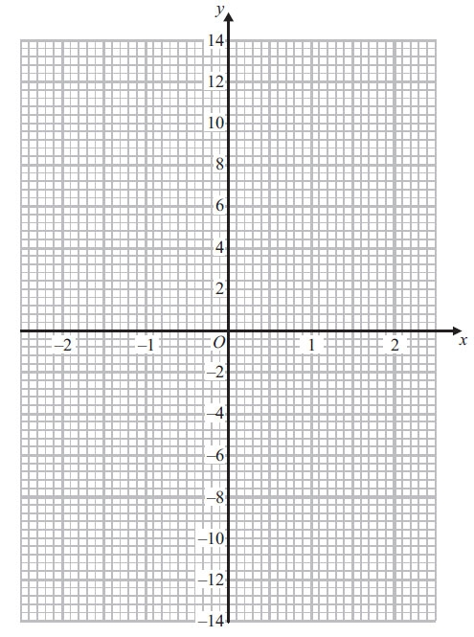
(2)
(Total for Question is 4 marks)

Q5.
The graph of y = f(x) is drawn on the grid.
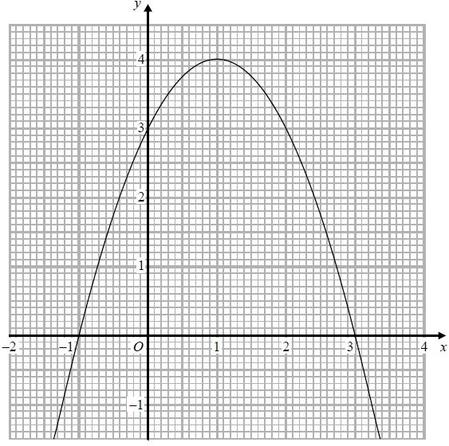
(a) Write down the coordinates of the turning point of the graph.
(..........................., ...........................)
(1)
(b) Write down the roots of f(x) = 2
...........................................................
(1)
(c) Write down the value of f(0.5)
...........................................................
(1)
(Total for question = 3 marks)
Q6.
The expression x² – 8x + 21 can be written in the form (x – a)² + b for all values of x.
(a) Find the value of a and the value of b.

a = . . . . . . . . . . . . . . . . . . . . . .
b = . . . . . . . . . . . . . . . . . . . . . .
(3)
The equation of a curve is y = f(x) where f(x) = x² – 8x + 21
The diagram shows part of a sketch of the graph of y = f(x).
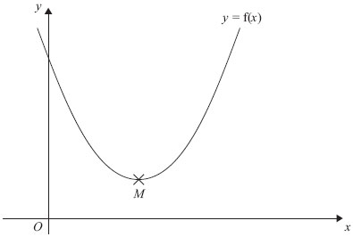
The minimum point of the curve is M.
(b) Write down the coordinates of M.

..............................................................................................................................................
(1)
(Total for Question is 4 marks)

Q7.
Show that

(3x − 1)(x + 5)(4x − 3) = 12x³ + 47x² − 62x + 15

for all values of x.

(Total for question is 3 marks)

Q8.
Solve x² > 3x + 4
...........................................................
(Total for question = 3 marks)

Q9.
Solve the inequality x² > 3(x + 6)
...........................................................
(Total for question = 4 marks)

Q10.
(i) Sketch the graph of f(x) = x² − 5x + 10, showing the coordinates of the turning point and the coordinates of any intercepts with the coordinate axes.
(ii) Hence, or otherwise, determine whether f(x + 2) − 3 = 0 has any real roots.
Give reasons for your answer.

(Total for question = 6 marks)

Q11.
The number of slugs in a garden t days from now is p_{t} where
p₀ = 100
p_{t + 1} = 1.06p_{t}
Work out the number of slugs in the garden 3 days from now.
...........................................................
(Total for question = 3 marks)

Q12.
(a) Show that the equation x³ + 4x = 1 has a solution between x = 0 and x = 1
(2)
(b) Show that the equation x³ + 4x = 1 can be arranged to give 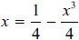
(1)
(c) Starting with x⁰ = 0, use the iteration formula 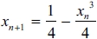 twice, to find an estimate for the solution of x³ + 4x = 1
...........................................................
(3)
(Total for question = 6 marks)

Q13.
The number of bees in a beehive at the start of year n is P_{n}.
The number of bees in the beehive at the start of the following year is given by

P_{n + 1} = 1.05(P_{n} − 250)

At the start of 2015 there were 9500 bees in the beehive.
How many bees will there be in the beehive at the start of 2018?
...........................................................
(Total for question is 3 marks)

Q14.
(a) Show that the equation 3x² − x³ + 3 = 0 can be rearranged to give
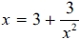
(2)
(b) Using
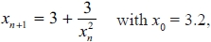
find the values of x₁, x₂ and x₃
...........................................................
(3)
(c) Explain what the values of x₁, x₂ and x₃ represent.
.............................................................................................................................................
.............................................................................................................................................
(1)
(Total for question is 6 marks)

Examiner's Report
Q1.
Many candidates failed to attempt this question, and of those who did, it was most common to see a plethora of crosses, usually well away from the desired region. Many ignored the line x = 3.

Q2.
No Examiner's Report available for this question

Q3.
The values of y corresponding to positive values of x were generally worked out correctly. There was less success with the negative values, especially the value of y at = −1. In part (b) values were generally plotted accurately and the points joined with a smooth curve, although the occasional set of straight line segments was also seen. Part (c) proved beyond most candidates. Correct solutions were split between those who connected up the whole question and drew the straight line with equation y = x + 3. They were then able to pick out the required values of x for the two marks. Other candidates restarted, rearranged the equation and solved it, usually by factorisation. If the two values of x were given then the marks were awarded. Some candidates spotted that x = 4 satisfies the original equation, but without any of the two approaches shown they did not score any marks.

Q4.
The majority of candidates gained full marks for this question, finding the missing values and drawing a correct graph. Very few candidates failed to calculate at least one correct value. The points were usually accurately plotted although the point (2, 11) was sometimes plotted at (2, 13). Some candidates only gained one mark in part (b) as they joined the points with straight lines rather than drawing the curve freehand. Some did not join the points at all and some drew a line of best fit for the points. Curves were sometimes inaccurate, not passing through the points exactly or drawn with too thick a line or with several lines. Some candidates seemed to have pre-conceived ideas as to what the graph should look like and drew a parabola that contradicted their calculations.

Q5.
No Examiner's Report available for this question

Q6.
This question was poorly answered. It was clear that only a small minority of candidates were well practised in the technique of completing the square. Candidates who realised what was required often went on to carry out this technique but then spoiled their responses by writing a = −4, b = 5. Other candidates wrote (x + 4)² +5 then a = 4, b = 5. This was clearly incorrect working and could not be awarded the marks. "8" and "21" were commonly seen incorrect answers. Part (b) was answered correctly by only a small minority of candidates with many of the more able candidates failing to see the connection between the two parts of the question.

Q7.
No Examiner's Report available for this question

Q8.
No Examiner's Report available for this question

Q9.
No Examiner's Report available for this question

Q10.
No Examiner's Report available for this question

Q11.
No Examiner's Report available for this question

Q12.
No Examiner's Report available for this question

Q13.
No Examiner's Report available for this question

Q14.
No Examiner's Report available for this question

Mark Scheme
Q1.
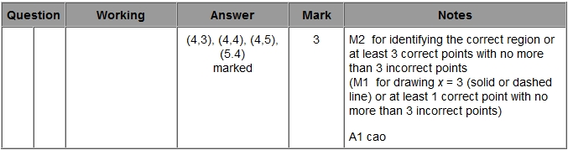

Q2.
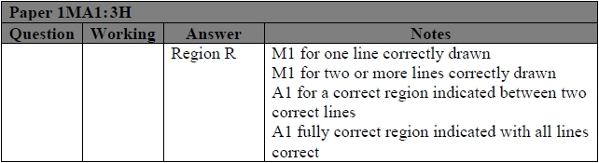

Q3.
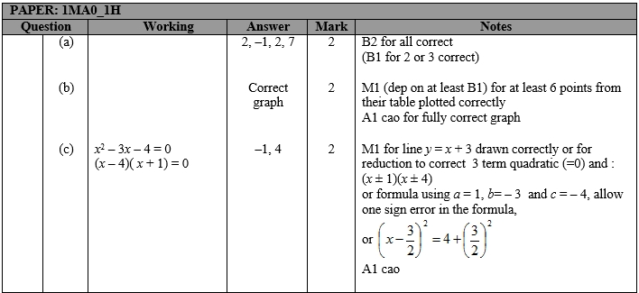

Q4.
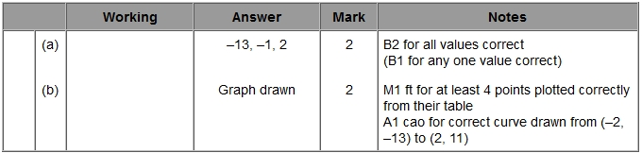

Q5.
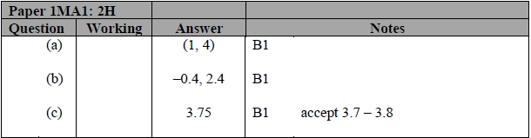

Q6.
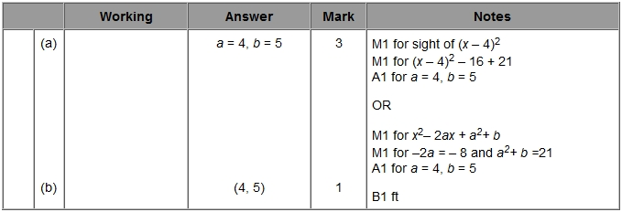

Q7.
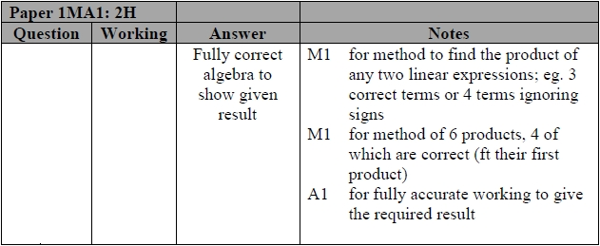

Q8.
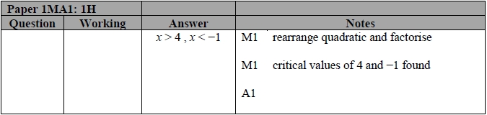

Q9.
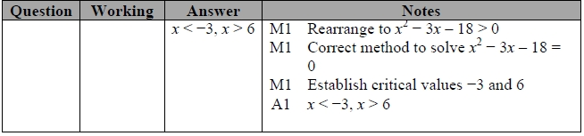

Q10.
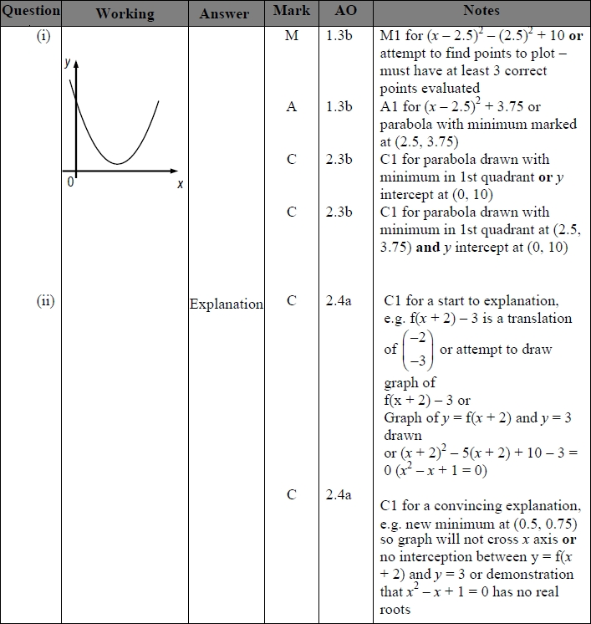

Q11.
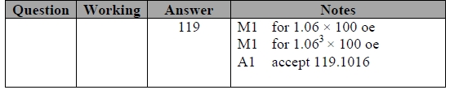
Q12.
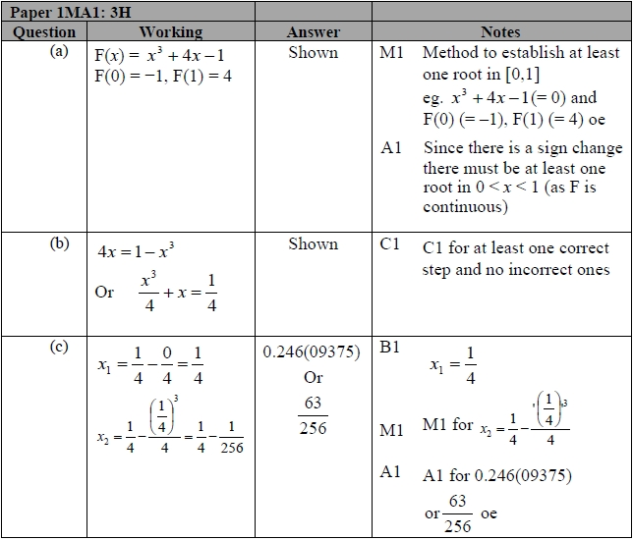

Q13.
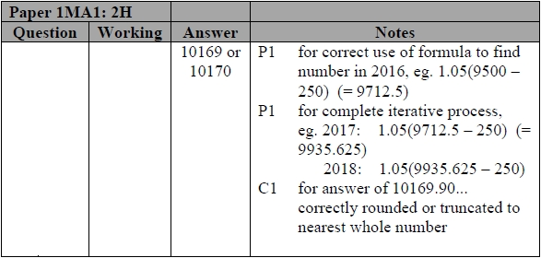

Q14.
