Name: _______________________________________________
Higher Unit 16 topic test
Date:
Time: 50 minutes
Total marks available: 45
Total marks achieved: ______

Questions
Q1.
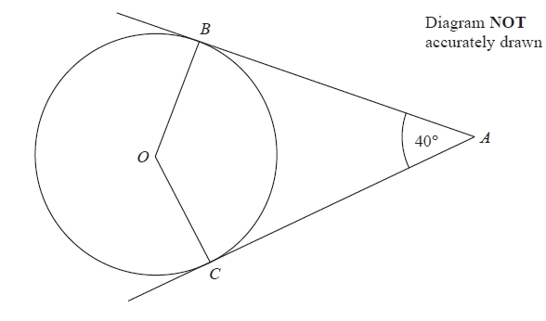
B and C are points on the circumference of a circle, centre O.
AB and AC are tangents to the circle.
Angle BAC = 40°.
Find the size of angle BCO.
...........................................................°
(Total for Question is 3 marks)
Q2.
*
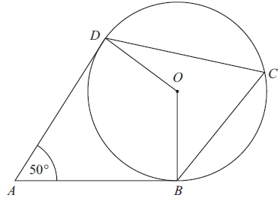 Diagram NOT accurately drawn
B, C and D are points on the circumference of a circle, centre O.
AB and AD are tangents to the circle.
Angle DAB = 50°
Work out the size of angle BCD.
Give a reason for each stage in your working.

(Total for Question is 4 marks)

Q3.
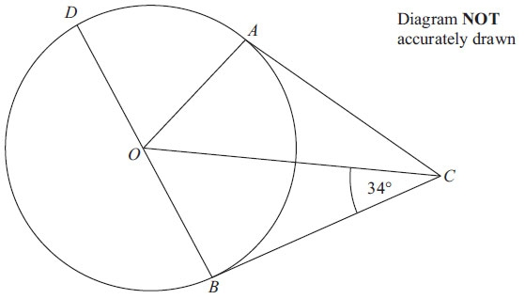
A, B and D are points on the circumference of a circle, centre O.
BOD is a diameter of the circle.
BC and AC are tangents to the circle.
Angle OCB = 34°.
Work out the size of angle DOA.

..............................................................................................................................................
(Total for Question is 3 marks)

Q4.
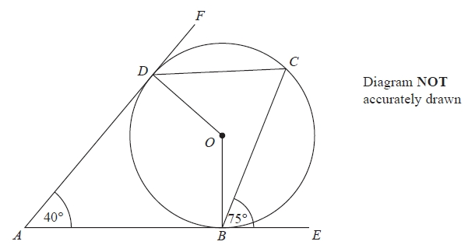
B, C and D are points on the circumference of a circle, centre O.
ABE and ADF are tangents to the circle.
Angle DAB = 40°
Angle CBE = 75°
Work out the size of angle ODC.
...........................................................°
(Total for Question is 3 marks)

Q5.
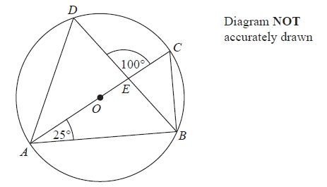
A, B, C and D are points on the circumference of a circle, centre O.
AC is a diameter of the circle.
AC and BD intersect at E.
Angle CAB = 25°
Angle DEC = 100°
Work out the size of angle DAC.
You must show all your working.
........................................................... °
(Total for question = 4 marks)

Q6.
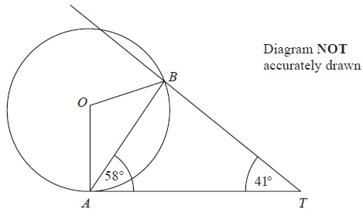
A and B are points on the circumference of a circle, centre O.
AT is a tangent to the circle.
Angle TAB = 58°.
Angle BTA = 41°.
Calculate the size of angle OBT.
You must give reasons at each stage of your working.
(Total for Question is 5 marks)

Q7.
*
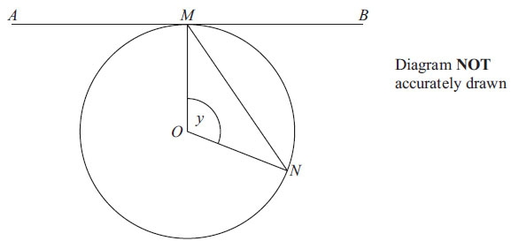
M and N are two points on the circumference of a circle centre O.
The straight line AMB is the tangent to the circle at M.
Angle MON = y
Prove that angle BMN = ½ y

(Total for Question is 5 marks)

Q8.
*
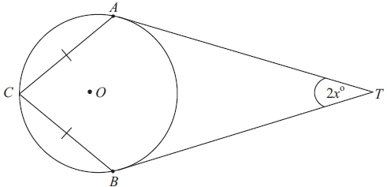 Diagram NOT accurately drawn
A, B and C are points on the circumference of the circle, centre O.
TA and TB are tangents to the circle.
CA = CB.
Angle ATB = 2x°.
Prove that angle ACB = (90 – x)°.

(Total for Question is 5 marks)

Q9.
(a) On the grid, construct the graph of x² + y² = 16
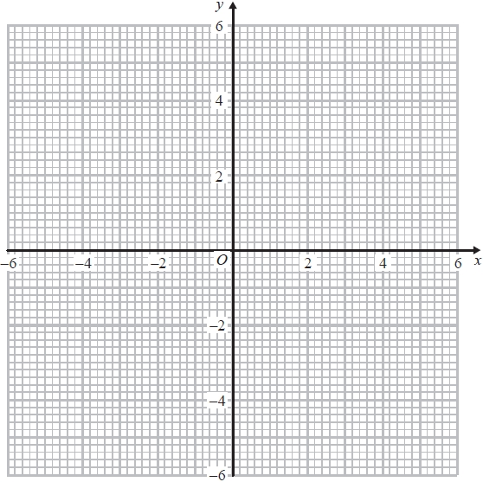
(2)
(b) Find estimates for the solutions of the simultaneous equations
x² + y² = 16
y = 2x + 1
...........................................................
(3)
(Total for question = 5 marks)
Q10.
Here is a circle, centre O, and the tangent to the circle at the point P(4, 3) on the circle.
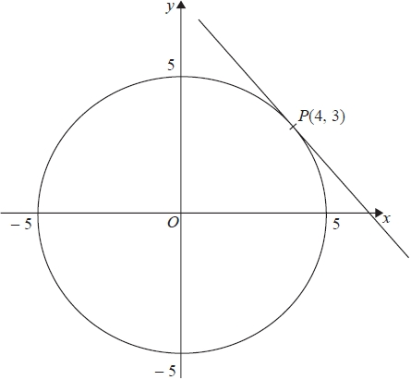
Find an equation of the tangent at the point P
...........................................................
(Total for question is 3 marks)

Q11.
The line l is a tangent to the circle x² + y² = 40 at the point A.
A is the point (2, 6).
The line l crosses the x–axis at the point P.
Work out the area of triangle OAP.
...........................................................
(Total for question = 5 marks)

Examiner's Report
Q1.
Most students scored a mark for showing that either angle OBA or angle OCA was 90°, generally by indicating this on the diagram. However many students lost marks because they did not identify which angle they were finding when doing calculations. It was very common to see 360 − 90 − 90 − 40 = 140 without any indication that this was a calculation to find angle BOC. Just writing 140 in the correct place on the diagram would suffice. Others had no understanding of 3 letter angle notation. 20° was often seen on the diagram for angle BCO but then 140° was written in the answer space. Students should be encouraged to write all calculated angles in the appropriate space on the diagram as this would greatly increase the number of method marks awarded.

Q2.
When asked to give reasons in a geometry questions, reasons must be correct and must use correct mathematical language. Reasons given in responses seen to this question were often incomplete or not completely correct. 'Angle between tangent and circle is 90°' and 'angle at origin is twice the angle at the edge of the circle' are both examples where a communication mark was not awarded as the statements were not accurate enough. It is also important to ensure that the final answer is communicated properly. In this case the value of the angle had to be linked with the angle itself so sight of Angle BCD = 65° (or similar) was expected rather than just to see a 65° somewhere amongst the candidate's working. Very few candidates used the alternate segment theorem as part of their explanation.

Q3.
This question testing circle geometry gave a good distribution of marks, with some candidates being able to recognise that the angle between a radius and a tangent is 90°, mostly seen on the diagram. A further small percentage were able to establish, by using a correct method, that angle AOC or angle BOC was 56° or that angle AOB was 112°, while only a quarter could gain all 3 marks for a fully correct solution and identify the answer as 68°.
Some candidates incorrectly assumed OC = BC and tried to use an isosceles triangle. Most candidates were not good at naming the angles that they were finding and as a consequence some lost marks by not identifying correctly which angle they were trying to calculate.

Q4.
There were a variety of methods to complete this problem with its complex configuration. The most common successful approach was to calculate the reflex angle BOD and the angle at the circumference BCD, then use the angle sum of a quadrilateral together with angle OBC = 15°. Other approaches were rare. They included using the alternate segment theorem (although often wrongly applied), or using angle BOC = 150° and angle BOD = 140° followed by using angles round the point O and a suitable isosceles triangle.
In many cases candidates wrote down figures but did not relate them to the angles found. In this case the marks could often not be awarded unless the 55° was given as the answer. Many candidates sensibly put values of angles on the diagram and these were accepted as evidence of correct processes.

Q5.
There were many attempts at this question where students failed to show any knowledge of circle theorems, but rather made false assumptions about angles in order to provide some basic work. This included assuming there were isosceles triangles, where there were none. Some found ABE to be 55°, but without the knowledge that ABC was 90° this got them nowhere useful.
Centres need to remind students that when working with geometry problems they need to either write the angles on the diagram, or if only presented in working, these workings need to clearly show which angles are being worked with.
Few students gained full marks.

Q6.
Most candidates were able to score some marks in this question. Many were able to find the size of the angle OBT, but few were able to state all the reasons for their choice of calculations or state them correctly. Furthermore, it was often unclear as to how particular calculations were related to the overall solution of the problem. Candidates should be reminded to clearly identify the angles they are calculating by either an appropriate angle notation (three letter notation here) or by annotating the diagram. A popular incorrect answer involved the erroneous identification of angle ABT as 90°, ie incorrectly interpreting BT as a tangent to the circle.

Q7.
Most candidates gained some credit in this question. Over time the performance has increased, with candidates becoming more aware of the need to give reasons for statements about angles. In this question not only was it necessary to show the 90° angle or state its position on the diagram, but also to justify it as "the angle between a tangent and radius is 90°". Many candidates also went on to state further properties such as OMN and ONM being equal. Further than this required working with algebraic expressions, which was beyond the majority of candidates.

Q8.
Many candidates gained a mark for correctly identifying a right-angle at OAT and/or OBT even if they made no further progress. Others assumed CAT or CBT were 90° or even that ACB was. A variety of proofs were attempted but in this question where marks were awarded for Quality of Written Communication, it was essential that theorems were quoted accurately using correct mathematical language.

Q9.
There were some excellent solutions to this question showing an accurately constructed circle followed by the plotting of a suitable line and accurate reading off of the solutions of the simultaneous equations. Students who did not see the connection between parts (a) an (b) often began a solution using substitution but they rarely completed the question successfully. They struggled to manipulate the equations correctly. A small but significant group of students found the values of x but lost a mark because they did not find the corresponding values of y.

Q10.
No Examiner's Report available for this question

Q11.
No Examiner's Report available for this question

Mark Scheme
Q1.
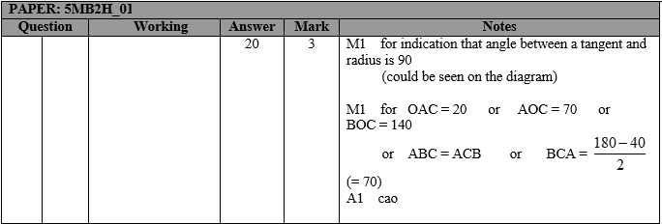

Q2.
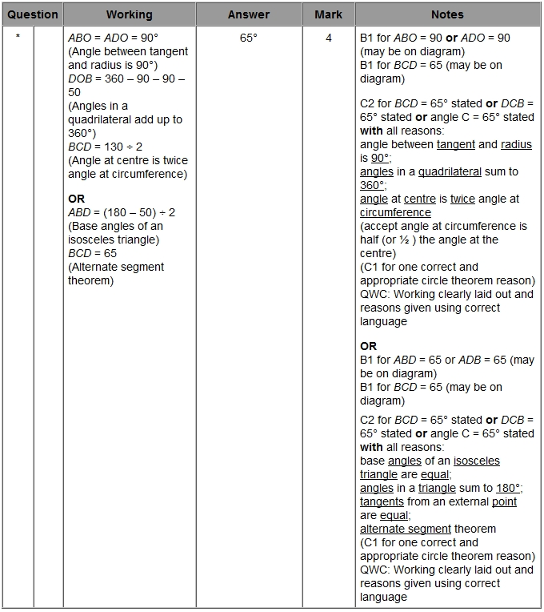

Q3.
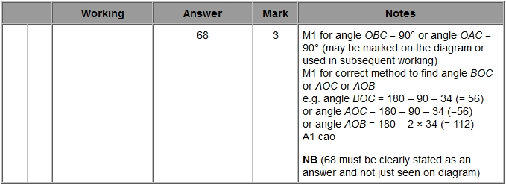

Q4.
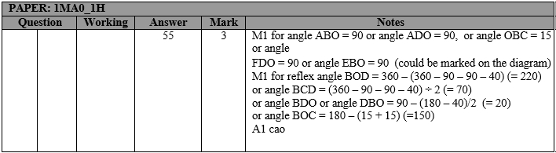

Q5.
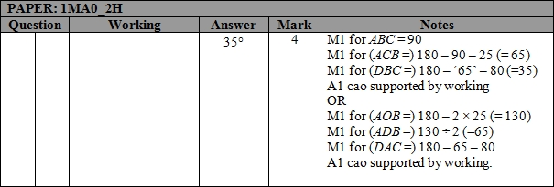

Q6.
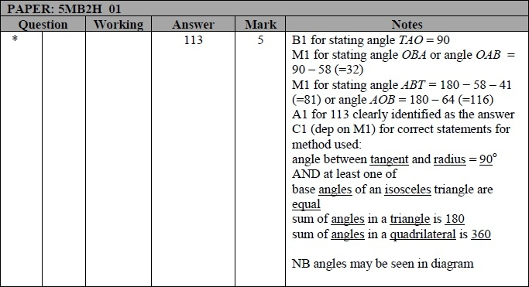

Q7.
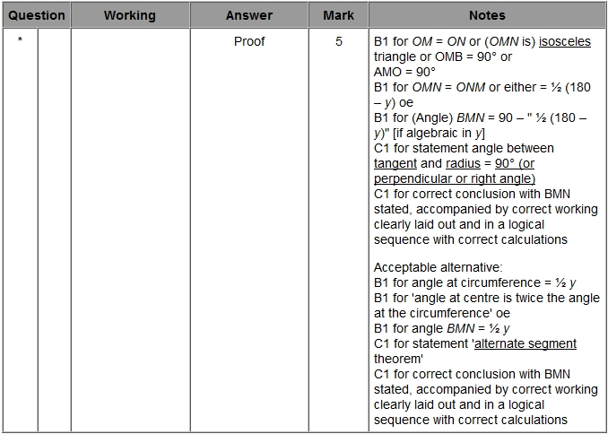
Q8.
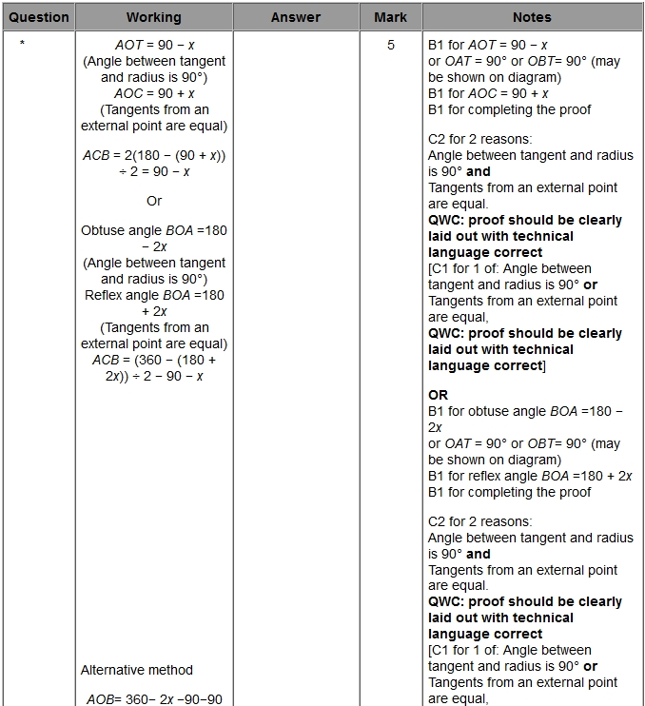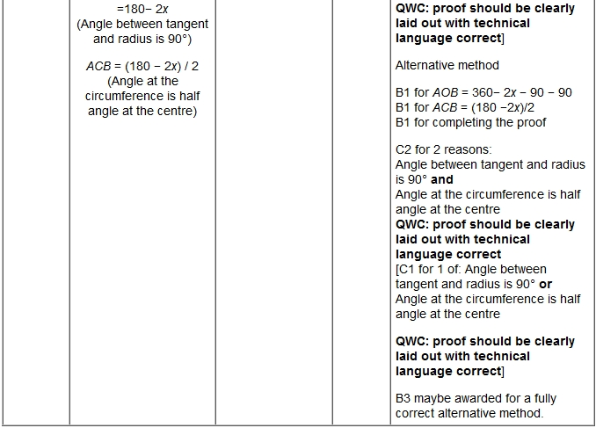

Q9.
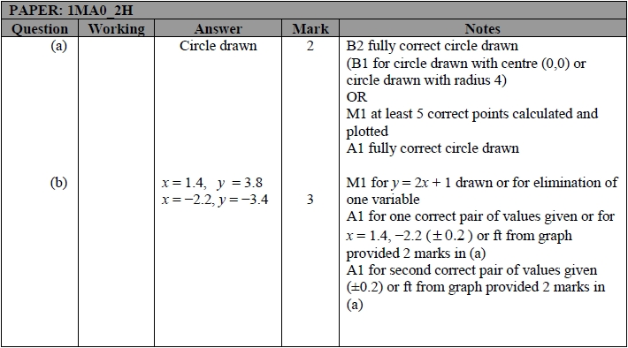

Q10.
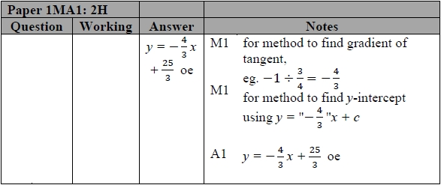

Q11.
