Name: _______________________________________________
Higher Unit 17 topic test
Date:
Time: 60 minutes
Total marks available: 51
Total marks achieved: ______

Questions
Q1.
Rationalise the denominator 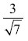

. . . . . . . . . . . . . . . . . . . . . .
(Total for Question is 2 marks)

Q2.
Simplify 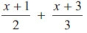

..............................................................................................................................................
(Total for Question is 3 marks)
Q3.
Simplify fully 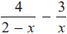
...........................................................
(Total for question = 3 marks)

Q4.
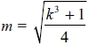
Make k the subject of the formula.
...........................................................
(Total for question is 3 marks)
Q5.
Write 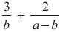 as a single fraction in its simplest form.

..............................................................................................................................................
(Total for Question is 3 marks)

Q6.
Simplify fully 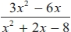
...........................................................
(Total for Question is 3 marks)

Q7.
Write (5 − √5)² in the form a + b√5, where a and b are integers.
...........................................................
(Total for Question is 2 marks)

Q8.
Rationalise the denominator of 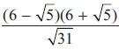
Give your answer in its simplest form.

..............................................................................................................................................
(Total for Question is 3 marks)

Q9.
Show that 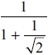 can be written as 2 − √2

(Total for question = 3 marks)

Q10.
(a) Rationalise the denominator of

..............................................................................................................................................
(2)
(b) Expand and simplify

..............................................................................................................................................
(2)
(Total for Question is 4 marks)

Q11.
* Prove algebraically that the difference between the squares of any two consecutive integers is equal to the sum of these two integers.

(Total for Question is 4 marks)
Q12.
Prove that
(2n + 3)² – (2n – 3)² is a multiple of 8
for all positive integer values of n.

(Total for Question is 3 marks)

Q13.
Show that 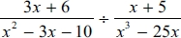 simplifies to ax where a is an integer.

(Total for question = 4 marks)

Q14.
Solve 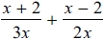 = 3
x = ...........................................................
(Total for question is 3 marks)

Q15.
Solve 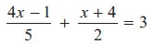

x = . . . . . . . . . . . . . . . . . . . . . .
(Total for Question is 3 marks)

Q16.
The graph of y = f(x) is drawn on the grid.
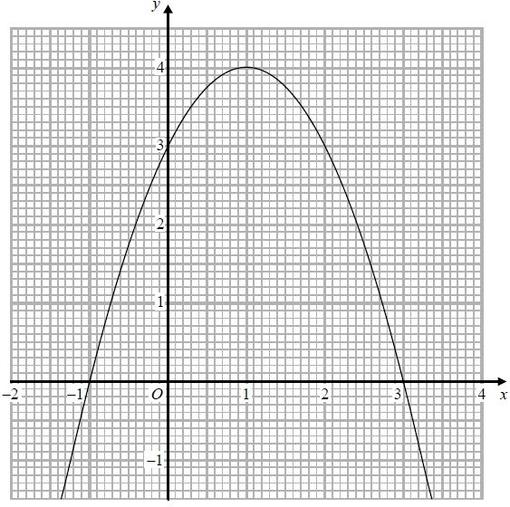
(a) Write down the coordinates of the turning point of the graph.
(..........................., ...........................)
(1)
(b) Write down the roots of f(x) = 2
...........................................................
(1)
(c) Write down the value of f(0.5)
...........................................................
(1)
(Total for question = 3 marks)
Q17.
The function f is such that
f(x) = 4x − 1
(a) Find f⁻¹(x)
f⁻¹(x) = ...........................................................
(2)
The function g is such that
g(x) = kx² where k is a constant.
Given that fg(2) = 12
(b) work out the value of k
k = ...........................................................
(2)
(Total for question = 4 marks)

Examiner's Report
Q1.
Many candidates were aware that they needed to multiply by and so gained a method mark however many could not accurately complete this operation. A common wrong answer was to write 21 as the numerator. Others found the correct answer and then went on to try to evaluate it further, thus giving a final incorrect answer losing the accuracy mark.
There were more correct answers than in previous papers as more candidates managed not to carry on from the correct answer to simplify incorrectly.

Q2.
It was obvious that many candidates had been taught to cross multiply without understanding that they were still dealing with a fraction and so a common error was to multiply both fractions by 6 and so clear the fractions giving an answer of 5x + 9. Incorrect attempts to add the fractions were common – multiplying the numerators and adding the denominators was a fairly common mistake; the most common incorrect answers were 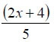 or 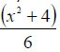 . Candidates who attempted this incorrect method gained no marks. It was disappointing to see a number of candidates get the correct two equivalent fractions and then fail to expand the brackets in their numerators correctly. Others failed at the final stage. Having reached the correct answer of 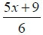 they then attempted to simplify this further inappropriately, sometimes to 5x + 1.5 and thus failed to gain the final accuracy mark. Some candidates did not see this as an expression but tried to turn it into an equation to solve for x.

Q3.
In this question many students realised that they needed a common denominator and this mark was often scored. Few students gained all three marks as the negative sign in front of the second fraction caused problems for many students.

Q4.
No Examiner's Report available for this question

Q5.
This question was answered well by the most able candidates but proved too difficult for many. Those who appreciated the need for a common denominator were often let down by poor algebraic skills, expanding brackets incorrectly or leaving them out altogether. Those who used a correct common denominator and got further through the solution often cancelled incorrectly. Some candidates arrived at the correct answer but then attempted to simplify it and cancelled incorrectly. These candidates lost the final accuracy mark.

Q6.
The final question on the paper was well answered by the more able students although some of these students lost the final mark by writing ^{3x}⁄_{x+4} = ^{3x}⁄₄ or some other incorrect 'simplification'. The most common incorrect response was to try to 'cancel' the x² terms as well as the terms in x.

Q7.
Many students were unable to deal with the surds. Many of those that could expand the two brackets wrote − 5 as the last term rather than + 5. This led to an incorrect answer of 20 − 10√5. Many others could not correctly combine the two 'middle' terms writing an answer of 30 + 10√5 whilst others gave an answer of 30 − 55.

Q8.
This question involved multiplying out the brackets, rationalising, and simplifying the surds. Many failed to expand the brackets correctly. Those who multiplied numerator and denominator by too early ended up with every term having a attached. Many candidates were unable to simplify their answers; some thought that 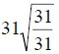 could not be simplified any further.

Q9.
No Examiner's Report available for this question

Q10.
In part (a), common errors included candidates squaring the numerator and denominator or just multiplying 5 by √2, but many of those who attempted it did get the correct answer.
Part (b) was attempted far less frequently. There were some marks given for correct expansion of brackets, but in only a few cases were candidates then able to simplify their expressions correctly. It was disappointing to find many who missed the middle terms in the expansion. There were many errors with signs. Very few candidates recognised this as the difference of two squares.

Q11.
In this question on algebraic proof there were very few fully correct answers. One mark for establishing n and n + 1 or equivalent was awarded to a few candidates and another small number of candidates who were able to write (n + 1)² − n² gained 2 marks. Some candidates were then able to correctly expand the brackets and correctly simplify the expression to 2n + 1 or equivalent, scoring 3 marks. For the fourth mark candidates had to establish and state that both elements of the original statement were equal.
A significant number of candidates used an arithmetic approach and gained no marks. There were also many nil attempts.

Q12.
The majority of candidates had no understanding of what was required in this question. Candidates either attempted the proof by substituting various values of n into (2n + 3)² – (2n – 3)² or they made no attempt at all. A significant number of those who did know what was required lost marks by failing to use brackets or by incorrectly writing their algebraic expressions. It was not uncommon to see '4n² + 12n + 9 – 4n² – 12n + 9 = 24n' which is an incorrect statement. This question was an algebraic proof and required the algebra to be correctly written at all times. Many candidates gained one mark for the correct expansion of either (2n + 3)² or (2n – 3)² but were then unable to proceed any further. Some expanded (2n + 3)² as 4n² + 9.

Q13.
No Examiner's Report available for this question

Q14.
No Examiner's Report available for this question

Q15.
Performance on algebraic fractions does not seem to get very much better over time, although a few candidates did gain 1 mark for writing the left-hand side of this equation over a common denominator or correctly multiplying out by a common multiple of 2 and 5.
A common error was to see all the left-hand side multiplied by 10, but not the righthand side. The percentage of candidates who could then turn this into a linear equation of the form ax = b was very small and fully correct solutions of ¹²⁄₁₃ were seldom seen. There were many attempts using inappropriate trial and improvement methods, all of which were unsuccessful.

Q16.
No Examiner's Report available for this question

Q17.
No Examiner's Report available for this question

Mark Scheme
Q1.
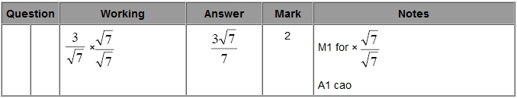

Q2.
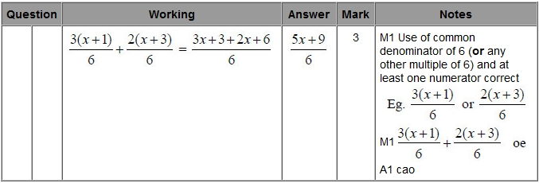

Q3.
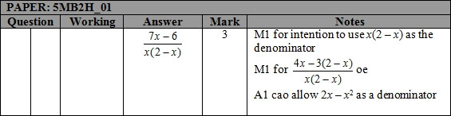

Q4.
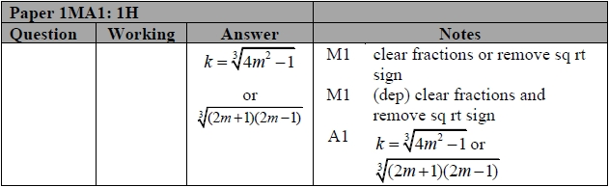

Q5.
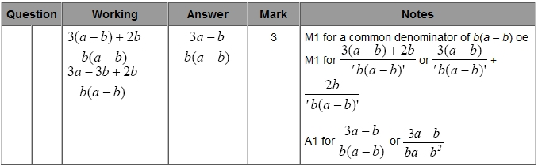

Q6.
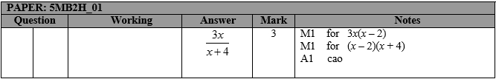

Q7.
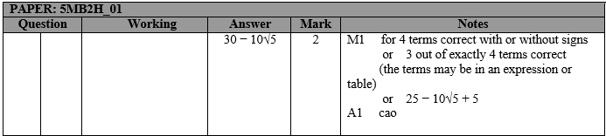

Q8.
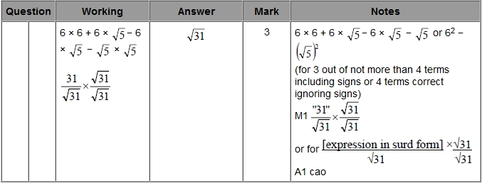

Q9.
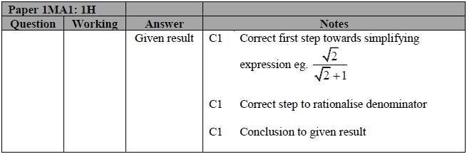

Q10.
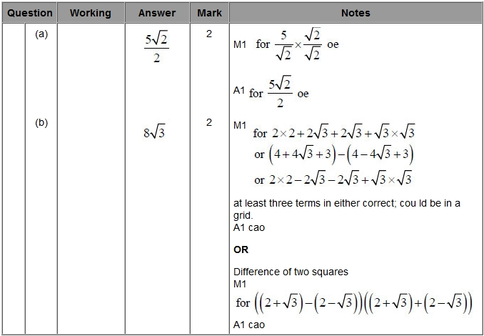

Q11.
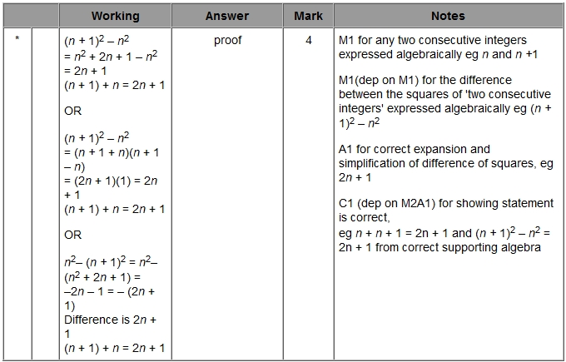

Q12.
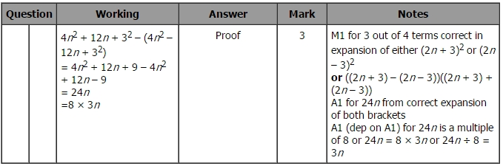

Q13.
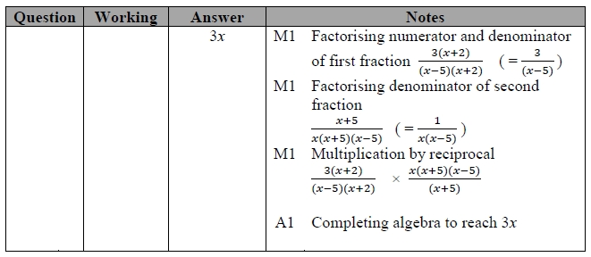

Q14.
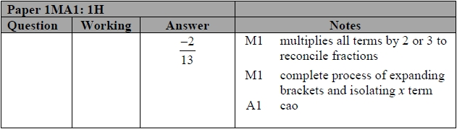

Q15.
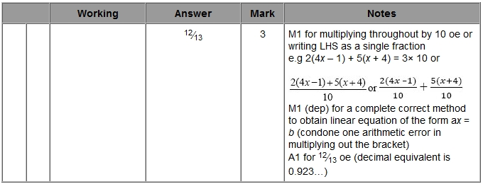

Q16.
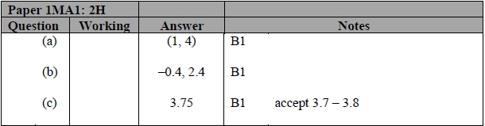

Q17.
