Name: _______________________________________________
Higher Unit 18 topic test
Date:
Time: 55 minutes
Total marks available: 47
Total marks achieved: ______

Questions
Q1.
∗
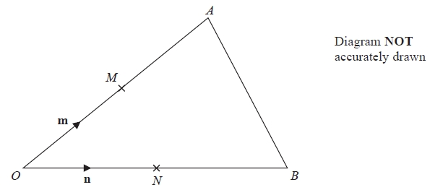
OAB is a triangle.
M is the midpoint of OA.
N is the midpoint of OB.
= m
= n
Show that AB is parallel to MN.
(Total for Question is 3 marks)

Q2.
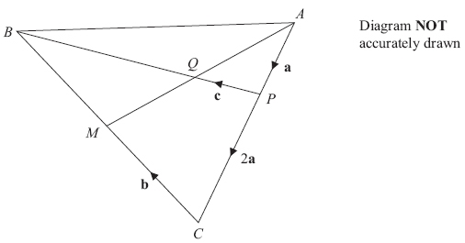
M is the midpoint of BC.
Q is the midpoint of AM.
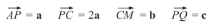
(a) Find in terms of a and b.
= . . . . . . . . . . . . . . . . . .
(1)
(b) Find in terms of c.

= . . . . . . . . . . . . . . . . . .
(4)
(Total for Question is 5 marks)

Q3.
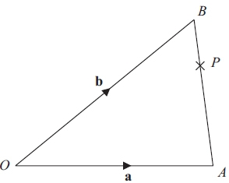 Diagram NOT accurately drawn
OAB is a triangle.
= a
= b
(a) Find in terms of a and b.

..............................................................................................................................................
(1)
P is the point on AB such that AP : PB = 3 : 1
(b) Find in terms of a and b. Give your answer in its simplest form.

..............................................................................................................................................
(3)
(Total for Question is 4 marks)

Q4.
The diagram shows a regular hexagon OABCDE.
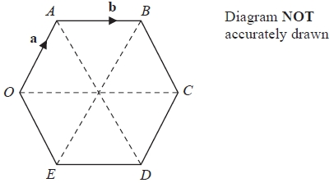
= a
= b
M is the midpoint of OE.
N is the midpoint of AB.
(a) Find in terms of a and/or b.
= ...........................................................
(3)
(b) Describe fully what your answer to part (a) shows about the lines OA and MN.
.............................................................................................................................................
.............................................................................................................................................
(2)
(Total for question = 5 marks)
Q5.
OAB is a triangle.
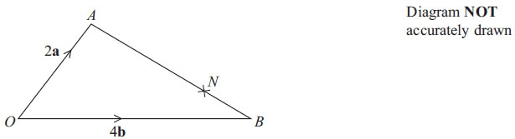
N is the point on AB such that AN : NB = 3 : 1
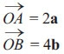
(a) Find in terms of a and b.

..............................................................................................................................................
(1)
(b) Find in terms of a and b.
Give your vector in its simplest form.

..............................................................................................................................................
(3)
(Total for Question is 4 marks)

Q6.
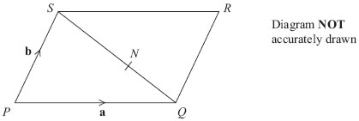
PQRS is a parallelogram.
N is the point on SQ such that SN : NQ = 3 : 2
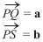
(a) Write down, in terms of a and b, an expression for .
= . . . . . . . . . . . . . . . . . . . . . .
(1)
(b) Express in terms of a and b.

= . . . . . . . . . . . . . . . . . . . . . .
(3)
(Total for Question is 4 marks)

Q7.
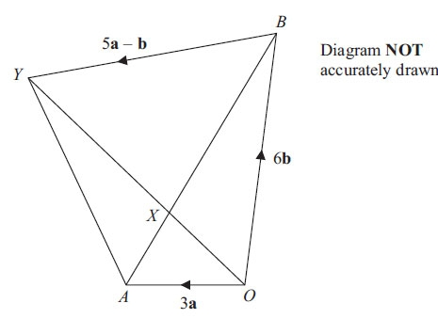
OAYB is a quadrilateral.
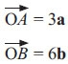
(a) Express in terms of a and b.

..............................................................................................................................................
(1)
X is the point on AB such that AX : XB = 1 : 2
and = 5a – b
*(b) Prove that 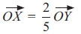

(4)
(Total for Question is 5 marks)
Q8.
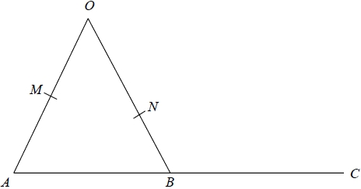
OMA, ONB and ABC are straight lines.
M is the midpoint of OA.
B is the midpoint of AC.
where k is a scalar quantity.
Given that MNC is a straight line, find the value of k.

(Total for question = 5 marks)

Q9.
OACB is a parallelogram.
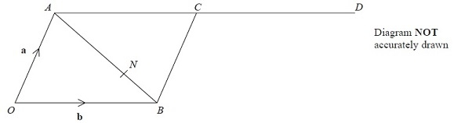
D is the point such that
The point N divides AB in the ratio 2:1
(a) Write an expression for in terms of a and b.
...........................................................
(3)
*(b) Prove that OND is a straight line.
(3)
(Total for Question is 6 marks)

Q10.
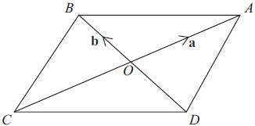 Diagram NOT accurately drawn
ABCD is a parallelogram.
The diagonals of the parallelogram intersect at O.
= a and = b
(a) Write an expression, in terms of a and/or b, for
(i)
. . . . . . . . . . . . . . . . . . . . . .
(ii)
. . . . . . . . . . . . . . . . . . . . . .
(ii)
. . . . . . . . . . . . . . . . . . . . . .
(3)
X is the point such that = 2a – b
(b) (i) Find an expression, in terms of a and b, for

. . . . . . . . . . . . . . . . . . . . .
(ii) B, A and X lie on the same straight line.
Explain why.
..............................................................................................................................................
..............................................................................................................................................
..............................................................................................................................................
(3)
(Total for Question is 6 marks)

Examiner's Report
Q1.
Candidates who had some idea of how to find the vectors and in terms of m and n, generally scored at least two of the three marks. The third mark was to give a reason based on the forms for and of why the two lines are parallel. Generally candidates earned the final mark by stating that 2n – 2m was a multiple of n – m. In general, notation was poor, with arrows above vectors rarely shown and with underling of m and n usually absent.
Some candidates did not read the information carefully enough and found that and were half the values given in the answer. These candidates could score a maximum of two marks.

Q2.
Part (a) was answered correctly by many candidates. In contrast part (b) was rarely attempted. Working was often unlabelled and difficult to follow so it was virtually impossible to follow the candidates' routes to solving the problem. Many established a first step of correctly identifying QB as 2a +2b − c but then did not know what step to take next.

Q3.
Many candidates have a lack of confidence when it comes to working with vectors and this question was frequently not attempted. Those who did attempt it often gained at least one mark as part (a) was generally answered quite well. In part (b) correct expressions for the vector AP were much more common than correct expressions for the vector BP. Those trying to use BP often failed to recognise that the change in direction required a change of signs. Candidates with some idea of what was required often scored one mark for a suitable 'vector journey' although sign errors were often apparent. Some candidates lost marks by failing to include brackets. Those who scored the first two marks for a correct expression for OP were often unable to simplify their answer to gain the final accuracy mark. Misunderstanding of ratios led a considerable number of candidates using ¹⁄₃ instead of ¼. Responses to this question were often confused and difficult to follow making the marking of them more challenging for examiners.

Q4.
A significant number of students did not attempt this question. Where it was attempted, responses could only rarely be given any credit. Students showed little understanding of how to approach questions such as this. Vector equations were often not clearly expressed either in terms of directed line segments or in terms of a and/or b. A small number of students could write down a correct vector expression for and so gained one mark but they could not usually write this expression accurately in terms of a and/or b.

Q5.
This question was attempted by most candidates and many were successful. The most common error was to give the vector for BA instead of for AB.
In Part (b), few candidates started by writing a simple vector equation such as ON = OA + AN, or ON = OB + BN. The biggest difficulty for those who made a serious attempt was getting the direction signs of the vectors correct. Candidates who worked with OA + AN were generally the more successful. Those who chose OB + BN often went on to use NB instead of BN, writing 4b + ¹⁄₄(4b – 2a) instead of 4b + ¹⁄₄(2a – 4b). Some candidates lost the final mark as they were unable to simplify their vector correctly. Other common errors were failing to use brackets appropriately, e.g. writing ³⁄₄ 4b – 2a instead of ³⁄₄(4b – 2a), and misinterpreting the ratio and dividing AB into thirds rather than into quarters.

Q6.
A significant proportion of candidates could express SQ correctly in terms of a and b though there were a substantial number of candidates who had no idea how to tackle this question. Pythagoras rule, the formula for the area of a triangle and other formulae were used to give incorrect expressions such as a² + b2 and ½ab. Some candidates' responses in both parts of the question consisted of numerical ratios. There were some good answers to part (b) of the question but candidates often showed poor communication skills in writing vectors by omitting brackets – for example expressions such as ²⁄₅− b + a + b were commonplace. Attempting to simplify vector expressions also caused difficulties for many candidates. It would seem that many candidates could benefit from further practice in the manipulation of vectors.

Q7.
The straightforward part (a) of this vector question was correctly answered by only a few of the candidates; when a proof was required in part (b), the percentage of successful candidates dropped even lower.
One mark was awarded to those who could establish that vector AX was a third of vector AB or that vector OY was equal to the sum of vectors OB and BY.
A further small number gained 3 marks and were able to show that vector OX was equal to 2a + 2b and vector OY was equal to 5a + 5b but were unable to connect the two with a convincing statement of proof as is required in a question testing quality of written communication (QWC).

Q8.
No Examiner's Report available for this question

Q9.
The biggest difficulty for those who made a serious attempt at part (a) was getting the direction signs of the vectors correct. Relatively few candidates chose to write a simple vector equation such as ON = OA + AN or ON = OB + BN as their starting point. Candidates who worked with a + 2/3AB were generally more successful. Those who started their path with vector b frequently used b + 1/3AB instead of b + 1/3BA. Difficulty in expanding brackets or omitting brackets altogether prevented some candidates from gaining marks even though their reasoning appeared to be correct.
In part (b), relatively few candidates achieved any marks. Some candidates were able to find a correct expression (usually simplified) for OD. A smaller number were able to give a correct expression for ND. Often, however, unsimplified or incorrectly simplified answers for ON meant that candidates were unable to prove a straight line relationship. Those candidates obtaining all 3 marks were generally very coherent in their justification though few were actually explicit in their recognition of a common point. Some explanations were unclear with candidates mentioning "gradient" or "same amounts of a and b" rather than stating that one vector was a multiple of the other. Some candidates set about proving ON + ND = OD.

Q10.
Part (a) was usually well answered by those who understand vector notation. The most common error was leaving expression incomplete or ambiguous by not resolving multiple signs, for example –a+ -b.
In part (b) many candidates gave the correct response of a-b. Marks for the explanation were harder to come by. References to parallel lines were needed; evidence of vector notation, for example showing expressions were multiples of each other, provided good evidence of understanding.

Mark Scheme
Q1.
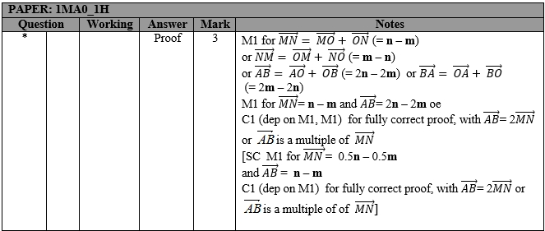

Q2.
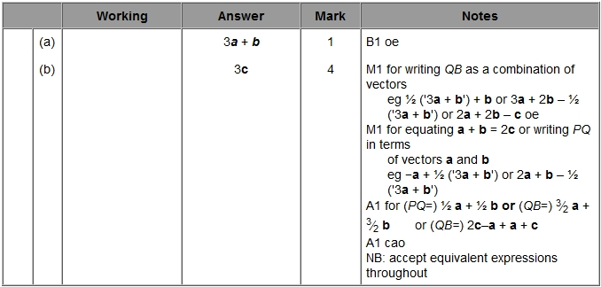

Q3.
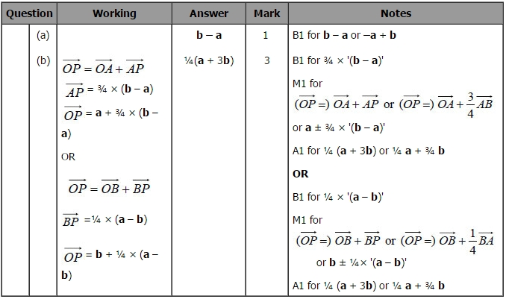

Q4.
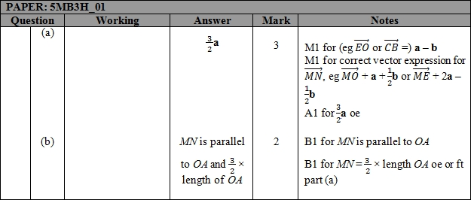

Q5.
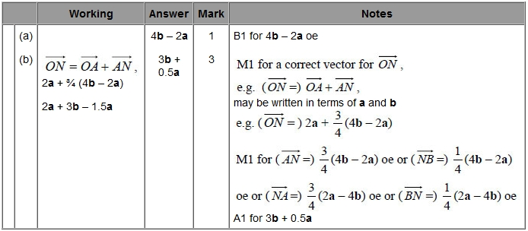

Q6.
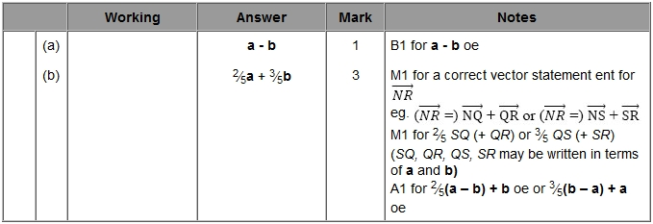

Q7.
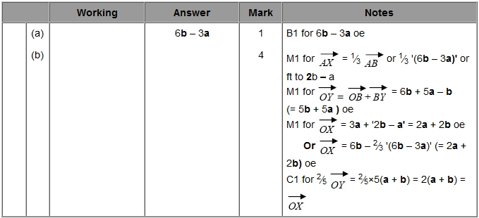

Q8.
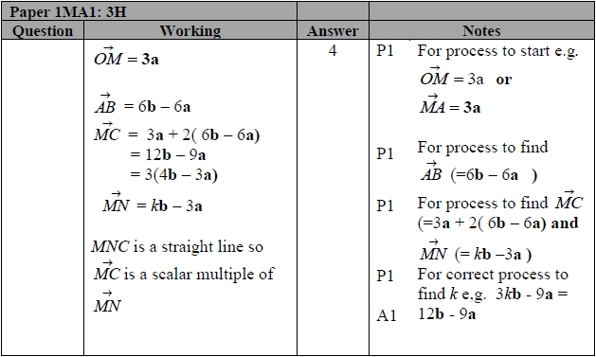

Q9.
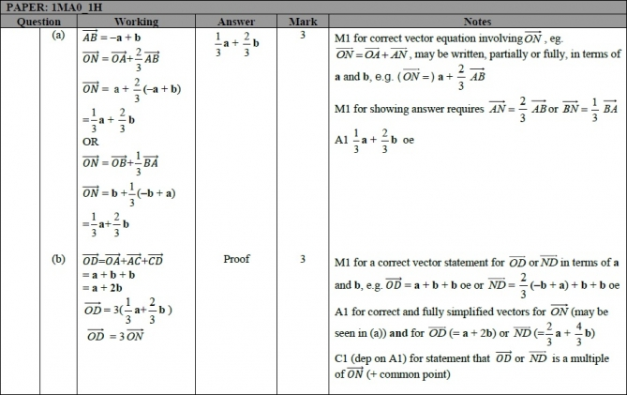

Q10.
