Name: _______________________________________________
Higher Unit 19 topic test
Date:
Time: 50 minutes
Total marks available: 45
Total marks achieved: ______

Questions
Q1.
(a) Complete the table of values for y = ⁶⁄x
x | 0.5 | 1 | 2 | 3 | 4 | 5 | 6
y |  | 6 | 3 |  | 1.5 |  | 1
(2)
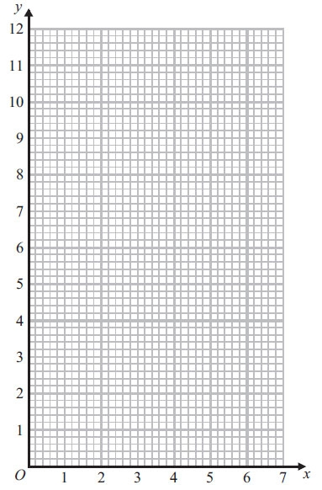
(b) On the grid, draw the graph of y = ⁶⁄_{x} for 0.5 ≤ x ≤ 6
(2)
(Total for Question is 4 marks)

Q2.
The graph of y = f(x) is shown on each of the grids.
(a) On this grid, sketch the graph of y = f(x – 3)
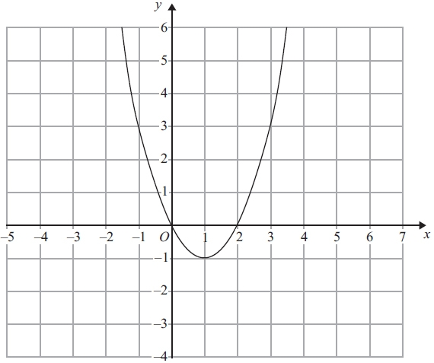
(2)
(b) On this grid, sketch the graph of y = 2f(x)
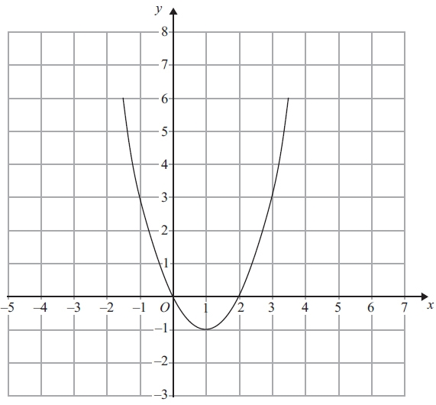
(2)
(Total for Question is 4 marks)

Q3.
The graph of y = f(x) is shown on both grids below.
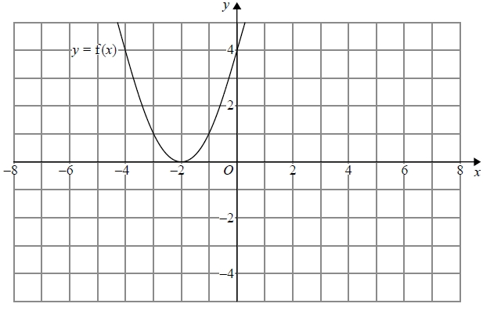
(a) On the grid above, sketch the graph of y = f(−x)
(1)
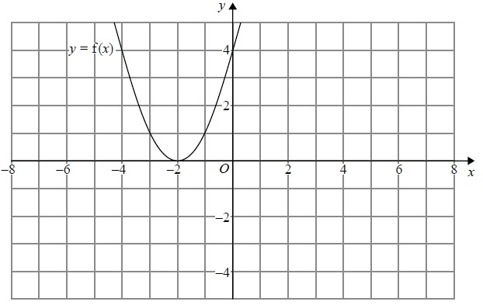
(b) On this grid, sketch the graph of y = −f(x) + 3
(1)
(Total for question = 2 marks)

Q4.
y = f(x)
The graph of y = f(x) is shown on the grid.
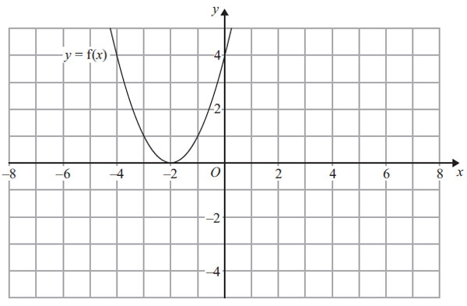
(a) On the grid above, sketch the graph of y = – f(x).
(2)
The graph of y = f(x) is shown on the grid.
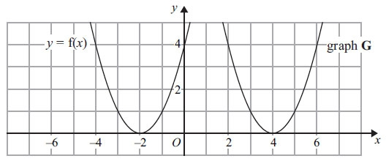
The graph G is a translation of the graph of y = f(x).
(b) Write down the equation of graph G.

..............................................................................................................................................
(2)
(Total for Question is 3 marks)

Q5.
These graphs show four different proportionality relationships between y and x.
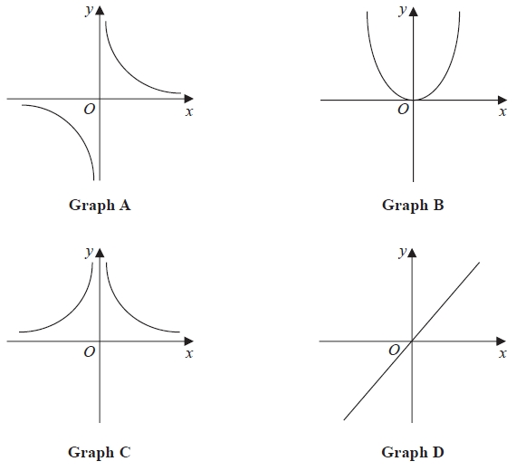
Match each graph with a statement in the table below.
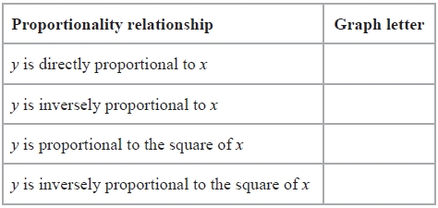

(Total for question is 2 marks)
Q6.
d is inversely proportional to c
When c = 280, d = 25
Find the value of d when c = 350
d = ...........................................................
(Total for question = 3 marks)

Q7.
y is inversely proportional to x
When x = 1.5, y = 36
Find the value of y when x = 6
...........................................................
(Total for question = 3 marks)

Q8.
The graph shows information about the velocity, v m/s, of a parachutist t seconds after leaving a plane.
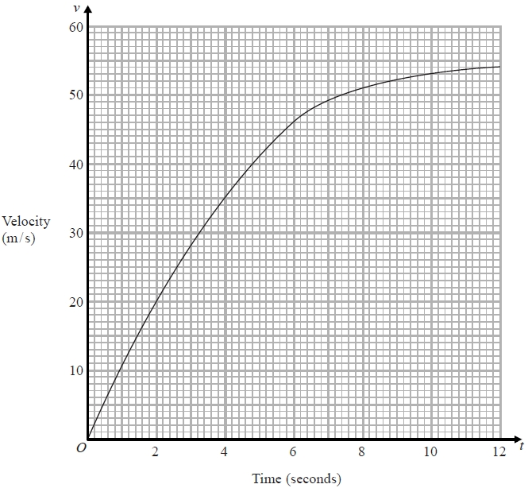
(a) Work out an estimate for the acceleration of the parachutist at t = 6
........................................................... m/s²
(2)
(b) Work out an estimate for the distance fallen by the parachutist in the first
12 seconds after leaving the plane.
Use 3 strips of equal width.
........................................................... m
(3)
(Total for question is 5 marks)
Q9.
Here is a speed-time graph for a car.
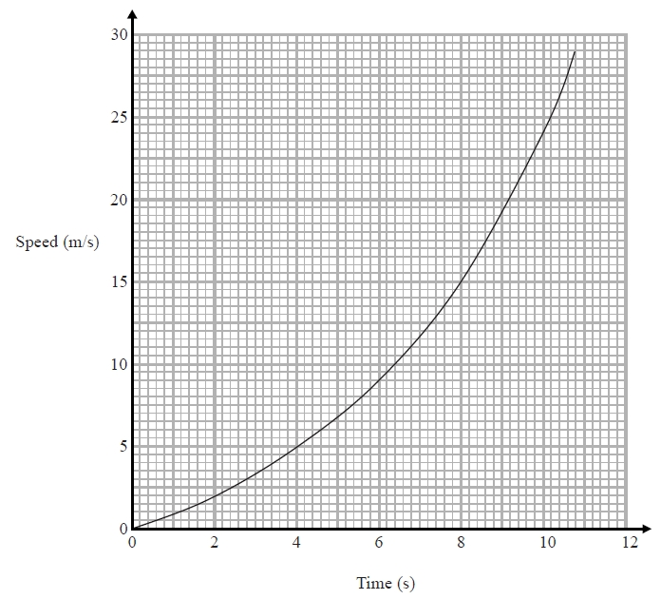
(a) Work out an estimate for the distance the car travelled in the first 10 seconds.
Use 5 strips of equal width.
........................................................... m
(3)
(b) Is your answer to (a) an underestimate or an overestimate of the actual distance?
Give a reason for your answer.
.............................................................................................................................................
.............................................................................................................................................
(1)
(Total for question = 4 marks)
Q10.
Karol runs in a race.
The graph shows her speed, in metres per second, t seconds after the start of the race.
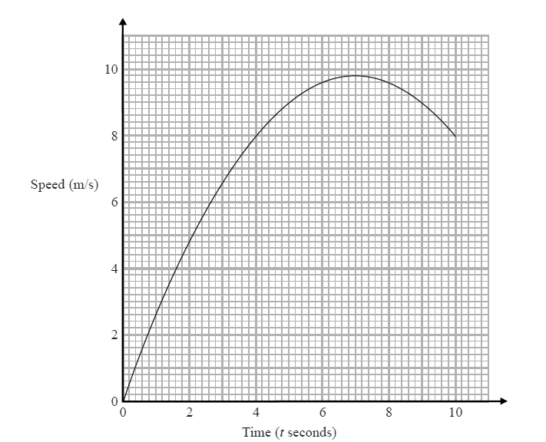
(a) Calculate an estimate for the gradient of the graph when t = 4
You must show how you get your answer.
...........................................................
(3)
(b) Describe fully what your answer to part (a) represents.
.............................................................................................................................................
.............................................................................................................................................
(2)
(c) Explain why your answer to part (a) is only an estimate.
.............................................................................................................................................
.............................................................................................................................................
(1)
(Total for question = 6 marks)

Q11.
D is directly proportional to the cube of n.
Mary says that when n is doubled, the value of D is multiplied by 6
Mary is wrong.
Explain why.
.............................................................................................................................................
.............................................................................................................................................
.............................................................................................................................................
(1)
(Total for question = 1 mark)

Q12.
Louis and Robert are investigating the growth in the population of a type of bacteria.
They have two flasks A and B.
At the start of day 1, there are 1000 bacteria in flask A.
The population of bacteria grows exponentially at the rate of 50% per day.
(a) Show that the population of bacteria in flask A at the start of each day forms a geometric progression.
(2)
The population of bacteria in flask A at the start of the 10th day is k times the population of bacteria in flask A at the start of the 6th day.
(b) Find the value of k.
...........................................................
(2)
At the start of day 1 there are 1000 bacteria in flask B.
The population of bacteria in flask B grows exponentially at the rate of 30% per day.
(c) Sketch a graph to compare the size of the population of bacteria in flask A and in flask B.
(1)
(Total for question = 5 marks)

Q13.
A pendulum of length L cm has time period T seconds.
T is directly proportional to the square root of L.
The length of the pendulum is increased by 40%.
Work out the percentage increase in the time period.
........................................................... %
(Total for question is 3 marks)

Examiner's Report
Q1.
Part (a) was well done by the majority of candidates. However, there were a significant number of candidates who made no attempt to complete the table.
Most candidates who completed the table went onto score at least one mark in part (b). Common errors were (0.5, 3) and (5, 1.25). There continues to be a number of candidates who plot the points from the table and then just leave the graph as a series of plotted points rather than attempting to draw a smooth curve. Some candidates did join their points but with straight line segments rather than a smooth curve.
One fairly common incorrect response was to plot all of the points but only join the points from (1, 6) to (6, 1), not from (0.5, 12).

Q2.
Candidates generally had more success with part (a) than part (b). In part (a) when an attempt at a translation in the x axis direction was seen it was as likely to be that of y = f(x + 3) as that of the required y = f(x - 3). Some sketches were rather too rough to be able to award any marks. Candidates would be well advised to look for those points where the graph passes through integer coordinates and transform these points carefully. In part (b) the transformation of y = f(½ x) was clearly confused with the required transformation of y = 2f(x) and y = f(x) + 2.

Q3.
No Examiner's Report available for this question

Q4.
Candidates in GCSE Mathematics usually struggle with transformation of functions and this question was no exception. In part (a), less than a quarter could show that they understood that −f(x) was a reflection of the curve in the x axis and that (0, 4) and (−4, 4) reflected to (0, −4) and (−4, −4) respectively, but half of these could show an inverted parabola with a maximum point shown at (−2, 0). Many candidates lost a mark as their inverted parabola was hastily drawn and did not pass through the required points.
In part (b), very few candidates could write y = f(x − 6) as the required equation of the translation with y = f(x + 6) and y = f(x) + 6 being the most common wrong answers, with a few gaining the mark for writing y = (x − 4)².

Q5.
No Examiner's Report available for this question

Q6.
No Examiner's Report available for this question

Q7.
No Examiner's Report available for this question

Q8.
No Examiner's Report available for this question

Q9.
No Examiner's Report available for this question

Q10.
No Examiner's Report available for this question

Q11.
No Examiner's Report available for this question

Q12.
No Examiner's Report available for this question

Q13.
No Examiner's Report available for this question

Mark Scheme
Q1.
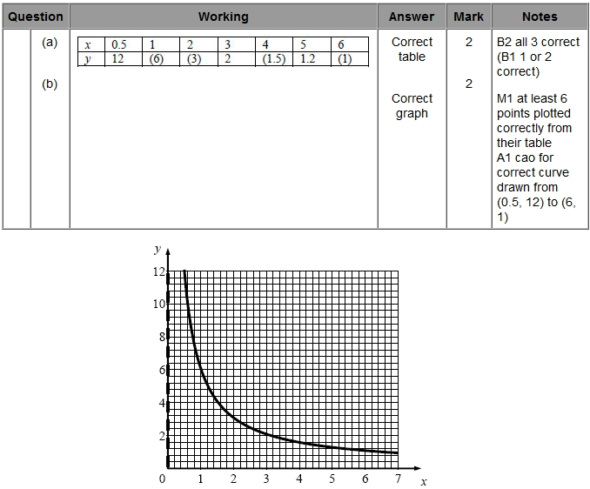

Q2.
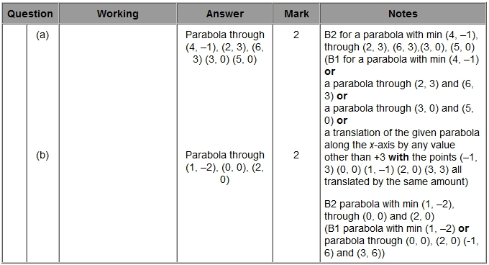

Q3.
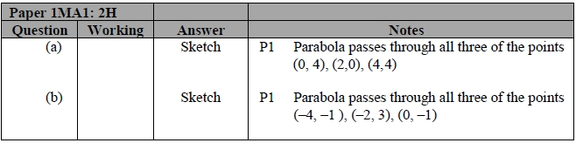

Q4.
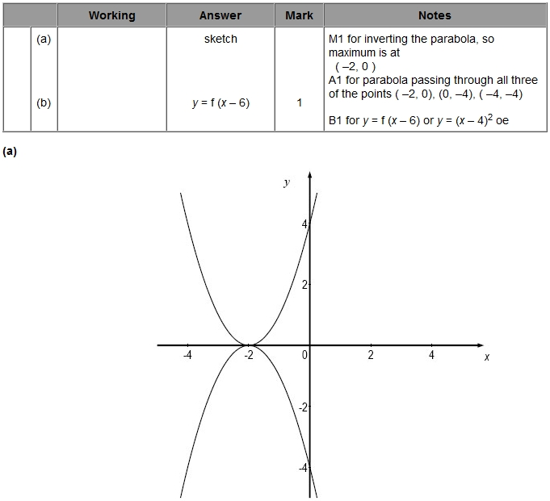

Q5.
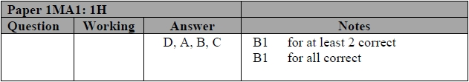

Q6.
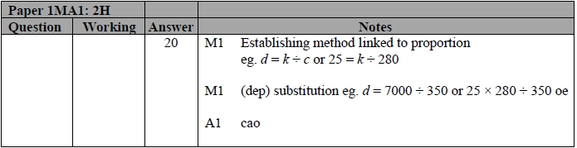

Q7.
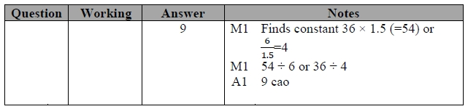

Q8.
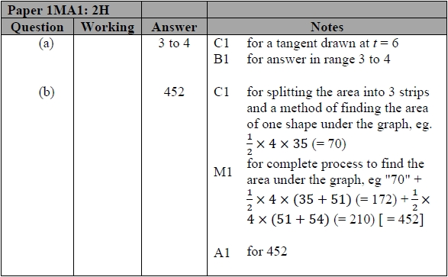

Q9.
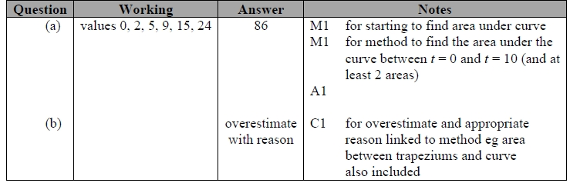

Q10.
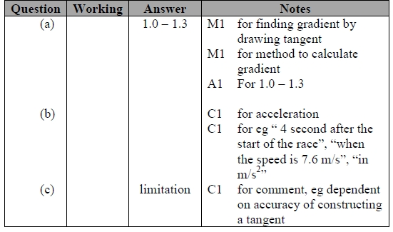

Q11.
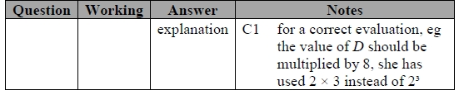

Q12.
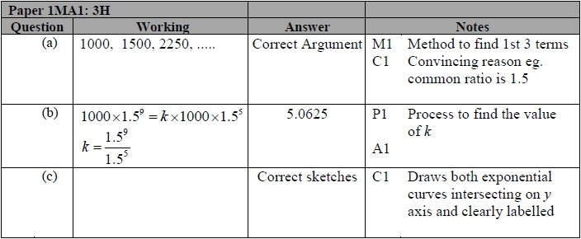
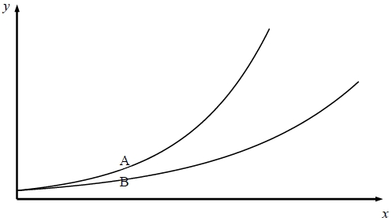

Q13.
