Name: _______________________________________________
Higher Unit 4 topic test
Date:
Time: 50 minutes
Total marks available: 46
Total marks achieved: ______

Questions
Q1.
A set of tyres normally costs £500
In a sale there is a 30% discount.
Work out the sale price of the set of tyres.
£...........................................................
(Total for Question is 3 marks)

Q2.
A TV costs £400
Peter pays a deposit of 15%.
How much does Peter still have to pay for the TV?

£ . . . . . . . . . . . . . . . . . .
(Total for Question is 3 marks)
Q3.
Liam, Sarah and Emily shared some money in the ratio 2 : 3 : 7
Emily got £80 more than Liam.
How much money did Sarah get?

(Total for question = 3 marks)

Q4.
Work out 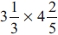
Give your answer as a mixed number in its simplest form.
...........................................................
(Total for question = 3 marks)
Q5.
On a farm, out of every 15 acres of the land are used to grow crops.
Wheat is grown on of the land used to grow crops.
What percentage of the total area of the land on the farm is used to grow wheat?

(Total for question = 3 marks)

Q6.
Work out 3¹⁄₃ ÷ 4¾

..............................................................................................................................................
(Total for Question is 2 marks)

Q7.
Last year, Jora spent
30% of his salary on rent
²⁄₅ of his salary on entertainment
¼ of his salary on living expenses.
He saved the rest of his salary.
Jora spent £3600 on living expenses.
Work out how much money he saved.

£ . . . . . . . . . . . . . . . . . . . . . .
(Total for Question is 5 marks)

Q8.
Here is a plan of Martin's driveway.
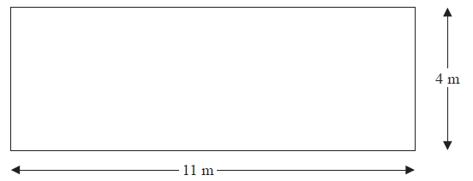
Diagram NOT accurately drawn
Martin is going to cover his driveway with gravel.
The gravel will be 6 cm deep.
Gravel is sold in bags.
There are 0.4 m³ of gravel in each bag.
Each bag of gravel costs £38
Martin gets a discount of 30% off the cost of the gravel.
Work out the total amount of money Martin pays for the gravel.
£...........................................................
(Total for Question is 5 marks)

Q9.
60 children go to a nursery.
The ratio of girls to boys is 3 : 2
The children go to the nursery either in the morning or in the afternoon.
of the children go to the nursery in the morning.
The rest of the children go to the nursery in the afternoon.
7 boys go to the nursery in the afternoon.
Work out how many girls go to the nursery in the morning.
...........................................................
(Total for question = 5 marks)
Q10.
(a) Work out the reciprocal of 1.25
...........................................................
(1)
(b) Work out the value of 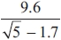
Give your answer correct to 2 decimal places.
...........................................................
(2)

(Total for question = 3 marks)

Q11.
Here are the ingredients needed to make 20 cookies.
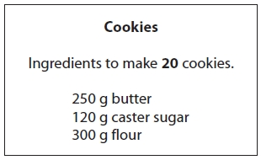
Sam is going to make some cookies.
She has these ingredients.
625 g butter 360 g caster sugar 1000 g flour
Work out the greatest number of cookies that Sam can make with her ingredients.
You must show your working.
...........................................................

(Total for question = 3 marks)

Q12.
Ben goes on holiday to Hong Kong.
In Hong Kong, Ben sees a camera costing HK$3179.55
In London, an identical camera costs £285
The exchange rate is £1 = HK$12.30
Ben buys the camera in Hong Kong.
How much cheaper is the camera in Hong Kong than in London?
...........................................................
(Total for Question is 3 marks)

Q13.
Lewis has a copper pipe with a length of 150 cm and a mass of 800 grams.
He cuts a piece of the copper pipe with a length of 90 cm.
Work out the mass of this piece of copper pipe.
........................................................... grams
(Total for Question is 2 marks)

Q14.
Express the recurring decimal as a fraction.
Give your answer in its simplest form.
...........................................................
(Total for Question is 3 marks)

Examiner's Report
Q1.
This proved to be a good opening question with the most students scoring all 3 marks. The most common error was to just write down the discount of £150 as the answer.

Q2.
Whilst the majority of candidates fully understood the need to subtract the deposit of £60 to work out the balance to be paid, many either added to get an answer of £460 or simply left £60 as their final answer through not carefully reading the question. There were a considerable number of candidates who could not calculate 15% correctly even when they had a correct starting value for 10%. Other errors were generally of an arithmetical nature; 40 + 20 = 80 was not uncommon.

Q3.
No Examiner's Report available for this question

Q4.
Many students could write the mixed numbers as improper fractions but then errors were made either in the multiplications or they omitted to change the improper fractions back to a mixed number.

Q5.
No Examiner's Report available for this question

Q6.
There were many good attempts at this fraction question. Many candidates correctly converted the fractions to vulgar form, but then made errors in performing the division. Some made the arithmetic harder by writing them using common denominators. Simplification was not required, so any equivalent answer was accepted. Many chose to convert the given mixed numbers into decimals, to then use their calculator to give the answer; this was accepted, as long as an accurate decimal equivalent of the answer was given (to at least 5 d.p.). Many lost marks initially by writing the first fraction as 3.3, a premature approximation. Those with scientific calculators could make good use of the fraction function to give the answer, but in this case it had to be written correctly and not using calculator notation.

Q7.
Candidates need to be encouraged to set their work out in a logical order when tackling a multi-stage problem. Haphazard working led to loss of zeros, incorrect subtraction and candidates seeming to lose track of their method. Often when finding ²⁄₅ of 14400, candidates found ¹⁄₅ but then did not carry on to double their answer. Many candidates knew how to find the correct proportions but were let down by poor multiplication skills. A significant number did not appreciate the detail of the question and found proportions of £3600 rather than £14400

Q8.
This question proved good at differentiating the candidates with a range of marks being awarded. The first method from the mark scheme was definitely the more popular approach to this question. There were a good number of fully correct answers, although it was a little disappointing to observe the number of these which did not include the 0 in 186.20 which was not penalised on this occasion. The most common error amongst otherwise good responses was when inconsistent units were used to calculate the volume.
Where part marks were awarded there were a variety of different reasons for this. Common reasons for a mark of 4 were not rounding to 7 bags and making an error in an otherwise correct calculation at some stage. Marks of two and three were also commonly given. Three marks were often awarded for having found a volume using inconsistent units followed by carrying out the remainder of the calculation correctly. Two marks was a frequent score for calculating the cost of the gravel before discount for some number of bags and then calculating the discount correctly, this often followed on from calculations which gave areas rather than a volume.
A reasonable number of candidates lost a mark as they found 30% and then did not subtract from the original amount to obtain 70%. Despite this being the calculator paper, many candidates used a non-calculator approach to find the percentage. A disappointing number of candidates did not recognise the need for consistent units to calculate the volume or, where they did, were not able to correctly convert the depth of the driveway to metres.

Q9.
Not all students can divide a quantity by a given ratio. The ability to do so enabled them to make a good start on this question since numbers of boys or girls was needed to move to a second stage. However, as long as the student stated some figures for boys or girls then credit could be given for some subsequent working. It was disappointing to find some students unable to find of an amount.
It was of course important in this 5 mark question for working to be shown in order for credit to be given. Even though many failed to get to the final answer, many method marks were given where examiners could see the evidence of appropriate working.

Q10.
The number of students writing down the correct answer to the first part of this question was disappointing. Many students clearly did not understand the term "reciprocal". The incorrect answers 1 and were commonly seen.
Part (b) of the question attracted more correct answers than part (a) though many students found the value of 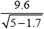 (= 5.28...) instead of the expression given. This seemed to indicate a lack of familiarity with the correct use of their calculator, in particular with how to use the square root function. Students are advised to check more carefully that the expression they are evaluating is the same as the expression they should be evaluating. Very few students who gave an incorrect answer showed intermediate calculations so one mark was rarely awarded.

Q11.
This was a well understood question with almost all students being able to score at least one mark and often two. Some students did make the correct calculations but then chose the incorrect number of cookies.

Q12.
Most candidates understood what they needed to do and marks were most frequently lost due to a lack of care and attention to detail. Monetary answers had to be shown with the correct currency units, and written correctly (eg £26.5 is not enough). There were also errors in undertaking subtraction, even neglecting to do it after a currency conversion.

Q13.
Many candidates demonstrated a correct method using a correct scaling ratio but premature approximation of their ratio prevented the award of full marks. 800 ÷ 1.6 and 90 × 5.3 were common errors. A significant number of candidates attempted to find the mass of 60 cm (150 − 90). If a correct ratio was used, this did gain some credit.

Q14.
It was surprising to see how many students used a correct method to get an answer of ¹⁴⁄₉₀ and did not put this answer in its simplest form. There were many good responses to this question generally approached by using a method of 100x − 10x or 10x − x. However, a significant number of students thought that the given decimal was 0.151515... These students were able to access the B mark for the special case. Students should be advised to expand the given recurring decimal to at least 6 figures to ensure they score the first method mark.

Mark Scheme
Q1.
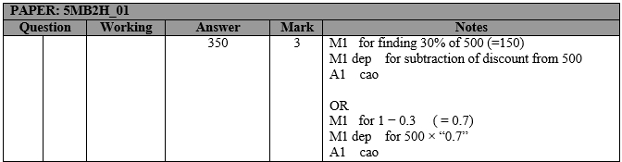

Q2.
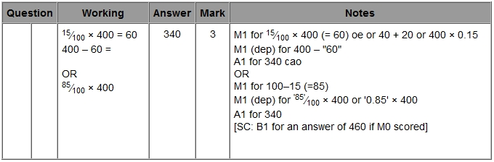

Q3.
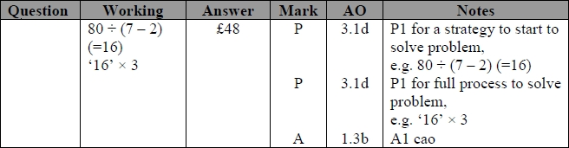

Q4.
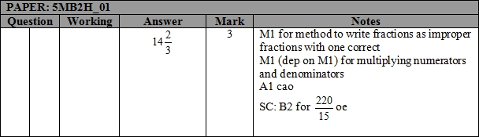

Q5.
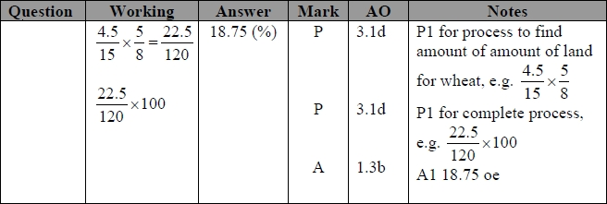

Q6.
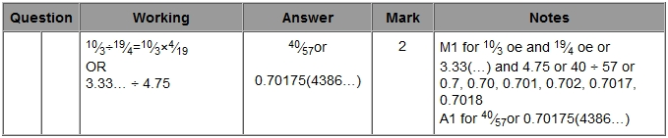

Q7.
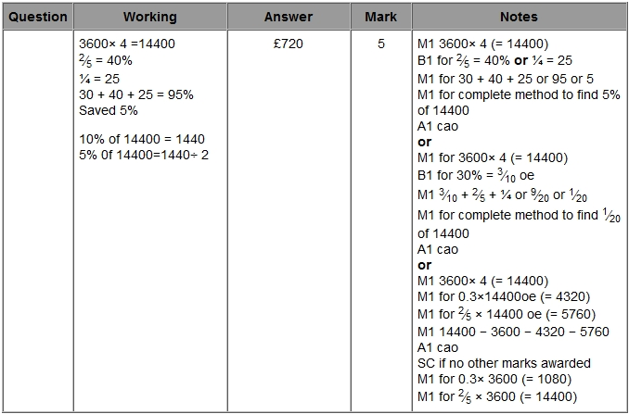

Q8.
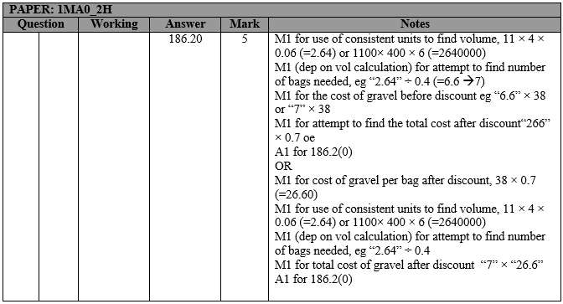

Q9.
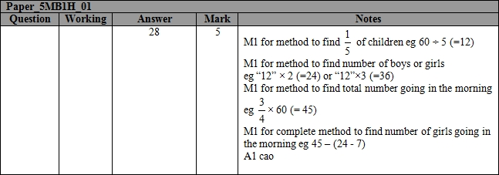

Q10.
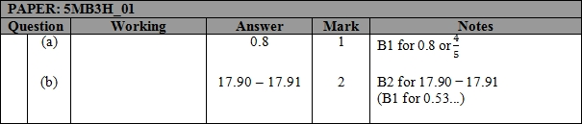

Q11.
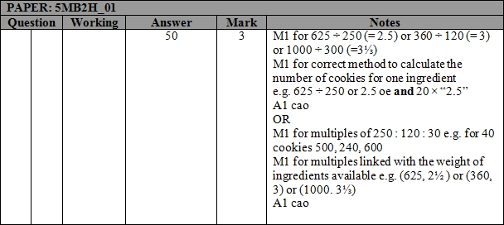

Q12.
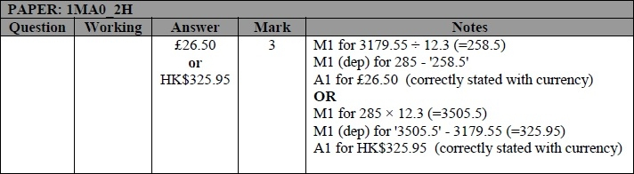

Q13.
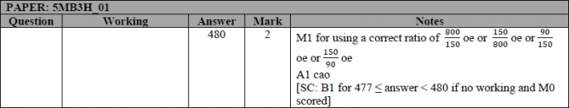

Q14.
