Name: _______________________________________________
Higher Unit 6a–b topic test
Date:
Time: 60 minutes
Total marks available: 54
Total marks achieved: ______

Questions
Q1.
The point A has coordinates (2, 3).
The point B has coordinates (6, 8).
M is the midpoint of the line AB.
Find the coordinates of M.
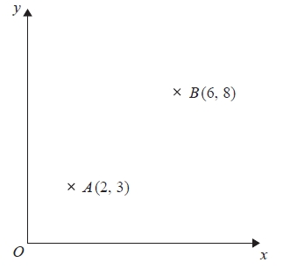
Diagram NOT accurately drawn
...........................................................
(Total for Question is 2 marks)

Q2.
Line L is drawn on the grid below.
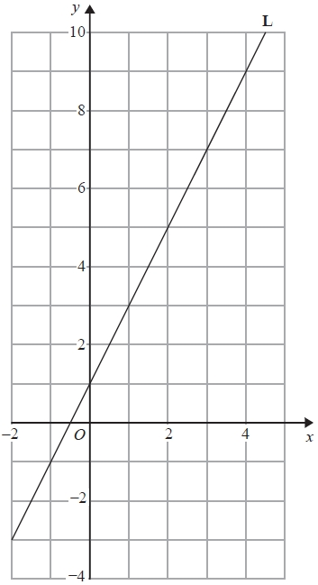
Find the equation for the straight line L.
Give your answer in the form y = mx + c
...........................................................
(Total for question is 3 marks)

Q3.
The diagram shows a straight line, L₁, drawn on a grid.
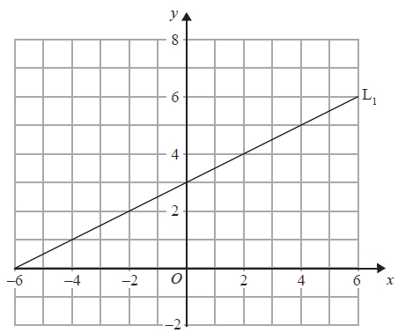
A straight line, L₂, is parallel to the straight line L₁ and passes through the point (0, −5).
Find an equation of the straight line L₂.
...........................................................
(Total for Question is 3 marks)

Q4.
Here are the equations of four straight lines.
Line A y = 2x + 4
Line B 2y = x + 4
Line C 2x + 2y = 4
Line D 2x − y = 4
Two of these lines are parallel.
Write down the two parallel lines?
Line ................................ and line ................................
(Total for question is 1 mark)

Q5.
(a) On the grid, draw the graph of y = 4x + 2 from x = –1 to x = 3

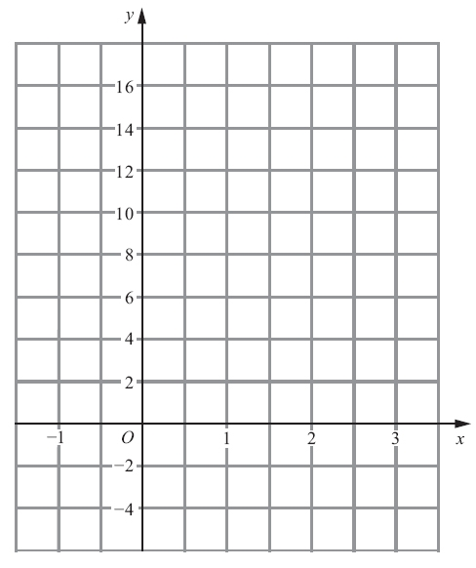
(3)
(b) (i) Write down the equation of a straight line that is parallel to y = 4x + 2

..............................................................................................................................................
(ii) Write down the gradient of a straight line that is perpendicular to y = 4x + 2

..............................................................................................................................................
(2)
(Total for Question is 5 marks)

Q6.
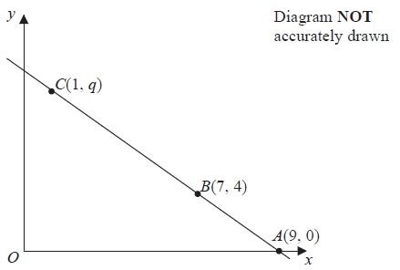
The points A, B and C lie on a straight line.
The coordinates of A are (9, 0).
The coordinates of B are (7, 4).
The coordinates of C are (1, q).
Work out the value of q.
...........................................................
(Total for Question is 3 marks)

Q7.
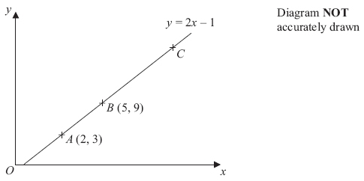
In the diagram,
the points A, B and C lie on the straight line y = 2x – 1
The coordinates of A are (2, 3).
The coordinates of B are (5, 9).
Given that AC = 3AB, find the coordinates of C.

..............................................................................................................................................
(Total for Question is 3 marks)

Q8.
* A is the point with coordinates (1, 3)
B is the point with coordinates (4, −1)
The straight line L goes through both A and B.
Is the line with equation 2y = 3x − 4 perpendicular to line L?
You must show how you got your answer.
(Total for Question is 4 marks)

Q9.
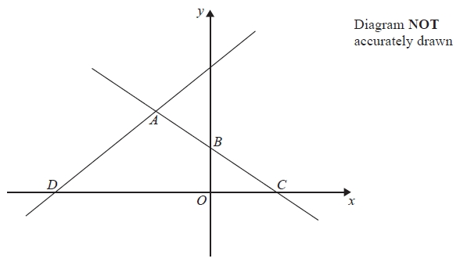
In the diagram, ABC is the line with equation y = − x + 5
AB = BC
D is the point with coordinates (−13, 0)
Find an equation of the line through A and D.
...........................................................
(Total for question = 5 marks)

Q10.
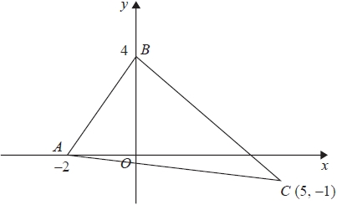
Find an equation of the line that passes through C and is perpendicular to AB.
...........................................................
(Total for question is 4 marks)

Q11.
You can use this formula to change a temperature C, in °C, to a temperature F, in °F.
F = 1.8C + 32
(a) Use the formula to change 20°C into °F.

. . . . . . . . . . . . . . . . . . . . . . °F
(2)
(b) On the grid opposite, draw a conversion graph that can be used to change between temperatures in °C and temperatures in °F.
(3)

(c) Use your graph to change 100 °F into °C.

. . . . . . . . . . . . . . . . . . . . . . °C
(1)

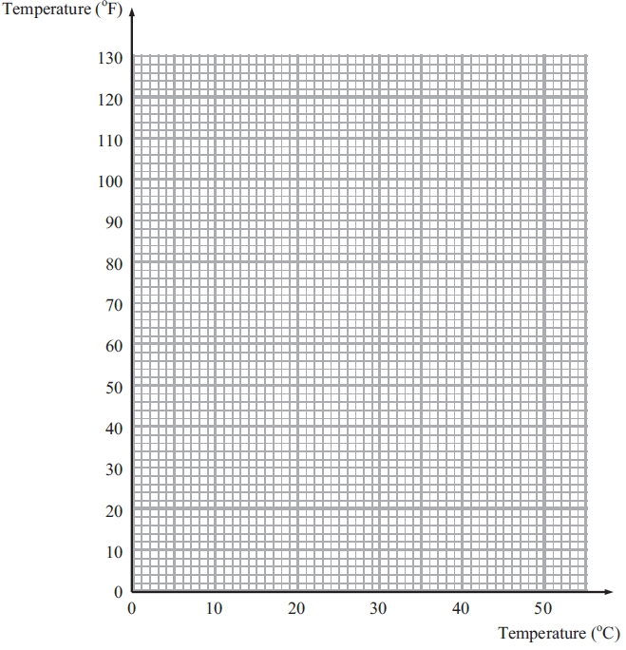
(Total for Question is 6 marks)

Q12.
Water is leaking out of two containers.
The water started to leak out of the containers at the same time.
The straight line P shows information about the amount of water, in litres, in container P.
The straight line Q shows information about the amount of water, in litres, in container Q.
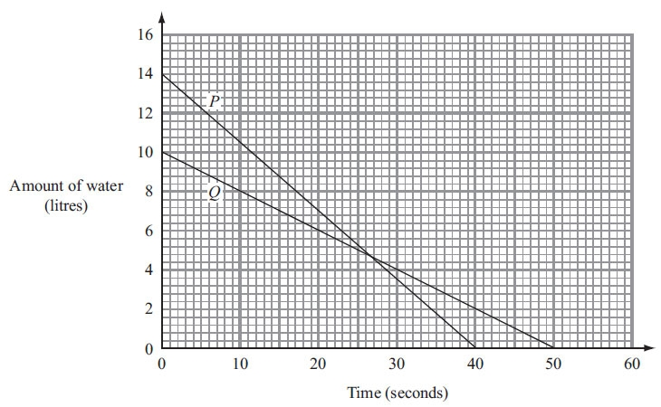
(a) Work out the gradient of line P.

. . . . . . . . . . . . . . . . . . . . . .
(2)
One container will become empty first.
(b) (i) Which container?
You must explain your answer.
..............................................................................................................................................
..............................................................................................................................................
(ii) How much water is then left in the other container?
. . . . . . . . . . . . litres
(2)
(Total for Question is 4 marks)
Q13.
You can use the graph opposite to find out how much Lethna has to pay for the units of electricity she has used.
Lethna pays at one rate for the first 100 units of electricity she uses.
She pays at a different rate for all the other units of electricity she uses.
Lethna uses a total of 900 units of electricity.
Work out how much she must pay.

..............................................................................................................................................
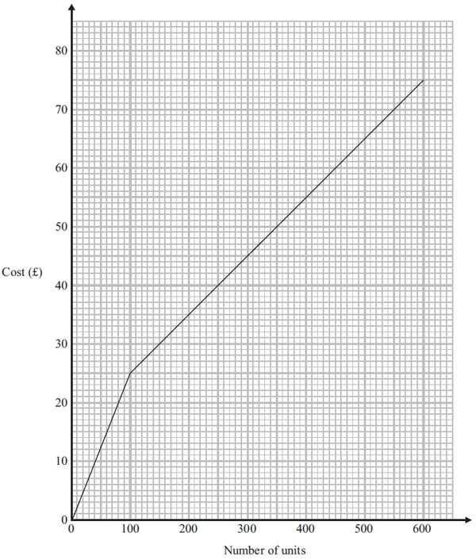
(Total for Question is 3 marks)

Q14.
The graph shows the depth, d cm, of water in a tank after t seconds.
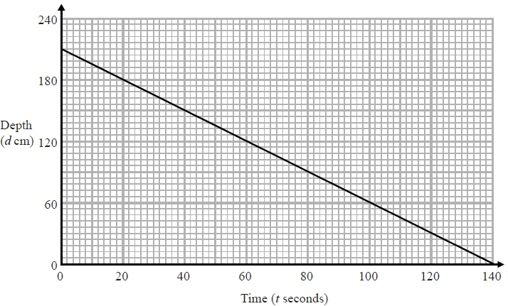
(a) Find the gradient of this graph.
...........................................................
(2)
(b) Explain what this gradient represents.
.............................................................................................................................................
.............................................................................................................................................
(1)

(Total for question is 3 marks)

Q15.
At 9 am, Bradley began a journey on his bicycle.
From 9 am to 9.36 am, he cycled at an average speed of 15 km/h.
From 9.36 am to 10.45 am, he cycled a further 8 km.
(a) Draw a travel graph to show Bradley's journey.
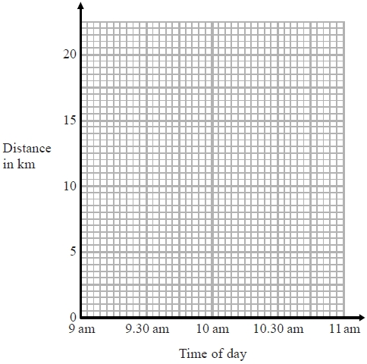
(3)
From 10.45 am to 11 am, Bradley cycled at an average speed of 18 km/h.
(b) Work out the distance Bradley cycled from 10.45 am to 11 am.
........................................................... km
(2)
(Total for question is 5 marks)
Examiner's Report
Q1.
This question was done well by a good number of candidates, however there were also a surprising number of incorrect answers. A common error which lost a mark was in giving the coordinate without the brackets. A small number of candidates listed the values between 2 and 6, and from 3 to 8 and "found" the midpoint by crossing off matching values from each end of their lists. For the most part, this was done successfully. The most common incorrect approach observed was to subtract the two coordinates and this gave an answer of (4, 5). A few candidates attempted to complete this question by labelling the axes despite the diagram being labelled as not to scale.

Q2.
No Examiner's Report available for this question

Q3.
Candidates were expected to show how they could find the gradient of the given line by using a variant of rise ÷ run. Many candidates were unable to do this and had no idea of what a gradient is. Some candidates were able to give the correct gradient for the given line L₁, but then gave a different coefficient of x for L₂. Candidates were much more confident in assigning the value of − 5 to c in y = mx + c.

Q4.
No Examiner's Report available for this question

Q5.
Over 50% of candidates drew clear, accurate graphs and scored full marks in the first part of this question. Most candidates plotted two or more points which they then joined to form a straight line. Relatively few candidates constructed a table of values before plotting points. A significant minority of candidates tried to use the gradient-intercept method to draw the line. This approach proved less successful. Most candidates using this method drew lines passing through (0, 2) but with an incorrect gradient. There was little evidence to suggest that the different scales on the x and y axes had confused candidates.
In part (b)(i) nearly 60% of candidates gave a correct equation. Of those who were not successful, a few gave an expression rather than an equation. In part (b)(ii) correct answers were rare. A large number of candidates who demonstrated an understanding of the situation gave the equation of a perpendicular line rather than the gradient. This highlights the need for candidates to ensure they read the particular demands of a question carefully.

Q6.
Many students found this question challenging. There were attempts to find the gradient of the line but this was rarely followed by correct thinking. The most successful method was by using differences and taking steps up the line; for example steps of 4 units up for each 2 steps across. However this often resulted in an answer of 12, failing to get the correct answer by not adding the initial step of 4.

Q7.
Many candidates worked out the x distance and the y distance from A to C, giving the answer (9, 18), failing to recognise that they needed to add these values to A (2, 3) to get the coordinates of C. Many were not able to work on their own initiative to solve this question.

Q8.
Many students were able to find the gradient of the line 2y = 3x − 4 or the gradient of the line passing through the points A and B, but relatively few were able to find both of these correctly. Correct reasons were often based on examples rather than by a direct appeal to the formula m₁ × m² = −1, eg "the gradient of the line perpendicular to 2y = 3x − 4 has to be − not −". Students should be advised to show their methods clearly, eg by quoting a suitable general formula for calculating gradients, before attempting to use it.

Q9.
This question was not well understood. Partial marks were awarded for a few students who were able to establish the coordinates of B as (0, 5) and/or C as (10, 0).

Q10.
No Examiner's Report available for this question

Q11.
Failure to substitute correctly and poor arithmetic led candidates down in part (a). Instead of multiplying 20 by 1.8 for the first part of the formula, many added instead giving a final answer of 53.8. Others had difficulty with multiplying by the decimal 1.8, some rounded this to 2 instead.
The lack of a table for pairs of values in part (b) meant that many candidates were quite disorganised in their working which led to some errors. Where the formula was used correctly, points were generally well-plotted and joined with a straight line although some candidates lost a mark as their line did not extend all the way from (0,32) to (50,122). Many candidates whose line was incorrect did score 1 mark for drawing a straight line through (0,32).
Values were read accurately for part (c) and candidates were awarded a mark for this even if the straight line was incorrect. Correct substitution into the formula was an acceptable method but several candidates substituted 100 incorrectly as if to convert Centigrade to Fahrenheit as in part (a).

Q12.
This question was not done well. In part (a) few candidates were able to work out the gradient of the line. Of those that realised that they need to calculate the increase in the amount of water divided by the time, many drew very small triangles on their graphs and consequently were unable to do the calculation with sufficient accuracy. Some ignored the scales, some used ^{x}⁄_{y}, some started their triangles on line P and finished them on line Q, and some, having obtained an accurate gradient of 0.35, did not realise that a negative sign was needed for the decrease. Candidates should be advised to draw large triangles on graphs to maximise the accuracy of their calculations of gradients.
A very common misconception in part (b)(i) was to compare the gradients of the graphs rather than the time it took each container to empty. Candidates need to be able to distinguish between a statement and a comparison.

Q13.
The fact there were two different rates was lost on many candidates. Sometimes the first 100 units was shown at £25 but the problem for most was in deciding what to do with the remaining units. These were either costs at the rate of £25, or some multiple of amounts which included the £25 from reading off values from the graph. Some build up methods failed to include the first rare (such as adding readings of 300 and 600 taken from the graph). A very successful approach was to list the cumulative amounts from 100, 200, 300, 400, etc. units, setting up a series that eventually led to the correct answer.

Q14.
No Examiner's Report available for this question

Q15.
No Examiner's Report available for this question

Mark Scheme
Q1.
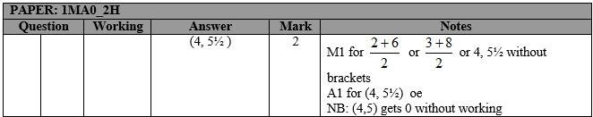

Q2.
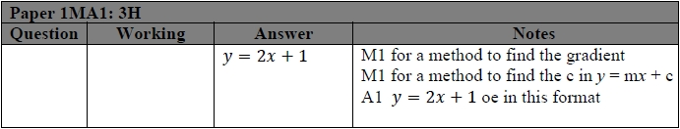

Q3.
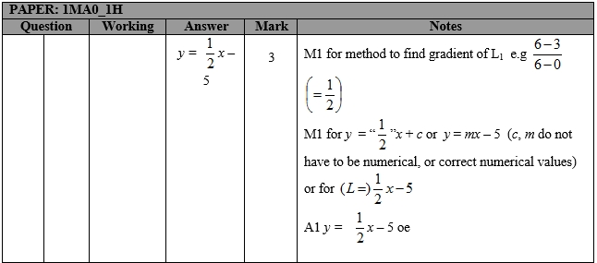

Q4.
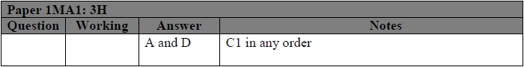
Q5.
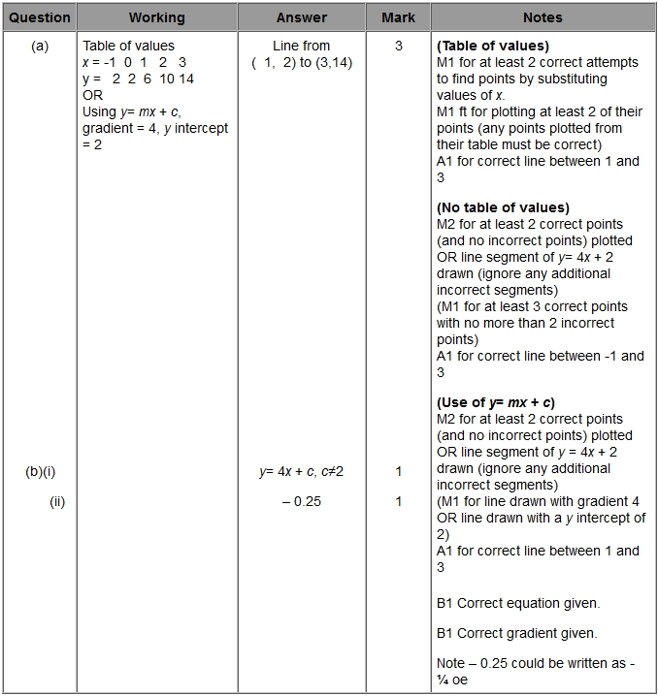

Q6.
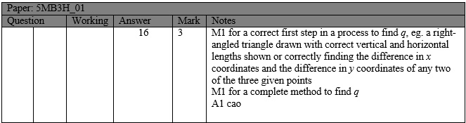

Q7.
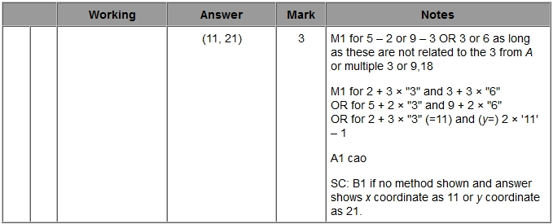

Q8.
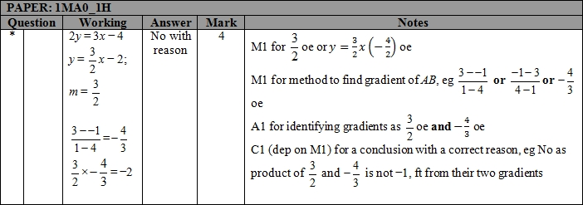

Q9.
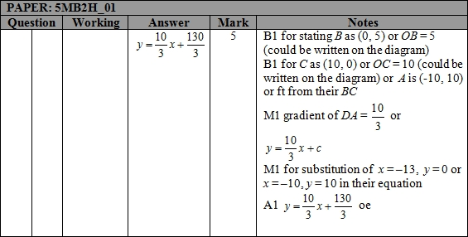

Q10.
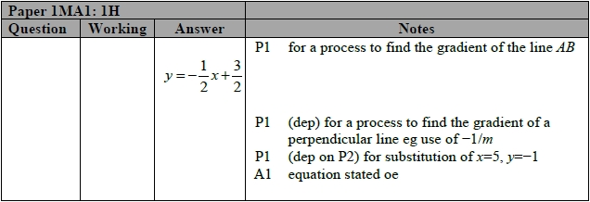

Q11.
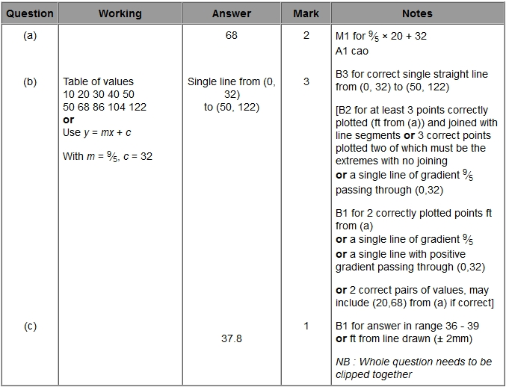

Q12.
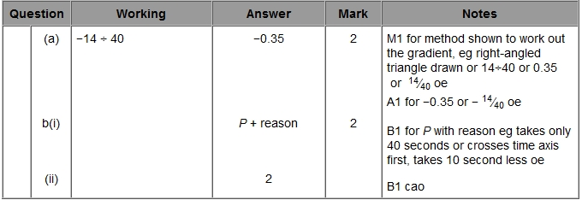

Q13.
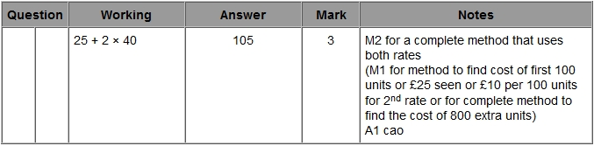

Q14.
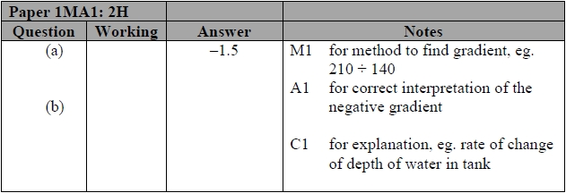

Q15.
