Name: _______________________________________________
Higher Unit 7 topic test
Date:
Time: 55 minutes
Total marks available: 51
Total marks achieved: ______

Questions
Q1.
The diagram shows a flower bed in the shape of a circle.
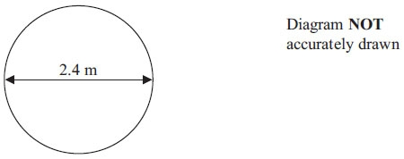
The flower bed has a diameter of 2.4 m.
Sue is going to put a plastic strip around the edge of the flower bed.
The plastic strip is sold in 2 metre rolls.
How many rolls of plastic strip does Sue need to buy?
You must show all your working.

(Total for Question is 4 marks)

Q2.
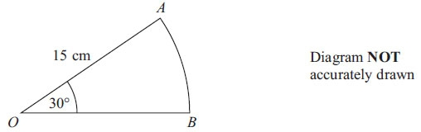
OAB is a sector of a circle, centre O.
The radius of the circle is 15 cm.
The angle of the sector is 30°.
Calculate the area of sector OAB.
Give your answer correct to 3 significant figures.

. . . . . . . . . . . . . . . . . . . . . cm²
(Total for Question is 2 marks)

Q3.
Here is a right-angled triangle.
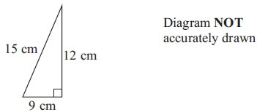
The shape below is made from 4 of these triangles.
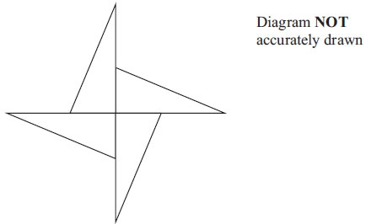
Work out the perimeter of the shape.

..............................................................................................................................................
(Total for Question is 3 marks)
Q4.
Here is a cuboid.
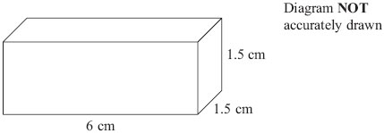
The cuboid is 6 cm by 1.5 cm by 1.5 cm.
Work out the total surface area of the cuboid.

. . . . . . . . . . . . . . . . . . . . . . cm²
(Total for Question is 3 marks)

Q5.
The diagram shows the plan of a playground.
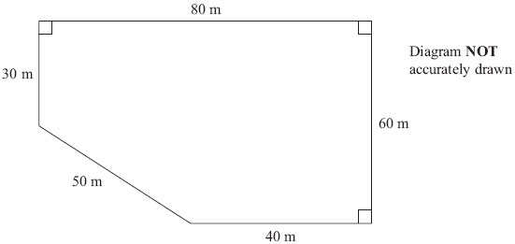
Bill is going to cover the playground with tarmac.
It costs £2.56 to cover each square metre with tarmac.
Work out the total cost of the tarmac Bill needs.

..............................................................................................................................................
(Total for Question is 4 marks)

Q6.
The diagram shows a triangular prism.
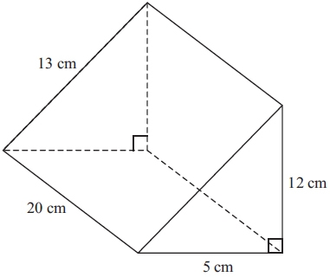Diagram NOT accurately drawn
Work out the total surface area of the prism.

. . . . . . . . . . . . . . . . . . cm²
(Total for Question is 3 marks)

Q7.
Janice cuts a triangle from a rectangular piece of metal.
She uses the rest of the metal to make a name badge.
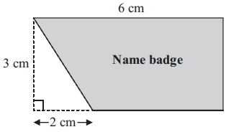Diagram NOT accurately drawn
The rectangle has length 6 cm and width 3 cm.
The right-angled triangle has base 2 cm and height 3 cm.
Work out the area of the name badge.

..............................................................................................................................................
(Total for Question is 4 marks)

Q8.
The diagram shows a solid made from a hemisphere and a cone.
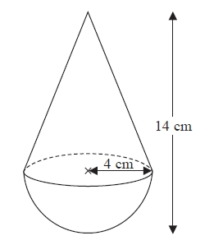
Diagram NOT accurately drawn
The radius of the hemisphere is 4 cm.
The radius of the base of the cone is 4 cm.
Calculate the volume of the solid.
Give your answer correct to 3 significant figures.
...........................................................cm³
(Total for Question is 3 marks)
Q9.
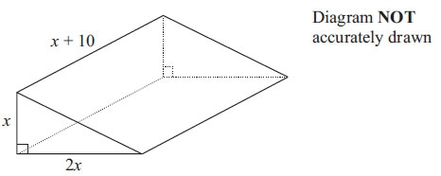
The diagram shows a solid triangular prism.
All the measurements are in centimetres.
The volume of the prism is V cm³.
Find a formula for V in terms of x.
Give your answer in simplified form.

..............................................................................................................................................
(Total for Question is 3 marks)

Q10.
A piece of wood has a length of 65 centimetres to the nearest centimetre.
(a) What is the least possible length of the piece of wood?

..............................................................................................................................................
(1)
(b) What is the greatest possible length of the piece of wood?

..............................................................................................................................................
(1)
(Total for Question is 2 marks)

Q11.
Ali has some packets.
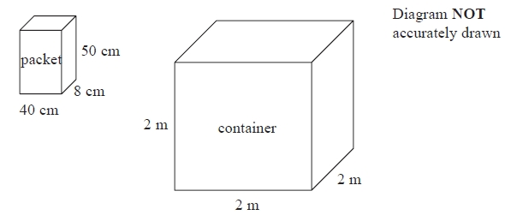
Each packet has dimensions 40 cm by 8 cm by 50 cm.
Ali fills a container with these packets.
The container is a cube of side 2 m.
Ali fills the container completely with these packets.
Work out the number of packets.
...........................................................
(Total for Question is 4 marks)
Q12.
A solid sphere has
a mass of 1180 g measured to the nearest gram
and a radius of 6.2 cm measured to the nearest millimetre.
Given that
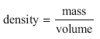
find the upper bound for the density of the sphere.
Give your answer to 3 significant figures.

. . . . . . . . . . . . . . . . . . . . . g/cm³
(Total for Question is 4 marks)

Q13.
The volume of a sphere is 70 cm³ correct to the nearest cm³.
Calculate the upper bound for the surface area of the sphere.
Give your answer correct to 1 decimal place.
You must show all your working.
...........................................................cm²
(Total for question = 4 marks)
Q14.
Chelsea's height is 168 cm to the nearest cm.
(a) What is Chelsea's minimum possible height?
........................................................... cm
(1)
(b) What is Chelsea's maximum possible height?
........................................................... cm
(1)
(Total for Question is 2 marks)

Q15.
Modelling the planet Mercury as a sphere, it has a radius of 2440 km.
(a) (i) Work out an estimate in square kilometres for the surface area of Mercury.
(ii) Without carrying out a further calculation, give evidence to show whether your method gives you an underestimate or an overestimate for the surface area of Mercury.
(3)
In July 2013, the spacecraft Messenger was near Mercury at a distance of 9.75 × 10⁷ km from Earth.
Taking the speed of light to be 3 × 10⁸ m/s,
(b) work out how long it takes light to travel a distance of 9.75 × 10⁷ km.
(3)

(Total for question = 6 marks)

Examiner's Report
Q1.
For this QWC question a full method and justification was required. Apart from some who used the area formula, most candidates knew what to do and marks were often lost due to a lack of communication rather than a lack of understanding. The main issues were not showing full working for finding the circumference of the circle and not fully justifying why 4 rolls of plastic strip were required. It was quite common for candidates to jump from a circumference of 7.5 to an answer of 4 rolls.

Q2.
Errors included using 30 cm as the radius rather than 15 cm, dividing the area of a circle by 6 rather than 12 (focusing on 180° rather than 360°) and using the formula for the circumference rather than the area of a circle. A common error was to divide the total circle area by the angle 30 rather than multiplying by ³⁰⁄₃₆₀.
Candidates tended to earn either no marks or full marks. Of those using the area formula correctly, a significant number failed to attempt any division, giving their answer as 706.(...), so failed to gain any credit.

Q3.
There were various ways of working out the perimeter. Most candidates did so by working out each of the lengths on the diagram; working out was not always clear, but candidates benefitted from writing the lengths of each of the lines considered on the diagram. The most common wrong answer was 144 from the 15+12+9=36 then ×4. A minority worked with area rather than perimeter. The missing length was too regularly given as 6 instead of 3.

Q4.
There was evidence that some candidates did not read the question with enough care with many calculating the volume instead of the surface area. Of those who worked with area, common errors included poor arithmetic, adding together edges instead of areas, and a failure to include all 6 sides.

Q5.
Candidates frequently realised that they had to either divide the shape into manageable areas, or take the triangle away from a whole rectangle.
There were a variety of approaches used in this question. In general triangles and rectangles appears to have been more successful than introducing a trapezium, although failure to include the " ¹⁄₂ " in triangle calculations cause problems for some candidates.
Weaker candidates chose incorrect dimensions for shapes they had chosen to work with. Most realised it was easiest to calculate the area and then multiply by £2.56; those who introduced this earlier usually lost their way in poorly presented workings.
In presenting answers some candidates did not have sufficient confidence in their own answers and divided by 100, thinking that the final amount was too much for resurfacing the playground, and that it could be done for ¹⁄₁₀₀ of the cost.

Q6.
A great many candidates, even at this level, still do not know how to find the area of a triangle; 12 × 5 = 60 cm² was often seen, and candidates would repeat this for the second triangular end. Many candidates again did not read the question carefully and attempted to find volume. Some candidates who did correctly work out the area of the front triangular end at 30 cm² then worked out ½ × 13 × 5 for the triangular end at the back. Other errors were often made by candidates not attempting to find the area of all of the 5 faces. Many candidates made the incorrect assumption that all three of the rectangular faces were identical, usually 20cm by 13cm.

Q7.
Again, many candidates demonstrated their inability to find the area of a triangle. Area of triangle = 3 × 2 = 6 was common. This was often followed by 18 (6×3) – 6 = 12. Even though the formula for the area of a trapezium is now on the Higher tier formula sheet, its use was scarce and often inaccurate. Many candidates correctly found the base of the trapezium as 4 cm but then multiplied it by 6. Some correctly found the area of the trapezium but then went on to subtract the area of the triangle.
The vast majority of candidates scored one mark, irrespective of their answer, by quoting the correct units of cm².

Q8.
Most candidates were able to identify a correct equation for one or both parts of the shape but there were many errors. The most common included failure to divide by 2 for the hemisphere, squaring instead of cubing the radius for the sphere and using 14 as the height of the cone. It was surprising how many candidates squared or cubed pi. Some candidates did not seem to identify any equation from the formula sheet. Occasionally early rounding of an interim answer resulted in an inaccurate final answer.

Q9.
Many candidates started this problem correctly by intending to multiply the three expressions. But few were then able to manipulate the expressions in order to produce a simplification. Over-simplification spoilt some answers that would otherwise have been correct. Candidates earned little credit when adding the expressions, trying to find the surface area, or failing to divide by 2 for a triangle, of which there were a significant number. As with all formulae, there was a need for a left hand side to the formula; very few included "V=" in their stated formula, which regrettably was a mark lost, an issue worth raising with future candidates.

Q10.
Part (a) was generally well answered with most candidates opting for 64.5. They were less successful with part (b) where answers of 64.4, 65.4, 65.49 and 65.9 were commonly seen.

Q11.
Poor arithmetic was an unwelcome feature of this question. Many students scored all 3 method marks but fell down on accuracy. It was not at all uncommon to see 200 ÷ 40 = 50 and 200 ÷ 50 = 40. Most students who converted 2 metres to centimetres were successful in scoring the first 2 marks. However, those that first found the volume of the container as 8 m³ struggled to convert this to cm3 or to convert 16 000 cm³ to m³. Others struggled to accurately work out 8 000 000 ÷ 16 000.
Students should be advised, when answering similar questions, to use the method of (200 ÷ 40) × (200 ÷ 50) × (200 ÷ 8) rather than finding the volume of the container and dividing this by the volume of the packet as this method does not always work when the container is not filled completely.

Q12.
This topic was clearly not well understood or prepared for. The vast majority of candidates gained one mark for 1180.5, but many showed no knowledge of bounds. Very few understood that they needed to substitute 6.15 in the volume formula before dividing. Some realised that they needed the upper bound for mass divided by the lower bound for volume and this was rewarded if 1180.5 or 6.15 was seen. Only the most able candidates gained full marks.

Q13.
Students needed to identify an upper bound for the volume of the sphere in order to make any progress in this question. Most students did not identify the question as one focussing on bounds despite the reference to "the upper bound" in the question. A small minority of students scored the mark for stating the upper boundary for the volume as 70.5. Often they got no further. Where students did identify an upper boundary, even where it was incorrect, examiners were able to award some credit for a correct method to find the radius and then the surface area of the sphere.

Q14.
Part (a) was well answered. In part (b) candidates need to remember that a truncated answer such as 168.49 is not accepted; this answer is a recurring decimal and that aspect of the decimal must be shown, otherwise 168.5 is also acceptable.

Q15.
No Examiner's Report available for this question

Mark Scheme
Q1.
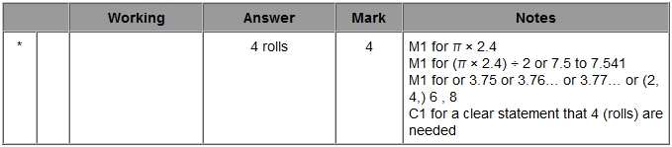

Q2.
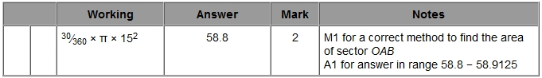

Q3.
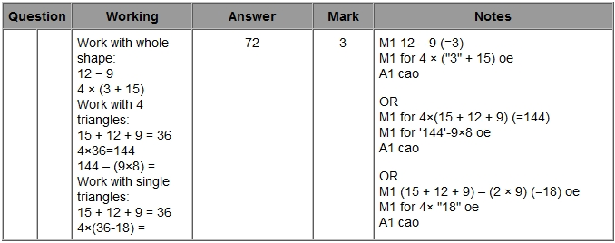

Q4.
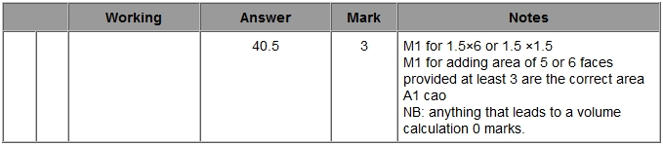

Q5.
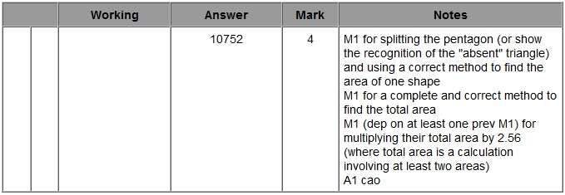

Q6.
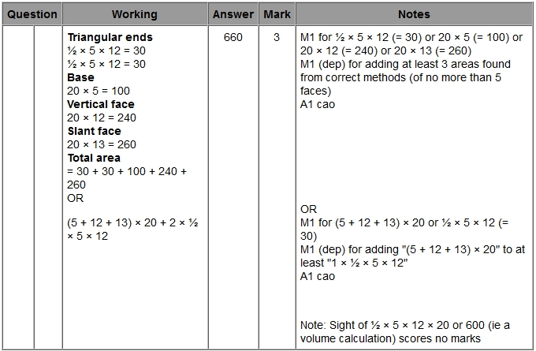

Q7.
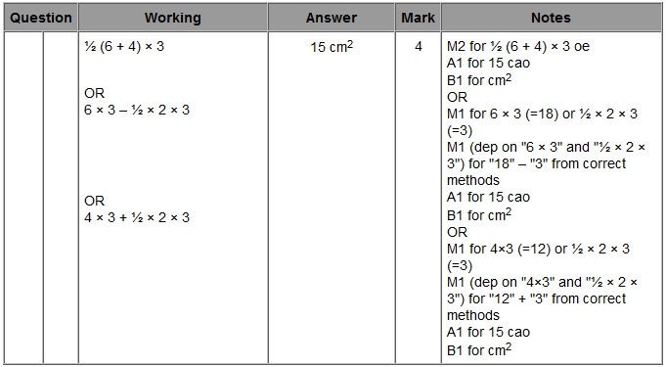

Q8.
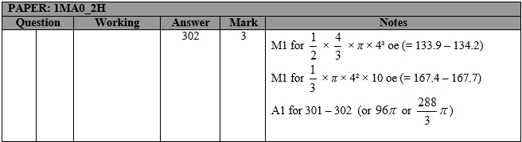

Q9.
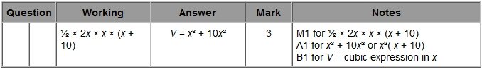

Q10.
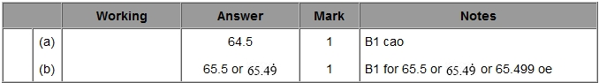

Q11.
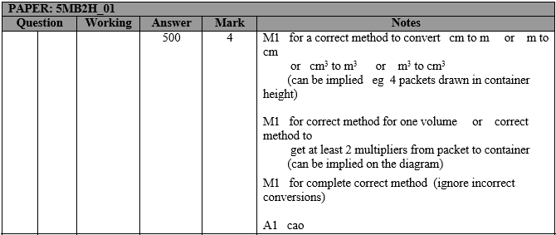
Q12.
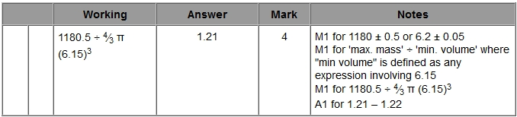

Q13.
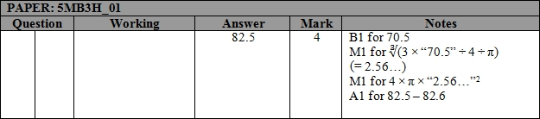

Q14.
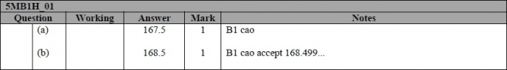

Q15.
