Name: _______________________________________________
Higher Unit 9 topic test
Date:
Time: 45 minutes
Total marks available: 41
Total marks achieved: ______

Questions
Q1.
(a) (i) Factorise x² – 12x + 27

..............................................................................................................................................
(ii) Solve the equation x² – 12x + 27 = 0

..............................................................................................................................................
(3)
(b) Factorise y² – 100
..............................................................................................................................................
(1)
(Total for Question is 4 marks)

Q2.
Solve, by factorising, the equation 8x² − 30x − 27 = 0
...........................................................
(Total for Question is 3 marks)

Q3.
The expression x² – 8x + 21 can be written in the form (x – a)² + b for all values of x.
(a) Find the value of a and the value of b.

a = . . . . . . . . . . . . . . . . . . . . . .
b = . . . . . . . . . . . . . . . . . . . . . .
(3)
The equation of a curve is y = f(x) where f(x) = x² – 8x + 21
The diagram shows part of a sketch of the graph of y = f(x).
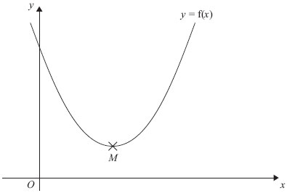
The minimum point of the curve is M.
(b) Write down the coordinates of M.

..............................................................................................................................................
(1)
(Total for Question is 4 marks)

Q4.
Solve the simultaneous equations
4x + y = 25
x − 3y = 16
x =...........................................................
y =...........................................................
(Total for Question is 3 marks)

Q5.
Solve the equations
x² + y² = 36
x = 2y + 6
...........................................................
(Total for Question is 5 marks)
Q6.
A cinema sells adult tickets and child tickets.
The total cost of 3 adult tickets and 1 child ticket is £30
The total cost of 1 adult ticket and 3 child tickets is £22
Work out the cost of an adult ticket and the cost of a child ticket.
adult ticket £...........................................................
child ticket £...........................................................

(Total for question = 4 marks)

Q7.
Solve 3x² − 5x − 1 = 0
Give your solutions correct to 3 significant figures.
...........................................................
(Total for question = 3 marks)
Q8.
–2 < n ≤ 3
(a) Represent this inequality on the number line.
(2)
(b) Solve the inequality 8x – 3 ≥ 6x + 4

..............................................................................................................................................
(2)
(Total for Question is 4 marks)

Q9.
3x + 5 > 16
x is an integer.
Find the smallest value of x.

..............................................................................................................................................
(Total for Question is 3 marks)

Q10.
(a) Solve the inequality 5e + 3 > e + 12
...........................................................
(2)
(b) On the grid, shade the region defined by the inequality x + y > 1
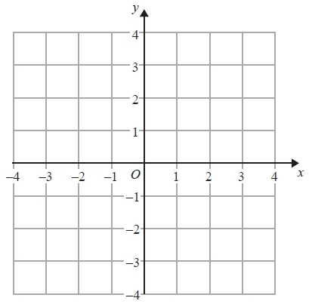
(2)
(Total for Question is 4 marks)

Q11.
On the grid below, show by shading, the region defined by the inequalities
x + y < 6 x > − 1 y > 2
Mark this region with the letter R.
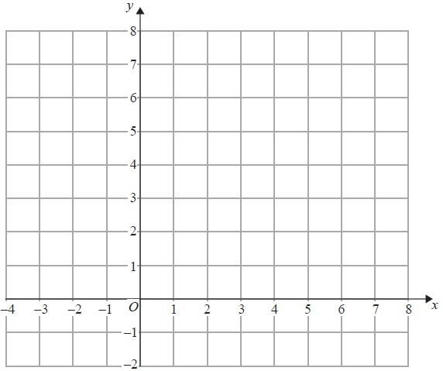
(Total for Question is 4 marks)

Examiner's Report
Q1.
It was disappointing to see that less than a quarter of candidates could factorise a three-term quadratic expression correctly and then solve the associated quadratic equation. However, some managed to factorise correctly and about the same number were able to give a solution where the 3 and 9 in the factors had the incorrect signs.
A surprising number of candidates did not realise that part (ii) followed on from part (i) and gave a solution involving the quadratic formula. In part (b) only a quarter of candidates were able to correctly factorise a quadratic expression where the terms were the difference of two squares (a popular question to include on a Higher Tier paper).

Q2.
Factorisation of a quadratic function with non-unitary coefficient of x² was poor. Many chose to employ the formula to solve the given equation. Any mistake in the use of the formula, which was more often than not, resulted in no marks. A fully correct solution by this method gained just one of the three available marks. Many did make good attempts at factorising but then failed to complete the solution. A common incorrect attempt at factorisation was (4x−9)(2x+3).

Q3.
This question was poorly answered. It was clear that only a small minority of candidates were well practised in the technique of completing the square. Candidates who realised what was required often went on to carry out this technique but then spoiled their responses by writing a = −4, b = 5. Other candidates wrote (x + 4)² +5 then a = 4, b = 5. This was clearly incorrect working and could not be awarded the marks. "8" and "21" were commonly seen incorrect answers. Part (b) was answered correctly by only a small minority of candidates with many of the more able candidates failing to see the connection between the two parts of the question.

Q4.
This was a standard simultaneous equation question which was, for some candidates a single step to eliminate one of the variables. Most candidates who had an idea of what to do multiplied the first equation by 3 and added. Those that subtracted were not awarded any marks. Others multiplied the second equation by 4 and subtracted. Those that added were not awarded any marks. In fact, elimination rather than substitution was the overwhelmingly commonly seen approach. Often, the elimination was carried out incorrectly with the difference between 12x and – x being found as 11x, for example. Once again, arithmetical weakness meant that candidates were losing marks. Typical errors included:
• Getting to 13x = 91 and failing to go any further
• Working out the difference between 64 and 25 and getting 41It was a pleasure to see some candidates properly checking their solution.

Q5.
The algebra required to solve these simultaneous equations was beyond the capabilities of most students, although the majority of students attempted the question. The first step was to perform a substitution into the first equation. Those who did this were often able to go on to expand their squared bracket, although a frequent error occurred with the squared term. Many students were able to simplify their quadratic equation into a form to be solved either by factorisation or by the use of the quadratic formula. Many students stopped at this point. It was pleasing to see a few go on to solve the quadratic, and to realise that their values for x and y needed to be correctly paired.

Q6.
Only a minority of students chose to derive a set of simultaneous equations to solve. The majority of students used a trial and improvement approach to the solution, which could only be credited on giving the correct answers. Common incorrect answers scoring 0 marks were £7.50 (from 30÷4) and £5.50 (from 22÷4).

Q7.
The most common error was in using −5 instead of 5 at the front of the formula. Another common error was in copying the formula but not extending the division line under the &#150;b, or in performing the calculations in the wrong order. Too many attempted T&I or factorising methods but failed to show sufficient progress to gain any marks.

Q8.
Part (a) of this question was quite well done though some candidates were unable to use the correct notation, ie that of empty or solid circles, at each end of the interval. A relatively common error was for candidates to draw a line from −1 to 3. It would appear that these candidates assumed that the values needed to be integers but then drew a continuous line between the 2 values. Some candidates indicated the correct end points of the interval but did not draw a line joining them. In part (b) candidates often found the critical value 3.5 or equivalent and so gained one mark. However 3.5 alone or x = 3.5 was often written on the answer line and examiners could not give this full marks. Poor manipulation of the inequality was also commonplace with incorrect simplifications such as 2x ≥ 1 seen.

Q9.
A large number of candidates failed to see the significance of the word ' integer' and so gave a fraction or decimal as their final answer. Most candidates were able to reach a value of 3.6 or 3.7 by either solving the equation 3x + 5 = 16 or dealing correctly with the inequality. Algebraic methods did not have to be used and some candidates, aware of the meaning of integer, simply substituted in integer values of x until the inequality became false.

Q10.
Part (a) was often answered well with students scoring at least one mark. Many treated this as an equality which resulted in e = 2.25 for one mark. Many quoted e > 2.25 and then simply write 2.25 on the answer line. This was not penalised. Failure to conclude with a value of 2.25 or equivalent was generally a result of either poor arithmetic (12 − 3 = anything but 9 was common) or poor algebraic manipulation; many adding e to both sides of the inequality by mistake.
In part (b), many students were unable to draw the straight line x + y = 1. The most common error was to draw the lines x = 1 and y = 1 and then shade the positive quadrant formed. Many drew the line x + y = 2. In addition shading was often in error showing confusion with the inequality.

Q11.
A fully correct solution was not the norm in this question. A great many candidates were unable to draw the three lines correctly; x = −1 and y = 2 were often drawn as y = −1 and x = 2 and often x + y = 5 or x = 6 and y = 6 were drawn instead of x + y = 6. Shading, whether 'in' or 'out', was generally well done but credit was dependent upon at least two correct lines.

Mark Scheme
Q1.
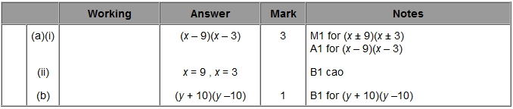

Q2.
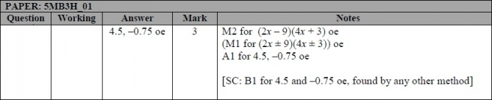

Q3.
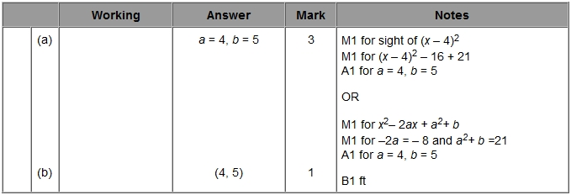

Q4.
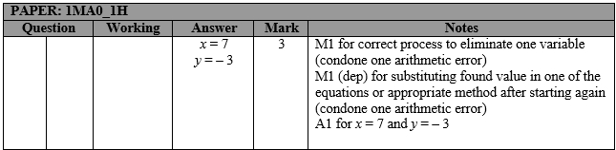

Q5.
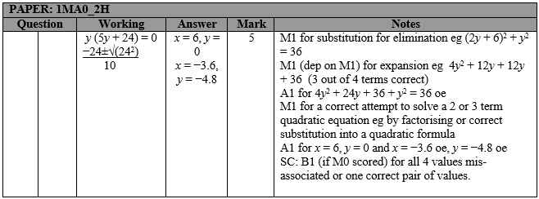

Q6.
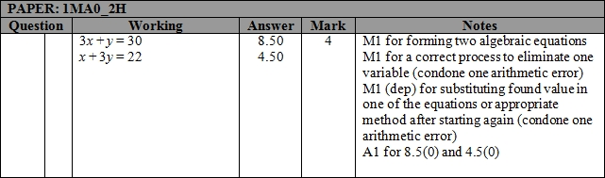

Q7.
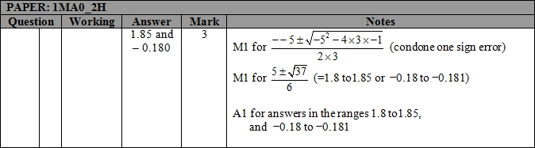

Q8.
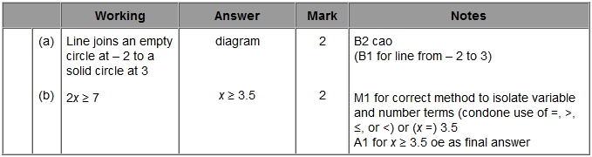

Q9.
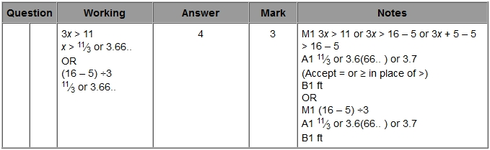

Q10.
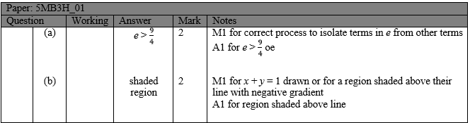

Q11.
